Agenda Item | 11, 11.1 and 11.2
Subject | Overview of meetings to date
Author | The Clerk
Date | 28/06/2021

Contents
Overview 1
Meetings to Date 1
Key Items of information Obtained on the Sale and Proposed Development of Westfield Down During and Following the Meetings 1
Development of the Senior Football Pitch, Mini Pitch Area and Changing Rooms 2
Meeting with Westfield Football Club in Relation to the development of the Senior Football Pitch 2
S106 Items to Consider following the S106 Working Group Meeting 3
Access Road to Changing Rooms and Car Park 4
Recreational Land as per the Third Schedule 4
Resolutions for Council to Consider 4
Appendix One: 4

Overview
- The propose of this document is to keep councillors and members of the public up to date with the meetings and progress to date. It is noted that a further meeting on the 8th July with Rother District Council is to be held with both District Councillors in attendance. A follow up on this meeting and the meeting on the 17th May will be published after this meeting.

Meetings to Date
- 17th May 2021 – Meeting between WPC, Rother District Council (RDC) and Optivo: To discuss sale and development of the land at Westfield Down
- 19th May 2021 – Meeting between WPC and Court Developments: To discuss sale and development of the land at Westfield Down
- 9th June 2021 – On Site Meeting with Court Development and Optivo to see site progress
- 19th May and 23rd June – Meetings Between WPC and Westfield Football Club

Key Items of information Obtained on the Sale and Proposed Development of Westfield Down During and Following the Meetings
- Currently only the 40% Affordable Housing Units (AFUs) covered under the S106 are the ones that Westfield residents will be getting priority for. Optivo have said that they will extend this to the other 24 properties.
- The whole site is currently appraised at 100% rented AFUs. Optivo are currently reviewing options to see what element of Shared Ownership properties they would be able to have of site. At the meeting it was muted that there could be a 50/50 split. The Chairman noted that this should be the minimum and the higher Shared Ownership properties the better for residents.
- RDC say there are 55 eligible households within Westfield Parish on the housing register (this is only for a rented AHU). The Clerk is working on further information to see how the current housing need matches the properties being developed on site for AHU rental.
- Residents eligible for rented AHUs will be done through the housing register.
- Residents wishing to show interest if shared ownership properties are going to be available. The Clerk would set up a page promoting this once there was confirmation on the % of shared ownership properties available and what types these would be.
- Rother Officers feel they have complied with the S106.
- There are no plans to currently include Market Dwelling properties on site.
- The Parish Council has requested a further meeting with Rother Officers and District Councillors to review the issues of transparency and adherences to the S106. Meeting will be held on the 8th July.

Development of the Senior Football Pitch, Mini Pitch Area and Changing Rooms
- The current timetable is to have the football pitch and laid to grass by August 2021 and to hand over to the Parish Council around August/September in 2022. Currently only one contractor has been approached to build the pitch Bourne who has made the following recommendations having seen the STRI August 2010 report:
  - The main difference between the STRI report and the proposal from Bourne Sports is to not do a 50% sand mix in the soil. Instead replace this with a 25ml sand carpet on top of the soil. The main reason was that the ‘mix soil’ would be far harder to maintain and keeping the grass/pitch watered. He also said that you would lose a lot of nutrients with the 50% soil mix and therefore require more fertiliser etc.
  - Estimated annual costs for the 25ml layer soil version - £5-7k per annum.
  - Estimated annual costs for the 50% mix soil version - £10-14k per annum.
  - Drainage will run from corner flag to corner flag providing an element of self-flushing within the system with 4m centres.
- The Parish is to be consulted with in regard to the proposed specification of the ‘Senior Football Pitch’. Rother under S106 Seventh Schedule, paras 1.1, 1.2 and 1.3 currently appointing an independent consultant to advise on the Bourne Proposal, the STRI Report and current regulations/requirements. Following this they will consult with the Parish Council to agree the specification. WPC have spoken to the Westfield Football Club and they have been advised that the current Bourne proposals would deliver a superior quality pitch.
- It was confirmed at the meeting on the 19th May that the whole area including the proposed mini pitch should be level. There is no requirement for the Developer to build the mini pitch under the S106 third schedule, para14 however the plans show that this will be a level piece of land so this must be delivered. At the 9th June on site meeting it was noted that some for of herringbone or field drainage would be required for this area as this would otherwise undermine the Senior Football Pitch or create a bog on the adjoining Recreational Area.

Meeting with Westfield Football Club in Relation to the development of the Senior Football Pitch
- Councilors have met with Westfield Football Club to discuss the future use of the Parish Field and the Senior Pitch.
- WFC wanted to confirm that Council are happy that the Senior Football Pitch and the area where the mini pitch should have gone will be for the sole use of WFC for their training and playing.
- WFC will work to develop a business plan for the next 5 years to show that the club is likely to be solvent for the term of the lease. They are currently asking at a minimum of 25years for their lease. This will enable the club to obtain grants to continue to develop the site to FA grade F standard.
- It was noted that the Parish Council does not have any funds for any further developments to the site such as floodlighting, stands etc. Any alterations to the site will require planning permission even the fencing. It was suggested about looking at the option of a natural hedgerow of hawthorn around the pitch and to look at the possibility of apply for a Lund Grant for the project. This would benefit in softening the look in the area as well as providing a suitable ‘fence’ until a permanent fencing could be put in place behind the hedging.

S106 Items to Consider following the S106 Working Group Meeting
- Court Development have emailed the Chairman to confirm that a brick plinth would be required as this is not shown on the original plans. The group confirmed this was required as per the S106 agreement in the Eighth Schedule page 30:

“External Walls shall be of insulated cavity construction. The outer leaf shall be built in stock bricks to a height of 600mm with a canted plinth. Above 600mm the wall shall be built in blockwork with a self coloured K render of similar.”

- The Chairman has also confirmed that the walls should be painted white and has requested that real rather than fake slate is used for the roofing.
- It was confirmed that the current plans for the changing rooms under planning application RR/2019/1067/P (see appendix one for outline plans) do not conform to the S106 nor do they confirm to FA standards. The S106 Eighth Schedule states the following requirements:
Disabled Facilities
  - Full account must be taken of the Disability Discrimination Act 1995. Toilets are required together with appropriate access separate from the players' access.
Public Toilets
  - Toilets must be provided consisting of at least 2 urinals and 1 WC for males and 2 WC's for females. Access must be separate from the players' access.
Changing Rooms Summary Specification
  - This should be read in conjunction with AJK Plan No. WDP2239/12. Where appropriate, all construction must comply with current Building Regulations . A small amendment will be required to the Plan to provide separate external access to the public toilets.
The current plans do not meet these requirements.
- It was confirmed that there are other outstanding items regarding the changing rooms Council would like to have clarity on the following items in relation to the internal specifications. For the below items the working group has suggested detailed plans showing where the following items for each will be positioned and the proposed fixtures being used:
Changing Rooms
  - Two changing rooms for players must be provided, each of a minimum of 18 square metres, excluding shower and toilet areas. Each must have a shower area comprising at least 4 shower heads, 1 wash hand basin and 1 WC.
Fittings
  - Supply and fit benches and clothes rails to players and officials changing rooms. Supply and fit unbreakable mirrors in all changing rooms and W.C areas
  - Two match officials' rooms must be provided, each of a minimum of 6 square metres, excluding shower and toilet areas. Each must have at least one shower, one wash hand basin and one WC.
  - All changing rooms must have hot and cold running water and must be heated.
Wall Finishes
  - Provide ceramic wall tiles to shower rooms in two coloured in a pattern. Provide white ceramic wall tile splash backs to minimum 200mm height in toilet area and cleaner's sink.
Floor Finishes
  - Supply and lay non slip vinyl flooring to corridors, changing rooms and toilet areas in colours. Supply and lay non slip ceramic tiles with coved skirtings in shower areas. Supply and fit mat and matwell frames to external doors to corridor
Sanitary Installation
  - Supply and fit sanitary ware and shower heads and sink and worktops to cleaner's room.
Services
  - Install hot and cold water services and electrical installation. Provide external foul and surface water drainage to changing rooms. Provide incoming water main and electrical main to changing rooms. Fit heaters to all changing rooms. Ensure that pipework is frost protected.

Access Road to Changing Rooms and Car Park
- Councillors need confirmation from ESCC if they are intending to adopt the entire length of the road up to the car park or will this only be the access to the AHUs as shown in Schedule Three, para 9.
- It is suggested that detailed plans of the access road as outlined in the S106 Ninth Schedule:

  - To be 3.5 metres wide with one passing place and turning head. It shall be constructed in 3 courses of bituminous asphalt to ESCC Highways Construction Specification on a DoT granular sub-base. Provide precast concrete kerbs to edge of roads with drop kerbs at junctions with car parking areas. Provide gulleys and drains for appropriate drainage system and petrol interceptor as required.
  - Car Park – Construct car parking spaces with cellular, porous, recycled plastic paving grid system such as BodPave 85 or as otherwise approved by the Council pursuant to planning permission reference RR/2011/2114/P (please note lastest application is RR/2019/1067/P). The grid to be installed on a well compacted, free draining, firm level sub-base DoT Type 3 incorporating a Tensar triAx TX 160 geogrid reinforcement layer to the manufacturer's recommendations. Fill the grid with sand soil rootzone and apply grass seed. Incorporate car park bay markers in grid system.

Recreational Land as per the Third Schedule
- Councillors need confirmation from Rother DC on the requirements the Recreational Land must achieve before the ‘Certificate of Satisfaction’ can be signed off under para 12.2.

Resolutions for Council to Consider
- For Cllrs Monro, Smith and Hall to meet with Optivo to determine the actual housing need for AHU rentals against the properties being built at Westfield Down.
- To confirm that Westfield Football Club will have sole use of the new Senior Football pitch to play and train their senior and junior teams.
- Following the submission of a business plan from WFC Councillors would consider if required some usage of the Parish Field for training purposes. However, this would still be under the conditions that the current changing rooms and barriers are removed from the Parish Field. Both items 26 and 27 will require the lease and license being signed off at Full Council at a later date.
- For the Clerk in consultation with the S106 Working Group to write to Court Developments outlining specific areas within the S106 they would like further clarification on.
- For Council to delegate authority to the Proper Officer in consultation with the S106 Working Group under section 101 of the 1972 LGA Act to act on behalf of the Parish Council in confirming the details in regard to the S106 requirements.

Appendix One:
RR/2019/1067/P changing room floorplans. The current plans do not show:
- Disabled Facilities
  - Require access separate from the players' access.
- Public toilets
  - Require access separate from the players' access.
  - Require separate external access to the public toilets.

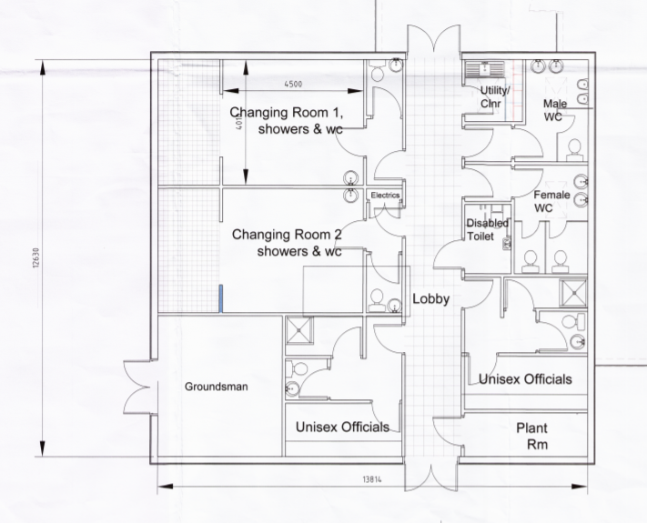

Appendix Two:
RR/2019/1067/P changing room floorplans proposed amendments received 28/06/21 showing the new external entrances.

