Agenda Item | 9.4
Subject | Work on Trees to be carried out
Author | The Clerk
Date | 07/10/2021

Overview
- To highlight the work already carried out and agree and the work left to carry out which the Clerk is getting quotes for.

Works Carried Out
- Three cherry trees at the Recreation Ground. All identified for removal. Clerk visited on site with TCV. It was agreed to remove all three cherry trees as per the tree survey report but to leave in the tree trunks for biodiversity benefits for local bugs and grubs.
- The hedge on the right hand side as you enter onto the Parish Field from Cottage Lane.

Works to be Carried Out
- Recreation Ground
  - Ornamental Fruit Tree – T2 – Reduce to 2 meter crown.
  - Field Maple – T3 – Carry out cyclical reductions.
  - Cherry – T5 – Remove lower limbs and reduce weight in tree and remove ivy.
  - Cherry – T6 – Remove lower limbs and deadwood.
  - Oak – T14 – Remove deadwood and lowest northern limb and south-eastern limb.
  - Lime Tree – T16 – Remove deadwood and reduce by 20/25%
  - Lime Tree – T17 – Remove deadwood and reduce by 20/25%
  - Lime Tree – T18 – Remove deadwood and reduce by 20/25%

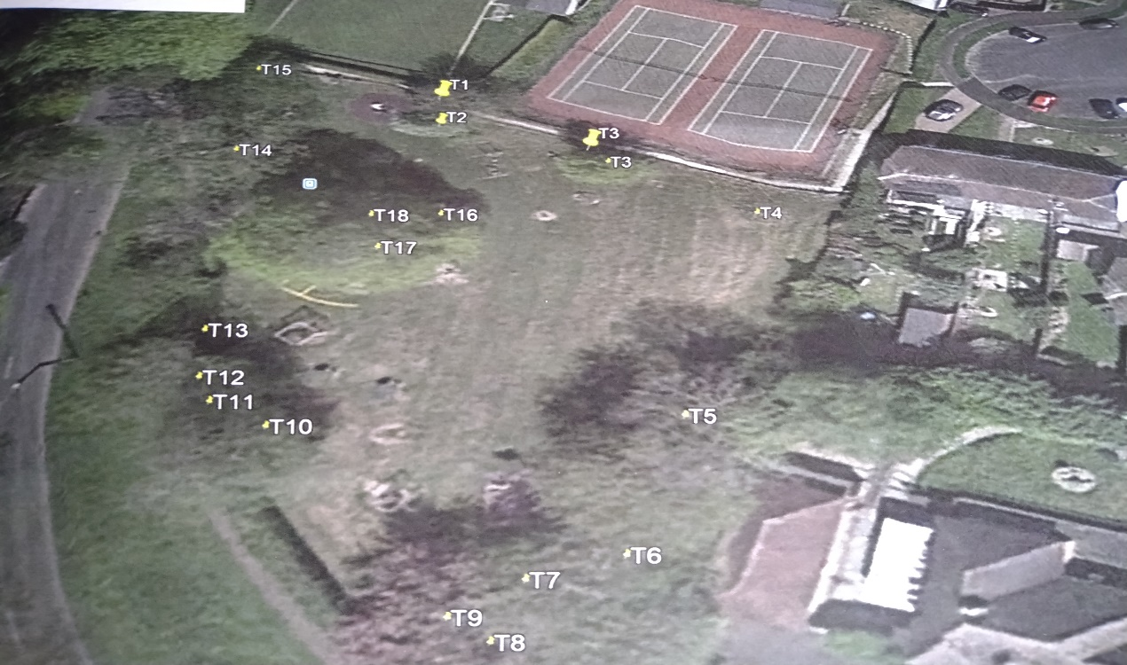

Resolutions for Council
- Council to agree the works and recommendation by the Clerk for contractor.

