Agenda Item | 13.3
Subject | Options for Brick Bus Stop opposite Londis Stores
Author | Proper Officer/Parish Clerk
Date | 03/03/2022

Overview
- The brick bus stop opposite the Londis stores requires a new roof. This has been identified by two Parish Councillors and the Clerk. As this brick bus stop no longer serves as a bus stop Cllrs are asked to look at a number of options on a way forward in addressing the matter.

Position of the Existing Brick Shelter
- Position on the Main Road
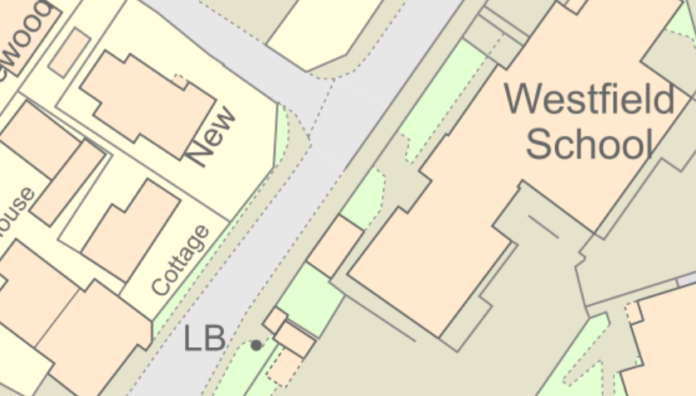
Existing brick shelter
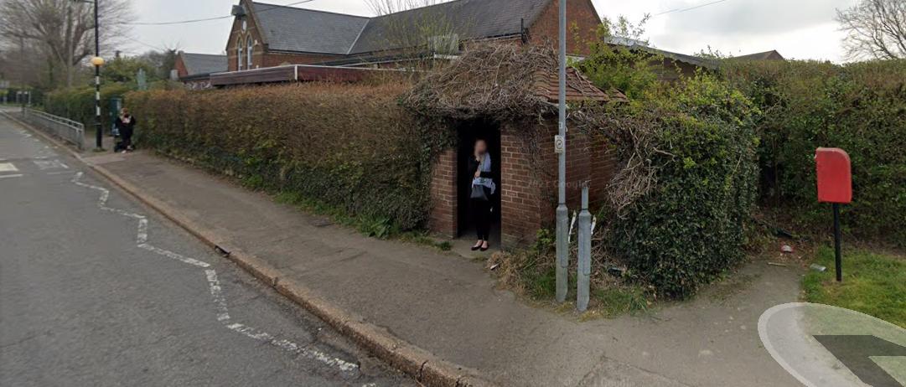
- Street view
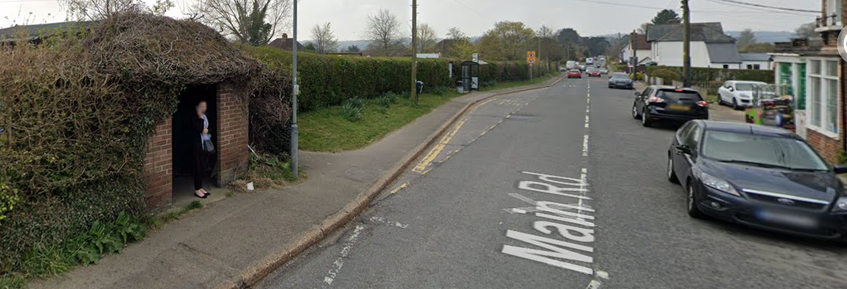

Potential Options
- Replace the existing roof and otherwise leave alone.
- Replace the brick shelter with another form of shelter.
- Remove the brick shelter completely and potentially extend the whole hedge to the cover the whole space.
- Remove the brick shelter all together and replace with a new hedge just at the back to cover up the hole and:
  - Turf the remaining area.
  - Plant up the area with either low maintenance shrubbery or plants.
  - Pave the area and put in a new bench and planters.
  - Pave the area and recite a new freestanding Parish Council notice board here.
- Please note any work on this area will require certified traffic management due to the close proximity to the road and it is a busy footpath and check licensing with ESCC.

Some Visual Options if Brick Shelter is removed

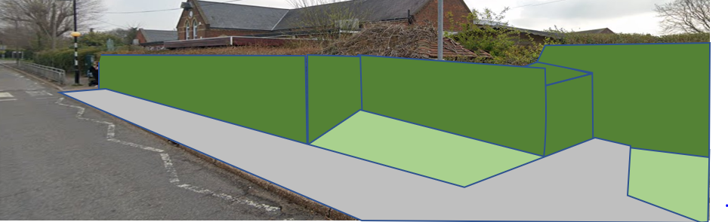
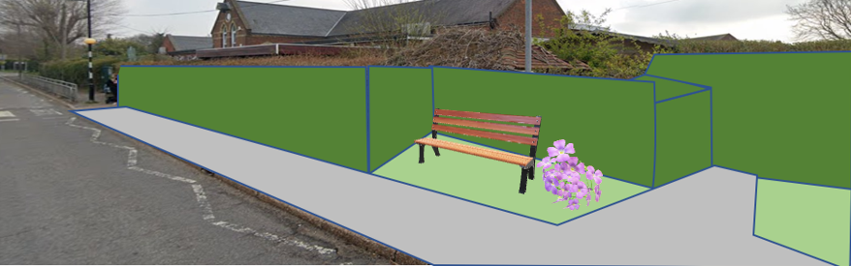
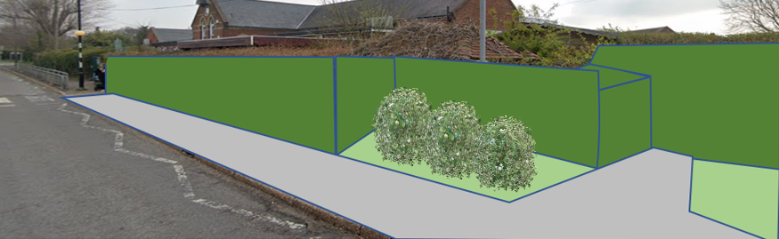

Resolutions for Council
- Council are asked to note the report and discuss if there is a preferred option or an alternative option they wish the Clerk to explore.
- If an option is agreed as previously discussed this option will be advertised within the Community to check residents input and feedback on the proposed option.

