Agenda Item | 8.1
Subject | FWAG Overview and proposal
Author | Proper Officer/Parish Clerk based on Environmental Working Groups recommendations
Date | 03/03/2022

Overview
- This report gives a top line overview of the potential areas the Environmental Working Group are looking at to build back some of the significant habitat lost during the clearing of Westfield Down.

Overview Map of Areas Discussed
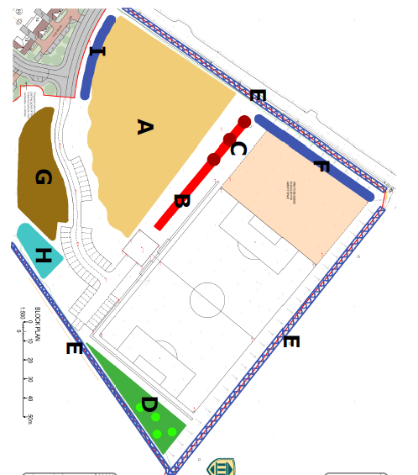

Overview of Area Proposals
- The Working Group has looked at each area and whilst this is an ongoing project have come up with the following proposals for Council to review:
  - AREA A – Main area of recreational land. To remain as an open space to be managed as parkland. Suggestion to plant several spaced trees on the site such as cherry blossoms.
  - AREAS B and C – To create a hedge in front of the football pitch area. This would help keep the pitch secure but also soften the overall landscaping for residents using AREA A.
  - AREA D – The whole area to be levelled out and planted up. Fairly tight planting of shrubs and trees. Area will be difficult to maintain but good bio-diverse reasons to leave fairly untouched.
  - AREA E – This is a significantly large area so has been broken down into three keys areas:
    - Hedge running alongside A28 – Whole hedge needs infilling and reinforcing to create a healthy hedge as well as a natural screen for the housing and recreational areas. This work should continue down to the road leading to the Drs surgery.
    - Hedge running along the top of the site long the access road – This needs a new hedge putting in along the whole track. Hedge to be slow growing for easy maintenance.
    - Hedge running parallel with the Cricket Ground and 1066 footpath – This hedge will need hard coppicing down to create a uniform and healthy hedgerow. Infilling will also be needed to plug up any gaps and ‘bays’ will stretch out into the Westfield Down site creating greater habitats for local wildlife. Any debris or rubbish will also need removing including the old wire fencing.
  - AREA F – this hedge will help create a ‘corridor’ for those wanting to use the footpath but also provide screening and security for the football pitch. It is important the hedges F connects at the top with hedge E and hedges B/C.
  - AREA G – Potential for a more specific bio-diverse area such as a wildflower meadow. This would need specific management to enable the wild flowers to flourish year after year.
  - AREA H – This is one of the only surviving areas from the original habitations from the clearing of Westfield Down. Intention to leave and potentially extend slightly this coppice area.
  - AREA I – Further hedging to soften the landscaping between the recreational are and housing. However it will also act as a key safety feature keeping those using AREA A safe and away from the access road and exit onto the A28.

Additional Observations
- It will be important to ensure hedgerows are connected and have similar mixes within them to allow wildlife corridors for local wildlife.
- Options to look at adding in ‘food sources’ for smaller mammals such as gelder rose and wild rose.
- Hedging needs to be reviewed where it can act as a safety barrier to roads and support the constraining of cars parking on the wider green areas.
- Clarification needs to be made on any ‘white gaps’ on the plan. Final proposals will need very tight areas meeting each other and addressing any spaces across the plan.
- The Working Group have also discussed the options to ‘screen’ the large grey block work at the bottom of the site near the SWALE. These ideas are ongoing but options would be to look at climbers and other planting to help cover up this area. It is a serious visual blot for existing neighbours to the site and those using the 1066 footpath.
- Working Group still have a significant amount of work to do in finalising the details of tree and hedge mixes using the FWAG report as a good guidance tool. It is also noted the size and age of trees and hedging will need to be specified for each area.
- The Working Group will also look to talk to the local school about the site and proposals for the bio-diversity gains. Other residential needs will also be considered such as a ‘sensory area’ or planting.
- Once a final plan has been agreed a timetable will need to be drawn up. The Working Group would also look to further consult with the High Weal AONB Unit and the County Ecologist on the proposals.

Resolutions for Council
- Council is asked to note the report and agree in principle the overall plan.

