Westfield Parish Council Objection Letter for

Planning Application RR/2022/1118/P

The below letter sets out the main objections for this planning application from Westfield Parish Council.
Contents
Position and Scale of Development 1
Impact on AONB Landscape and Character 3
Affordable Housing Statement 3
Ecological Assessments 4
Transport and Traffic Impacts 4
Impact on Flooding and Surface Water Run Off 6
Loss of Agricultural and Business Land 6
Conclusion 7

Position and Scale of Development
- In relation to other developments within the Parish and the situation of this site this is not a small-scale development. Westfield is a rural community which already has sites in the DaSA which identify 89 houses to be built. Another 28 outside of this figure will increase this figure to an overall increase of 10% new housing within the Parish which is situated within the AONB. Such levels move the Parish away from being a protected rural community within the AONB to an over development and over urbanisation of the Parish in particular as all the larger scale developments are being proposed only in the Westfield Village Ward.
- This development does not conform to Policy DEN2: The High Weald Area of Outstanding Natural Beauty (AONB) again because the development will not be small-scale. Whilst it may be argued that it could be seen purely on a map to be in keeping with the settlement pattern section of land, as it is next to some smaller scale development, this would be a falsehood. The site is not sustainable. The infrastructure is not there to support an additional 28 houses with the current footpath network not linking up to services, narrow country roads, poor public transport connections (only buses available) and confirmation from the surgery that they do not have the capacity to manage if all the other developments are also given planning. If the precedent is set allowing this field to be developed it will then open up adjacent fields to also be developed which is also unsustainable.
- The site cannot be viewed as an exception site under Policy DHG2: Rural Exception Sites as it is not delivering a proven local housing need for affordable housing in the village/Parish, as demonstrated in an up-to-date assessment of local housing need. In fact even the proposed affordable housing is not meeting local need in relation to the RDC housing register from July 2021. The size, tenure, mix and cost is not appropriate to the assessed local housing need. Finally, the site is not well related to an existing settlement and its services, including access to public transport.
- Plots 1, 2 and 3 because of their elevated position will be looking directly into the existing properties.
- The position of this development does not comply with Core Strategy Policy OSS4 as it detracts from the character and appearance of the locality turning a mature green screen of an agricultural piece of land, down a country lane into a urban housing development outside the development boundary.
- In the planning statement in states that ‘the site is therefore surrounded by residential development on three of its boundaries.’ This is an important point to clarify as the states could be seen as misleading. Figure 1 below shows the site to be developed and the field and green spaces around it:

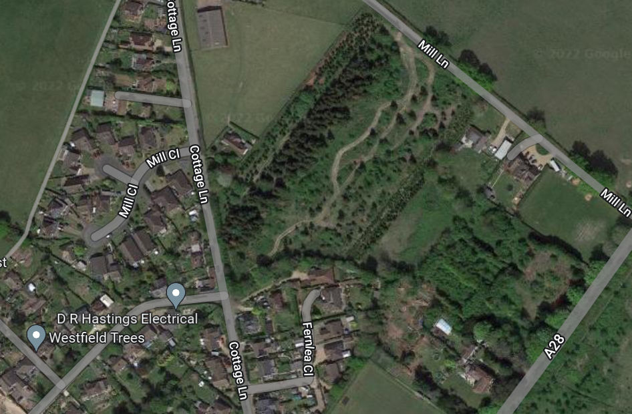
Moorhurst Site
Figure 1: Site location in relation to other development for illustrative purposes

- The residential development on the south boundary consists of several well-spaced properties. The residential development on the west of the property directly opposite consists of three properties and the back end of Mill Close. In the northern part of the proposed development there is only one house Ellenvale and then a wide-open green field. The north/north-east part of the field it is undeveloped green land. Whilst there is a proposal for the Moorhurst site (noted in blue on figure 1) this has currently been undecided. The comments from the High Weald AONB Unit state the current proposal for Moorhurst will take development almost up to the boundary and they note that it would be an overdevelopment of the area. Even if this area was developed up to the boundary it would still leave a significant green corridor between this site and the proposed development off Cottage Lane. The inference that ‘the site is therefore surrounded by residential development on three of its boundaries’ seems somewhat misleading. The boundaries in fact have significant green space around them and only residential development with more than one house on the south and west boundaries.
- The development also does not conform with Core Strategy Policy LHN1: Achieving Mixed and Balanced Communities. It states the in rural areas there is a requirement to provide a mix of housing sizes and types, with at least 30% one and two bedroom dwellings (being mostly 2 bed). There are no one bed properties on site and only 7 two bed instead of 8.4 which would give a 30% mix required.
- DaSA Policy DIM2 relating to development boundaries states development in the countryside outside of a development is limited only if it accords to specific Local Plan Policies or the countryside location is demonstrated to be necessary. Whilst the applicant may argue that due to Rother’s low housing supply allows this development to be permitted this does not take in the legal case of Monkhill Ltd v Secretary of State for Housing, Communities and Local Government & Anor (Rev 1) [2021] (discussed in detail in para 32). This case law gives greater balance to the protection of the AONB over development which will bring harm to the AONB. References to the developing Local Plan are irrelevant as the current Core Strategy and DaSA are the legal documents Rother Officers must follow.
- The applicant makes several references to the NPPF to be in favour of ‘sustainable development’. This site, as outlined in this objection letter is not sustainable. There is no footpath network to the village amenities, it does not have residential development on three sides of the proposed site boundary nor do three sides of the proposed site adjoin the existing development boundary. Furthermore, its position within the AONB will cause significant harm referring again to the case law noted in paras 9 and 38 which give great weight to the importance of the AONB and this is in itself good enough reason to turn down a planning application.
- It is noted by the applicant that planning permission should be granted in accordance with paragraph 11 of the NPPF. However, this proposal does not meet the requirements of paragraph 11 of the NPPF as it does not safeguard and improve the environment because of the harm to the AONB. This proposed development also does not ensure safe and healthy living conditions as there is no footpath network to the amenities in the village therefore creating dangerous conditions for people to walk along narrow, unlit, country lanes to access these amenities. Paragraph 25 of this letter outlines how little footpath network there is from the development to the village amenities. Any proposals to connect the development to the footpath network seem unlikely as there is not the room on the lane for this nor is there a continuous network into to the village amenities. The local surgery have also confirmed that they are at capacity so there is no clarity how residents in this development could be supported by the local surgery.
- The applicant themselves note that the site was previously rejected for Rother’s SHLAA as the conclusion was ‘it was in the AONB and poorly related to the main core of the village.’ This position has not changed. The site will be seen prominently from nearly all sides in relation to the AONB and is not in a sustainable location.

Impact on AONB Landscape and Character
- The proposal does not support: Policy DEN1: Maintaining Landscape Character. The site is higher up compared to the surrounding areas so any lighting is going to have a significant effect on the landscape. Therefore, developing this site because of the land’s higher situation within the AONB would not enhance the AONB landscape and beauty but make a significant mark and change to the landscape as the site will be so visible.
- The proposal does not support: Policy DEN2: The High Weald AONB. This development being within the AONB is directly affecting the setting of the High Weald AONB. Rather than enhance the AONB it is extending the housing into the AONB outside the development boundary further urbanising the countryside. Due to the scale of removal of trees, shrubs and scrub land on the roadside and on the area itself to accommodate this proposed development it is going to have a huge visual impact within the AONB. It will be clearly viewed from the road, neighbouring properties and across the AONB.
- The site does not conserve and seek to enhance its landscape and scenic beauty, having particular regard to the impacts on its character components, as set out in the High Weald AONB Management Plan. It is turning a green open space into an urban residential site outside the development boundary and is in an unsustainable position. Due to the lack of a consistent foot path network this will increase car usage in this area further disturbing the negative impact rather than enhancement of the AONB.
- When reviewing the Natural England dark skies maps this area of Westfield has a very good record of dark skies in this area of the Parish. These maps indicate that this area currently has a 0.25-0.5 reading which is penultimate level below the darkest levels for night skies. Further development here will cause light pollution which goes against the dark sky policies within the High Weald AONB Management Plan which lists degradation of night skies as one of their top five issues.

Affordable Housing Statement
- The current site does not address any of Westfield Parish’s housing need. In July 2021 the housing need was for the following:

Housing Register Data | One Bedroom | Two Bedroom | Three Bedroom | Four Bedroom | Total
Band A | 2 | 1 | 2 | 0 | 5
Band B | 4 | 6 | 2 | 0 | 12
Band C | 9 | 3 | 3 | 1 | 16
Band D | 13 | 8 | 1 | 0 | 22
Total | 28 | 18 | 7 | 1 | 55
Properties Being Built on Westfield Down | 4 | 12 | 19 | 4 | 39
Difference in Local Need | -24 | -6 | 12 | 3 | -15

- With the development of Westfield Down there is already a surplus of 12 x 3 bed houses for local need and 3 x 4 bedroom houses. Whilst the Parish Council has yet to have the AHUs confirmed due to the number of 3 and 4 bedroom houses being built on site the housing need for 3 and 4 beds will be met. Therefore, the proposal for the Cottage Lane development to build 7 x 3 bed and 1 x 4 bed does not match the local need. This is important as this development is also outside the development boundary and significantly impacting on the AONB. Therefore, any proposal in relation to the local housing need should be met. With an overwhelming need for 1 bed properties within the Parish and 0 being built on this development this does not meet the core affordable housing need within the Parish even if 35% (3.85) of the intermediate affordable housing was only 3 and 4 bedroom properties. If this was a sustainable site to develop the 3 x 2 bed properties would be suitable for the local housing need.

Ecological Assessments
- The current preliminary ecological appraisal (PEA) is inadequate to allow officers and elected members to have the relevant material evidence before an informed decision on building on this land can be considered. Whilst the Parish Council understands that this application is only for outline planning the ecological suitability of the site should be ascertained before any planning permissions can be given due to the issues raised in the PEA. In the report itself it states:
  - Exec Summary – The potential for the site to support reptiles such as grass snake, common lizard and slow worm (which are protected species) requires further surveys to be undertaken to determine how the proposed development could avoid, minimise or mitigate any adverse impact on reptiles if they are present.
  - Para 4.11 – No protected species were observed during the site visit. However, habitats on site are likely to support protected species.
  - Para 4.12 – The scrub, grassland and occasional log piles on site… provides good habitat for reptiles such as common lizard Zooteca vivapara, slow worm Anguis fragilis and grass snake Natrix Helvetica.
Therefore, we respectfully request that these surveys are carried out before any formal decision is taken especially as:
- the PEA was done in March outside the optimal site survey season;
- the issues the report itself raises about potential protected species on the site;
- the need for all relevant material considerations for the environmental and ecological impacts to be considered to enable officers to be able to make a sound judgement.
- It is noted that in the planning statement it states that ‘wildlife corridors’ will be situated along the southern and north-western boundaries. Considering the overdevelopment of the proposed site making full use of the site for housing, it seems that any ‘wildlife corridor’ would be so small it would be negligible in any benefits it could bring to the wildlife in the area considering the level of destruction of habitat for potential protected species.
- To achieve the proposed visual splays, you will have to decimate the existing green screening and habitat in the area removing nearly all the current trees and hedgerows which you can see from the image are mature and well established. This will be removing existing and established wildlife corridors which provide shelter, home and food for some of the expected protected species along with a wide range of nesting for birds. It is clear any biodiversity net gain cannot be achieved on the site due to the over development of the site. No clear details have been given on how this could be replaced locally. Confirmation of this should be agreed before any proposed development can be properly reviewed.
- There is also the likely presence of dormice with long links to habitat at Westfield Down. The site has clear potential for feeding bats.

Transport and Traffic Impacts
- The road that will be the main road servicing the proposed development is a narrow country lane. Figure 2 illustrates where the proposed entrance onto Cottage Lane will be. In the Google Map image, it is clear there are several issues with the proposed development site:
  - This is a narrow country lane. With a minimum of an additional 56 cars (potentially more with the substantial number of 3 and 4 bedroom houses) this is a significant increase in traffic for a small country lane.
  - The access into the development is directly opposite the existing houses. This will significantly impact on their daily lives and quality of life with car headlights now beaming directly into their properties on a daily basis producing ongoing light pollution.
  - There is no space for any proposed footpath to be built. If any such footpath was to be given consent it would further narrow the road into a very narrow single lane with no street lighting and pedestrians potentially walking up and down on a footpath making them very difficult to see at night going against Policy CO6 requiring a safe physical environment for pedestrian safety.
  - The end access onto the A28 from Cottage Lane is either via the end of Cottage Lane itself or Mill Lane. The latter is a significantly dangerous junction onto a 40mph road as visibility is very poor at this junction. Any development which increases traffic at this junction should be required to deliver significant traffic calming improvements at this junction such as a roundabout or reducing the speed to 30mph. The junction from the end of Cottage Lane onto the A28 also has significant visibility issues. This is particularly exasperated during school pick up and drop off.
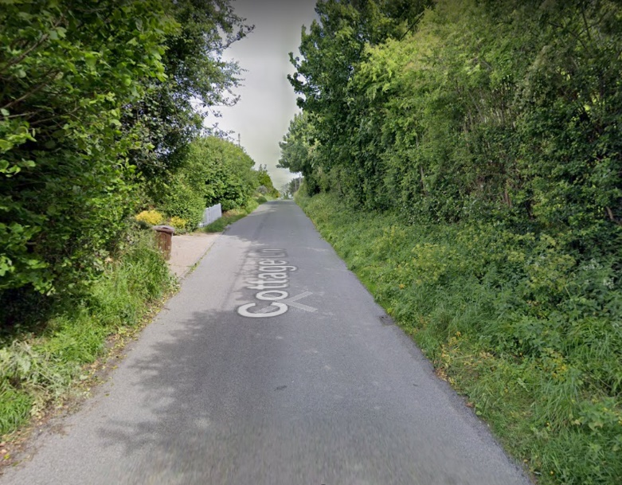
Figure 2 – Proposed entrance to the development

- The Transport Statement gives a standard review of additional trips. However due to the location of this site and the lack of sustainable footpath network to the local services this calculation seems underestimated.
- There is no sustainable footpath network from the site to the services within the villages. Therefore, any proposal to install a footpath “with the public footpath – Westfield 027 which runs between Cottage Lane to the A28” would need significant investment if this a genuine offer. Even if there is an intent to install a footpath the whole stretch of Cottage Lane there are considerable stretches where a footpath does not seem viable. The photos below in figures 3 to 6 show the lack of footpath ‘between Cottage Lane to the A28’.

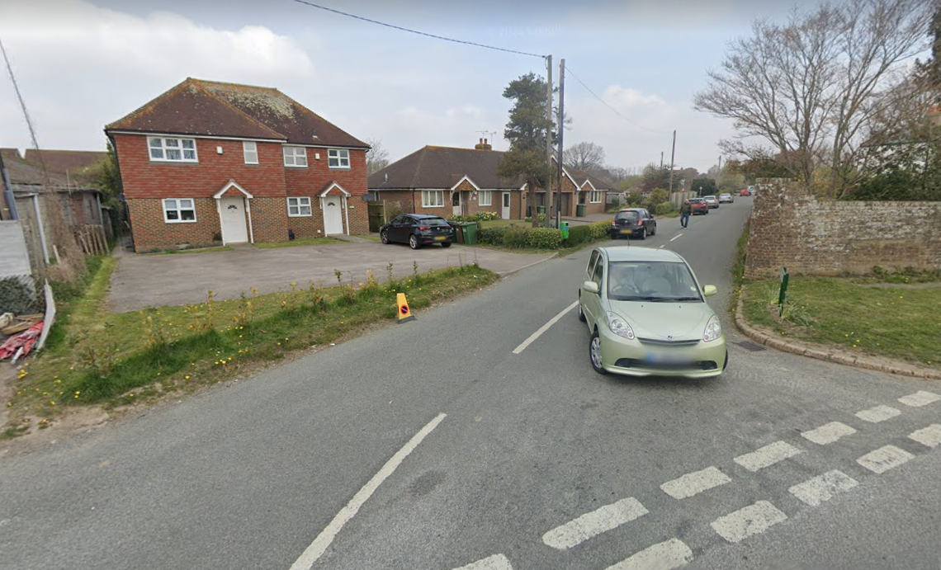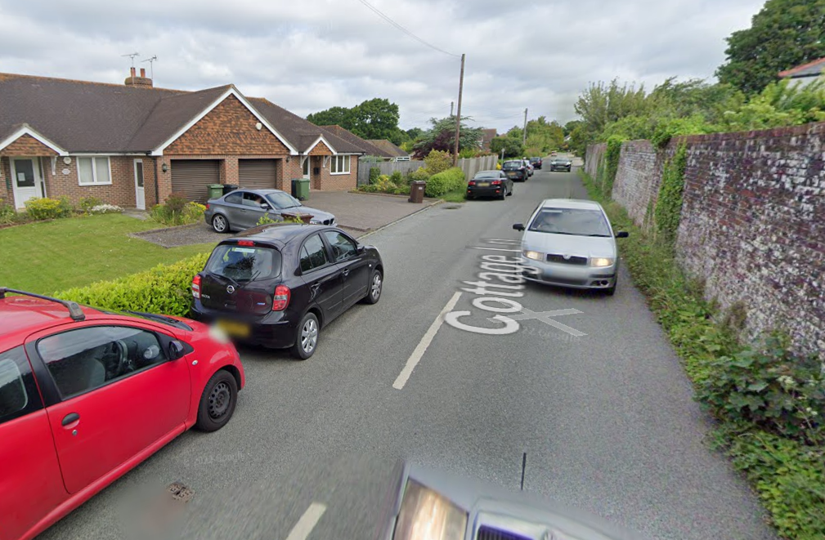
Figure 3 – Entrance Cottage Lane onto the A28 Figure 4 – Approx. 25 metres into Cottage Lane
from A28
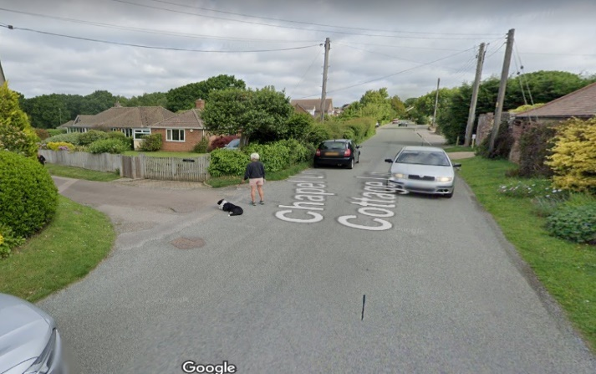
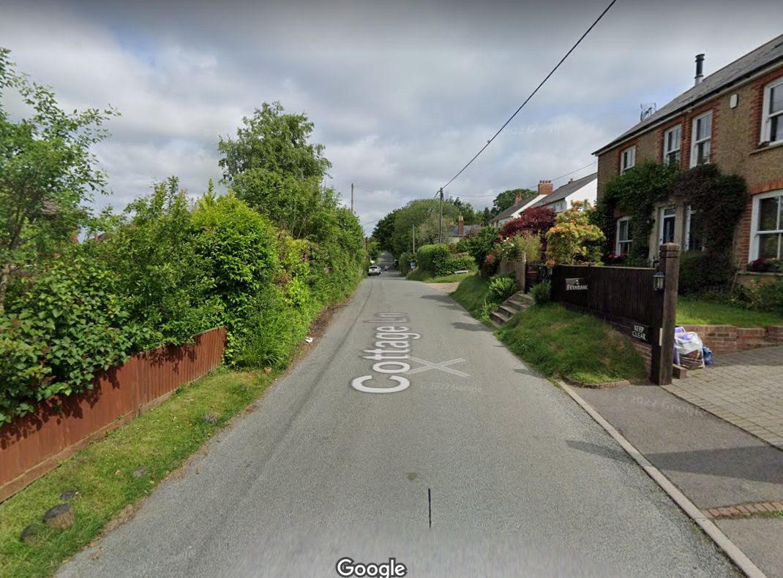
Figure 5 – Junction Chapel Lane and Cottage Lane Figure 6 – Up from Entrance to Parish Field

As you can see there are significant parts of the route from the proposed development where there is not a sustainable footpath network to do this. Therefore, anyone with children would not be able to safely walk their children to the school.
- There are no streetlights on this road so without a sustainable footpath it is dangerous to walk to the development from the village. An introduction of streetlights would not be acceptable because of the impact on the dark skies in the area.

Impact on Flooding and Surface Water Run Off
- The current site is elevated in relation to the houses situated at the entrance of New Cut and the historical houses in the ‘dip’ almost directly opposite the development. Recently the road surface was increased creating a slight rise to the road surface. Despite this only being a slight increase the impact has had significant consequences to these properties with increased flooding. Whilst the designs of the site do show some mitigation the mitigation to ‘discharge surface water from the propose development to public surface water sewer at a controlled rate’ does not seem sufficient enough considering the level of flooding in the area already.
- The current flood attenuation for the rainwater – has only been assessed for 1 in 100 flood. The Parish Council would request expect at least 1 in 500 year flood, albeit normal practice now is to plan for a 1 in 2000 year flood. The Parish Council feels this is significant due to the flooding neighbours are already experiencing. This will be made worse by the proposed development if they do not plan for flooding at the right level.
- The position of this development does not comply with Core Strategy Policy OSS4 as it will cause harm to the amenities of adjoining properties due to the existing issues of surface water run off neighbouring properties already face and the flooding this causes. The proposed mitigations does not give a robust enough proposal for the prevention of additional flooding to the existing properties within the area.

Loss of Agricultural and Business Land
- To date no soil assessments have taken place to assess the richness of the soil. In the past this site has been a successful agricultural field. RDC Core Strategy Policy OSS1 states that it would: “Give particular attention to the ecological, agricultural, public enjoyment and intrinsic value of the countryside, and continue to generally restrict new development to that for which a countryside location is necessary or appropriate to promoting sustainable land-based industries and sensitive diversification, primarily for employment uses.” This site not only has a history of successful agricultural production, but it is also currently sustaining the Christmas tree land-based industry. No details have been given on why this site cannot continue to be used for successful agricultural use or what is happening to the land-based use for the Christmas tree farm.
- Policy OSS3: Location of development states: “In assessing the suitability of a particular location for development, when both allocating land for development and determining planning applications, sites and/or proposals should accord with the relevant policies of this Core Strategy and be considered in the context of:
  - (ii) The capacity of, as well as access to, existing infrastructure and services, and of any planned or necessary improvements to them;
  - (viii) Any constraints relating to land stability, contamination, air quality, agricultural land quality and coastal erosion, and the ability to satisfactorily address these;”
This site is not accessible to existing infrastructure only via cars as there is no suitable footpath network into the main centre of the village. Development on the land should also be constrained due to the successful past of good agricultural land quality.

Conclusion
- This site on a map may look like a potential area for additional housing within Westfield. However, this site is truly unsustainable due to its lack of connectivity to the services within the village. The proposal to install a footpath seem unrealistic due to the scale of investment required and the narrowness of the Lane in areas.
- It is proposed to be developed on a small country lane with limited visual splays when entering onto the A28 from either the end of Cottage Lane or via Mill Lane.
- The ecology and position of the site needs greater investigation. However the level of damage to the existing biodiversity is significant without any clear mitigation, understand of the impact nor any details on how to deliver any biodiversity net gain on or off the site.
- The potential issues of increased flooding have not been mitigated with much detail and no consideration seems to have been given to the current issues neighbours face.
- It does not meet policy requirement at national or local level.
- The impact on the AONB for a range of reasons cited in this letter is reason enough to refuse this planning application. The position of the development, the scale and overdevelopment of the site, the destruction of the mature hedgerows, trees and the increase in light pollution and significant visual impact in the AONB landscape all will significantly harm and urbanise the countryside outside of the agreed development boundary. Whilst the developers can argue that Rother’s lack of housing supply overrides any true regard for policies or impacts on the AONB, the In Monkhill Ltd v Secretary of State for Housing, Communities and Local Government & Anor (Rev 1) [2021] EWCA Civ 74 Sir Keith Lindblom, Senior President of Tribunals, rejected a case brought by developer Monkhill against the Secretary of State for Housing, Communities and Local Government and Waverley Borough Council. When the case reached the High Court, Holgate J concluded paragraph 172 “is also capable of sustaining a freestanding reason for refusal in general development control in AONBs, National Parks and the [Norfolk] Broads”. Sir Keith said Monkhill’s main contention was that merely giving ‘great weight’ to ‘conserving and enhancing landscape and scenic beauty’ in an AONB does not provide a clear reason for refusal and that whether planning permission should be refused requires a balancing of all considerations. The judge said: “Elegantly as those submissions were presented…I cannot accept them. “They do not, in my view, reflect an accurate understanding of the policies we are considering and the way in which those policies are intended to operate. I think Holgate J was right to reject them, for the reasons he gave. I agree with him that the inspector’s decision is not flawed by a mistaken interpretation, or unlawful application, of relevant policy.” Westfield Parish Council therefore feels in balance the lack of housing supply does not give reason to allow development within the AONB outside the village’s development boundary for an unsustainable development.

https://nightblight.cpre.org.uk/maps/

