Agenda Item | 9
Subject | Parish Maintenance
Author | Clerk
Date | 03/10/2022

Overview
- An update on maintenance projects and works requiring a resolution from Council.

Agenda Item 9.1 – Handyman Schedule and Works
- The handyman continues to support the Clerk in the general maintenance of the parish. Additional items completed this month include:
  - Removed graffiti on the bench.
  - Cut back the hedge to allow easy access to the post box.
  - Installed new dog bin at Workhouse Lane and Westfield Lane and also removed old bins/pole debris.

Agenda Item 9.2 – Tennis Courts
- The original quote was only removed the tree. Additional quote received to remove stump and grind it out to allow for an additional tree/shrub to be planted.
- Recommend replacing the removed tree with a smaller evergreen shrub with minimal leaf or berry drop.

Agenda Item 9.3 – Noticeboard / Bus Shelter Works
- Work is progressing with the sites but due to other commitments the Clerk hasn’t been able to progress too much. The project support for the Council has now taken this project on.
- Westfield Lane site – The working group met on site and reviewed the layout. Having looked at the tree root system and a water meter cover the proposal to move the bus shelter nearer to the noticeboard would be difficult. It would also be difficult to move the noticeboard due to the large concrete posts the current noticeboard is attached to. The ground between the current noticeboard and bus shelter is the area the school children wait on in the morning and the area had been reduced to dirt. During the site visit Cllrs noted the overall poor quality of the footpath tarmac in this area as well. The proposal now is to tarmac the below area highlighted in grey to give a better footpath and a standing space for the school children. The agreed noticeboard will hopefully fit onto existing concrete posts. The bench will be removed and a proposed 7ftx7ft paved area in front of the new noticeboard. The bus shelter will just need to be removed, new grounds works ready for the installation of the new shelter.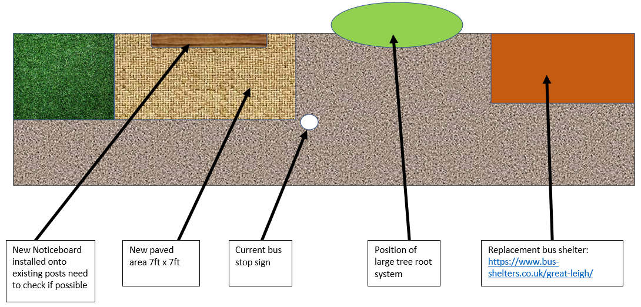
- Brick Shelter opposite Londis – The community survey has been made and approved by the working group. The project support worker will look to promote this on the Westfield Website and Facebook pages. The survey asks residents if they are happy to have the building removed and replaced. Options for replacement will need further investigation once the shelter and hedge, the front of the post box, have been removed if there is community support for this. Whilst the survey is up and running advice is being sort on the licenses needed from ESCC to remove the building, replace the bench, install new paving, install new noticeboard and to carryout works next to the A28 as traffic management will be needed.
- Whilst this work is being undertaken outlined in points 6 and 7 the proposal is to do a walk around from the newly replaced bench at the corner of Cottage Lane and the A28 to the bus shelter opposite the church. The idea would be to look at a staged approach to improve various sections of the public spaces along this route. This could include potentially new planters, hanging baskets, planting up new shrubs in areas or even just moving/replacing a bin or dog bin. A programme of works/ideas would be brought to Council and budgeted over the next two to three years depending on the proposed costs.

Agenda Item 9.4 – Dog Bins
- Due to the unsuccessful engagement of a local company the Parish Clerk with consultation with the Councillors has found a new contractor to empty the bins on a weekly basis. There are few waste disposal companies who have the correct waste management abilities to deal with dog waste as this is deemed a hazardous waste. Orchard Landscapes who currently manage the grass cutting and refuse management have also be able to take on the management of the dog bins. The owner is in regular contact with the Parish Clerk to feedback on the state of the bins.
- Unfortunately, due poor service received in the recent months and over many years the bins are not in a clean state internally. The new contractor will clean down and out the insides of the worst effected bins at a cost of £20 per bin. The bins are now emptied on time and weekly at £15 per bin. A review of any bins over or under used will be given to the Clerk over the next 6 months. If any bins are particularly over or under used it will be reviewed to see if more or less bins are needed in an area. Currently the most used bins are Workhouse Lane and the Parish Field bin.
- Proposal to move the bin on the outside of the Parish Field near the A28, which is currently under used, into the field to hopefully deal with the over use of the other bin and minimise either bin becoming over filled.
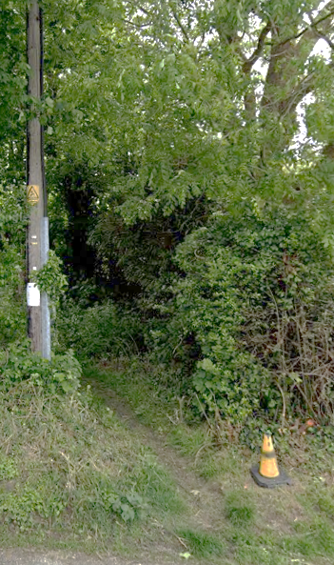

- Proposal to add an additional bin at the entrance of the footpath opposite the junction of New Cut and Cottage Lane as shown in figure one. Bin will be placed just inside of the foot path so it is not in the direct sunshine, it is easy for footpaths walkers to use but also still visible from the roadside for other dog walkers to use. The proposed colour of the bin will be green not red. If Councillors are in support the Clerk will look into obtaining a license from ESCC to install.

Figure One

Agenda Item 9.5 – Grass Cutting Schedule 2023/24
- Councillors are asked to resolve if they wish to:
  - Continue the self-delivery of the grass cutting for the urban areas within the Parish with a grant from ESCC of £592.
  - If Councillors resolve to continue the self-delivery will this continue to be fortnightly cuts between the months of March and September (potentially October if grass is still growing). Fortnightly cuts will be of the entire Parish including and green open spaces. Grass cuttings will be removed from the following locations: the Recreation Field, the twitten between Cottage Lane and the A28, Mill Close, Greenacres and Heathlands.

Agenda Item 9.6 – War Memorial Maintenance
- Councillors to note and thank the many years work of Toby Walsh. After many years of looking after the war memorial Toby has spoken to Veterans Growth who have offered to take over looking after this precious asset.

Councillors Resolution
- Councillors are asked to resolve the following matter on parish maintenance:
  - To stump grinding the tree at the bowls club once removed.
  - To replace the removed tree with either an evergreen tree or bush in consultation with the Bowls Club.
  - Agree in principle the new proposal for the Westfield Lane bus shelter. Clerk to work with project support to obtain quotes and licenses within the agreed budget. Any expenditure over budget would need full council approval.
  - To agree to a walk around between Cottage Lane/A28 junction and the church to look at potential options to improve the public spaces. Work to be carried by the project support worker.
  - To move the dog bins as outlined and install a new bin.
  - Decide whether to self-deliver the grass cutting for the urban areas and frequency of those cuts.
  - Support the Veterans Growth in maintaining the area around the war memorial.

