Agenda Item | 10
Subject | Parish Maintenance
Author | Clerk and Project Support
Date | 03/10/2022
Contents
Overview 1
Agenda Item 10.1 – Green Fencing 1
Agenda Item 10.2 – Netting and Poles 1
Agenda Item 10.3 – Ditch Clearing at Parish Field 1
Agenda Item 10.4 – Update Report from Bus Shelter Progress. 2
Agenda item 10.5 – Proposal to install a new fingerpost pointing to the Parish Council tennis courts. 2
Resolutions for Council 3

Overview
- An update on maintenance projects and works requiring a resolution from Council.

Agenda Item 10.1 – Green Fencing
- The green fencing has been repaired at the Parish Field. The handyman carried out this work and secured the fence.

Agenda Item 10.2 – Netting and Poles
- The poles and netting at the Parish Field have been fixed but the ones on the side nearest the housing need to be replaced. Cuffs have been put on them but this is a temporary fix. Plus the netting is in a very poor state of repair at the top and bottom.
- To buy (not install or delivery) new poles with new netting for 50 meters costs £3,502 +VAT but Council can claim back the VAT. Please note cost for 60 meters is £4,048 +VAT. As poles will be supplied with pulleys it would be a condition of the Football club to ensure the nets are pulled up from the ground after the meeting.

Agenda Item 10.3 – Ditch Clearing at Parish Field
- Due the to on going heavy rain fall it would be sensible to clear out the north and southern ditches at the Parish Field. To ensure suitable drainage from the site. This would be in consultation with the football club and when the ground would be suitable to have the digger on site with minimal damage to the grass. Clerk to obtain a cost but Councillors agree to delegate authority with a maximum cost of up to £300.

Agenda Item 10.4 – Update Report from Bus Shelter Progress.
- Councillors and Project Support met with ESCC Highways with Cllr Maynard for a site visit to both the brick shelter area opposite the shops and the Baldslow Down bus stop.
- Highways confirmed that the brick shelter is not on Highways land BUT the land belongs to East Sussex County Council (Law & performance) County Hall, Lewes Title No ESX297095 so would need permission before demolishing it if following the feedback from the resident survey if this is something the community wanted.
- It was noted that the brick shelter has 8ft of room behind it so this would have to be dug out, shored up and fenced (to limit visibility into the school playground).
- If residents did not support the removal of the brick shelter then other quotations would be looked at and the cost of such options. Until the survey has concluded no further options would be looked into.
- Highways confirmed the following would be needed on either site depending the final proposals:
  - A footpath closure license from Network Management would be needed, with the possibility of traffic management licence from ESCC Highways as well depending on the levels of works on both sites.
  - An excavation licence for either site (per site) would cost approx. £400.
  - Any new structures on the land would need a concrete plinth (or equivalent) to secure it. Each structure (e.g bench) would carry a structure licence of £60.
- The Baldslow Down site is more difficult in relation to the bus stop. If the Parish Council choose not to replace like for like on the bus shelter there is a high chance there will be an additional requirement to upgrade the entire area to accessible standards (incl. raised pavement etc) which would be hugely expensive. Further investigations would be carried out to confirm if this would be required. It was noted the ‘new’ bus stop across the road was put in a hedge with no safe standing space or footpath for children to disembark on.
- Highways noted that to tarmac over the current mud patch might be difficult to get permission and if the site was significantly changed they may have to have a low impact scheme assessment by them as well.
- Cllrs noted the brick already near the noticeboard (BD) could be easily renewed and for the shape of the herringbone brickwork suggested to be carried out in a 7x7ft space. It would also be possible to change the noticeboard.
- A meeting with Woodbase followed to see if the benches and noticeboards could be produced by a local supplier at a similar cost. Woodbase said they would be happy to discuss the benches/noticeboards but did not feel they could provide the shelter unless given detailed drawing.
- Proposed Next Steps:
  - Send over a full list of proposals for the Baldslow Down site and request all support or limitations of each element and cost of licenses etc:
    - Area to be retarmacked
    - Outline design of new bus shelter
    - New paved area.
  - Wait for the outcome of the resident survey before any further works are carried out on the brick bus shelter. However, due to the state of the roof the brick shelter will be deemed unsafe and blocked for residents to use.

Agenda item 10.5 – Proposal to install a new fingerpost pointing to the Parish Council tennis courts.
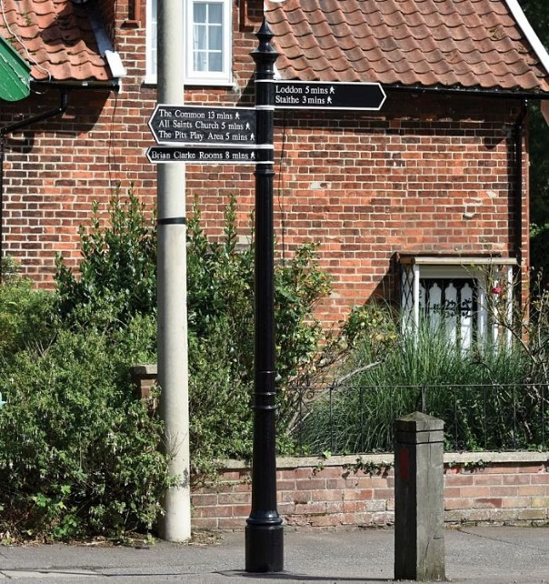
- The Clerk has reviewed the matter and is awaiting feedback from the Project Worker who has contacted ESH as the proposed fingerpost would be installed into Highways land. Therefore, it is likely the Council will need a license to carry this work out. We are also awaiting advice if there is a preference to a wooden or cast iron finger post or any restrictions using either.
- The Clerk has reviewed several sites. For a traditional style cast iron post with two arms the total cost (excluding installation and delivery) is £1,138+VAT.
- A white wooden fingerpost would cost approximately £650.
- We know from the recent bus shelter meeting that a license will be required for £60.
- The post is fixed into the ground by concreting in a post that goes underground. If Councillors choose to go ahead with the fingerpost the wooden one would be install by Phil Signs and the cast iron one we would need to check with the handyman if they would be happy to carry this out.
- Below is the proposed positioning of the fingerpost (image taken from google maps).

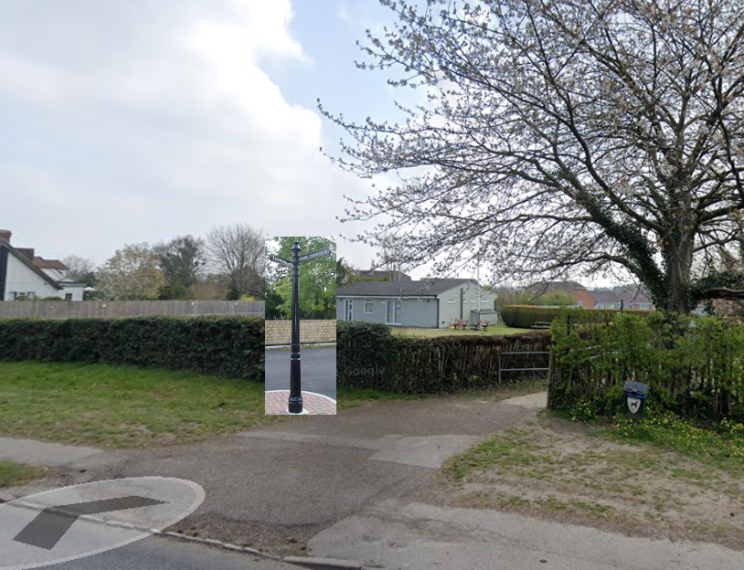

Resolutions for Council
- Councillors are asked to consider and resolve on the following items:
- Agenda Item 10.2 – Netting and Poles – For the Clerk to start the process of replacing the poles once the weather conditions allow. Councillors are asked to resolve to replace the 50 metres of netting and replace the posts. The Clerk will mark out to check if the extra 10 metre stretch is needed.
- Agenda Item 10.3 – Ditch Clearing at Parish Field – To allow the Clerk to have the northern and southern ditches cleared by a local contractor up to the sum of £350.
- Agenda Item 10.4 – Update Report from Bus Shelter Progress – Councillors are asked to agree to the proposed next steps:
  - Send over a full list of proposals for the Baldslow Down site and request all support or limitations of each element and cost of licenses etc:
    - Area to be retarmacked
    - Outline design of new bus shelter
    - New paved area.
  - Wait for the outcome of the resident survey before any further works are carried out on the brick bus shelter. However, due to the state of the roof the brick shelter will be deemed unsafe and blocked for residents to use.
- Agenda item 10.5 – Proposal to install a new fingerpost pointing to the Parish Council tennis courts – Councillors to resolve if they:
  - Wish to have a fingerpost at the posed site.
  - To agree if they have a preference to a white wooden or black cast iron fingerpost (subject to approval and feedback from ESH) and note the relevant costings.
  - Confirm how many ‘fingers’ and what they will be pointing to.

