Agenda Item | 9
Subject | Proposed Brief for Traffic Engineer
Author | Traffic and Transport Working Group
Date | 04/11/2021

Overview

- It is clear from the residents questionnaire that traffic is the key issue for residents. The below brief was originally put to Council in December 2021. Due to renewed concerns on traffic throughout the village Councillors are reviewing the original proposal. The proposal focused upon areas identified in responses to Westfield Parish Questionnaire. The below is the same proposal. Councillors are asked to consider the options and identify any additional areas they may wish to include if they choose to resolve to have the brief carried out.
- Due to the level of technical knowledge required the T&T Working Group thought that the most effective route would be to employ an engineer to review the stretch of A28. This would include the area from entering into the village via Westfield Lane and up to Mill Lane identified in Figure One: Section of A28 to review.

Focus of the Brief

Visibility and Safety Concerns identified in Figure Two: Safety concerns at two key junctions.
- The focus of these areas to look at ways of improving the layout of the junctions/surrounding areas to improve visibility:
  - Crossroads of Wheel Lane/Moor Lane – coming out of Wheel Lane and turning left onto the A28 visibility issues to the left due to not being able to see past parked cars.
  - Crossroads of Wheel Lane/Moor Lane – coming out of Moor Lane onto the A28 or to cross over into Wheel Lane difficulty seeing right.
  - Crossroads of Cottage Lane/Workhouse Lane – coming out of Cottage Lane either to turn right onto the A28 or cross over the A28 into Workhouse Lane poor visibility to the left.
  - Crossroads of Cottage Lane/Workhouse Lane – coming out of Workhouse Lane turning left or right poor visibility to the right.
  - Safety concerns about speeds of traffic on the A28 compounded by the poor visibility and traffic crossing the A28 at these points. Consideration to be given at for options to either improve the junction layout (options such as mini roundabouts etc.) and/or better visibility of the crossroads for those crossing over the A28 and those approaching the junction.
  - Issues about the speed of cars coming off of the A28 and going into Cottage Lane. With no pavement up to junction cars coming up the A28 turning left onto Cottage Lane pose a particular safety issue for any pedestrians walking up the road.
  - Additional concern – Traffic coming into the village from the bottom of Moor Lane

Traffic Calming
- To suggest clear options for effective traffic calming on this stretch of road. There is a perceived issue of speeding down the straight lines coming into and going out of the village shown on Figure Three: ‘Straight Runs’ particularly susceptible to speeding.
- Options for introducing ‘village gates’ within the village. Focus is to look at the area where the gates could be place where they will have the greatest effect for reducing speed for those entering the village. The aim is to alert drivers they are driving through a village and to reduce their speed.
- Suggestions of additional signage or road lining which could support traffic calming. It would also be helpful to understand if there are any ‘soft landscaping’ options that could be introduced.

Safe Crossings
- Options for potential ‘safe crossings’ along the routes. Area where there are not options for formal crossing options to identify ways of slowing traffic down to alert drivers people may be crossing. Also potential options for helping direct pedestrians to cross at safe spots avoiding dangerous areas.
Areas to consider outlined in Figure Four: Potential areas for a ‘Safe Crossing’ to include:
  - Cottage Lane cross the A28 allowing safe passage to the Dr’s and across workhouse lane.
  - Options for improving safety for residents crossing from the Church to the recreation ground.
  - Crossing Westfield Lane from Baldslow Down to Bus Stop (please note this is not shown on the map but further up Westfield Lane).
  - Suggestions of other sites which could support a ‘safe crossing’ and also act as a form of traffic calming would be welcomed.
  - How to raise awareness of the existing zebra crossing. This should act as a deterrent but does not seem to. Site looks tired and unkept so suggestions of improving visibility of the crossing including drivers approaching the crossing from either end of the village.

Dangerous Parking
- Like many villages there is an issue of dangerous parking. This is particularly notable during school drop off and pick up. However there is an issue of parking on bends, close to junctions and on pavements key areas in figure five. Suggestions how to curb any dangerous parking tied in with the above areas already identified.
- Review of potential additional yellow lines to support the above initiatives on the indicated stretch of road. In particular areas identified in Figure Six

Figure One: Section of A28 to review
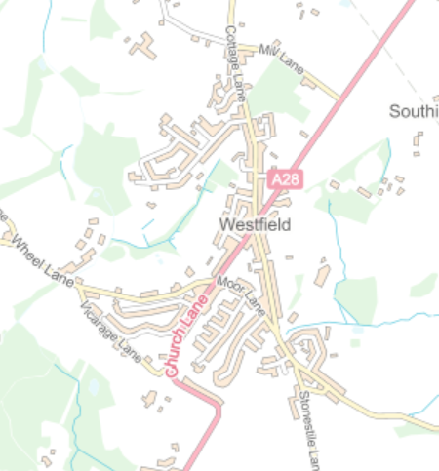

Figure Two: Safety concerns at two key junctions
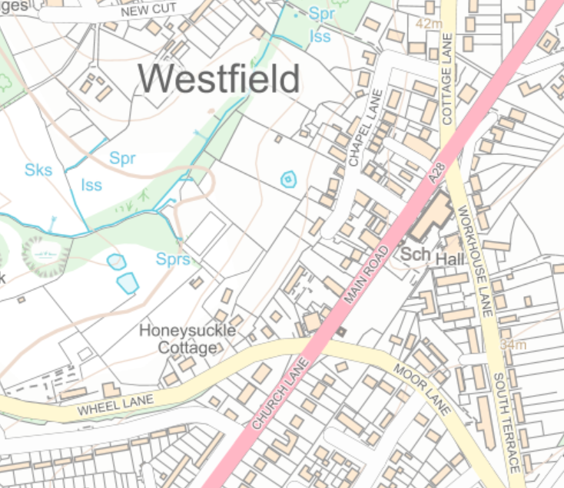

Figure Three: ‘Straight Runs’ particularly susceptible to speeding
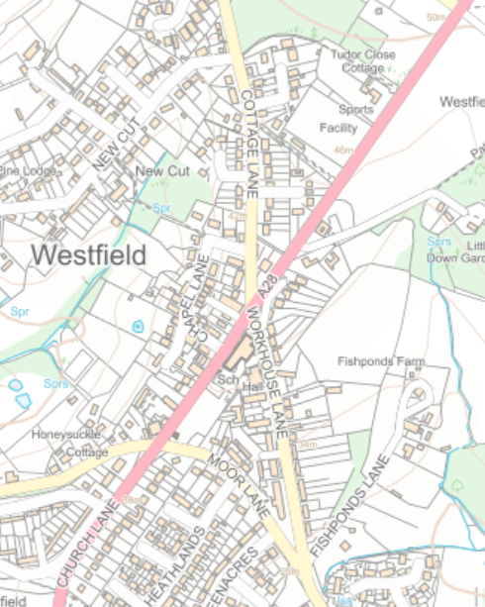

Figure Four: Potential areas for a ‘Safe Crossing’
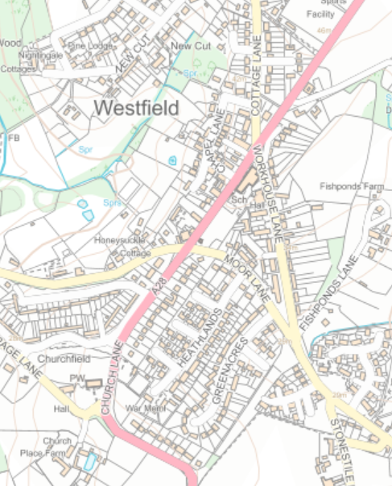
Areas to consider

Existing zebra crossing
Figure Five:

Resolution Suggestions:
- Change Workhouse Lane /South Terrace to one way direction of travel.
- Double Yellow Lines around New Inn side corner of Wheel Lane extending along A28 as far as New Inn Car Park entrance (To improve visibility from Wheel Lane).
- Double Yellow Lines around School side corner of Workhouse Lane extending to School Entrance. (To improve visibility at cross roads).

Resolution Suggestions:
- Change Workhouse Lane /South Terrace to one way direction of travel.
- Double Yellow Lines around New Inn side corner of Wheel Lane extending along A28 as far as New Inn Car Park entrance (To improve visibility from Wheel Lane).
- Double Yellow Lines around School side corner of Workhouse Lane extending to School Entrance. (To improve visibility at cross roads).

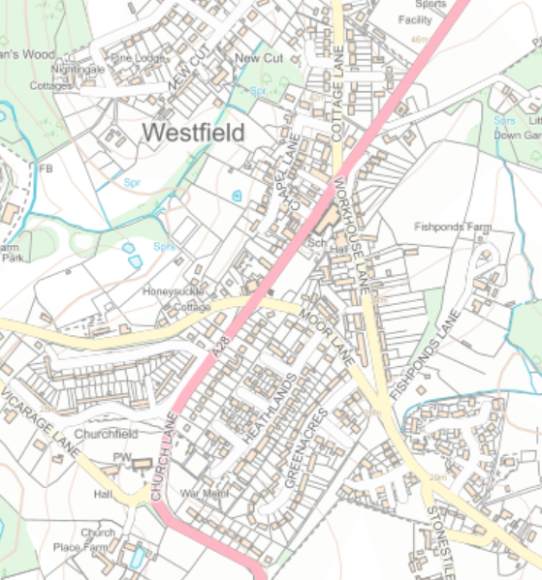

Resolutions for Councillors
- Councillors to review the proposed brief and consider if they wish to have the assessment carried out. The previous quote was for £3,120 + VAT.
- If Councillors do want to have the engineer carry out the brief if they wish to add in any areas.

