Agenda Item | 8
Subject | Updated Progress and Proposals re Westfield Football Club/Rec Ground
Author | Proper Officer/Parish Clerk
Date | 07/06/2023

Overview
- This document is intended as an update on the current position for handing over the football pitch to Westfield Football Club (WFC). Whilst Court Developments continue with the finalising of the site the focus for the Parish Council has been to work with WFC to ensure once the land is transferred to Westfield Parish Council (WPC) there are minimal delays in then transferring the land with an agreed lease to WFC.
- This document will also give an outline on the general process of Rother signing off the Westfield Down recreation ground site for completion. As the site is a single site until all the works around the recreational ground have been completed and signed off by Rother the Parish Council can not take on any part of the land.
- The Officer has been working with the Football Club following the recommendations from Council on the details of the lease and other matters including but not limited to:
  - Car park spaces
  - Floodlighting
  - Position of Clubhouse, dug outs and stand
  - Proposal for the area to be handed over in the lease.
- This report will also provide an update on the Football Clubs general position.

Process for Land Transfer – Areas Awaiting Sign Off
- For Rother to be able to sign off the ‘Certificate of Completion’ for the total works on the Recreation Ground including the football pitch the following must be signed off as outlined by the Senior Planning Officer overseeing Westfield Down:
  - Once the seeding (for the recreational land) has been completed (in accordance with the approved Grading & Seeding Works – Technical Specification), Court Developments need to notify the Council in writing. Council inspection to then take place with a view to signing-off this element of the recreational works.
  - Court Developments to notify the Council in writing once the final tarmac topcoat has been laid on the access road and Building Control Approval has been received for the changing room building. Surveyor inspections to then take place with a view to signing-off these elements of the recreational works. Please note that “as built” construction specifications for both the access road and parking areas have been provided, together with the details of road gulleys/discharge points.
  - Surveyors to inspect dimensions of the football pitch and associated grass strip & concrete-hardstanding as part of the inspections of the changing room building, access road and car park.
  - Separate ProPitch assessment of the football pitch to take place. This is to be carried out at similar time to the seeding works.
- As the site in the S106 is a single site the whole site has to be completed before it can be handed over to the Parish Council.

Current Position of the Football Club
- Currently Westfield Football Club are continuing to grow and developing their adult and junior teams. At the moment there are still the 6 adults teams including one veterans team around 20 players per team (120 in total). Junior teams have increased by 4 teams and potential to increase by another 3 as proving so successful.
- Total number of people in the teams are 118 adults and 158 youth = 298
- The percentage of youth players either from or originally from Westfield = 90-97%
- The Football Club is also working with the school looking at what football after school activities can be provided for school children.
- The Football Club have recently lost their youth pitch to play on which was based off Mill Lane.
- The percentage of adult players per team:
Adults Percentage played or associated with Westfield Fc from youth football
1st Team |  |  | 7 out of 20 |  | 35%
Reserves |  |  | 6 out of 20 |  | 30%
3rd Team |  |  | 9 out of 20 |  | 45%
4th Team |  |  | 18 out of 20 |  | 90%
Sunday Team |  |  | 4 out of 20 |  | 20%
Vets |  |  | 17 out of 18 |  | 94.40%
 |  |  |  | Total |  | 51.69%

Ownership and WFC Status
- To reconfirm Westfield FC is now a Community Amateur Sports Club (CASC). This means the club will be able to claim relief on money they use to promote and provide facilities for eligible sports. To register as a CASC you must:
  - be set up with a formal constitution, known as a governing document
  - be open to the whole community and have affordable membership fees
  - be organised on an amateur basis
  - be set up and provide facilities in the UK, the EU, Iceland, Liechtenstein or Norway (but in one country only)
  - be managed by ‘fit and proper persons’.
- CASCs can’t charge more than £31 a week for membership, and clubs that charge more than £10 a week must provide help (eg a discount) for people who can’t pay.
- CASCs must also not make a profit, unless this is reinvested in the club and spent only on promoting participation and providing facilities. They can also only provide benefits normally associated with an amateur sports club, eg use of equipment, coaching, post-match refreshments.
- Whilst a CASCs are able to pay players it was noted that WFC have no plays to pay their players or their expenses for matches and tours where players take part in and promote the club’s sport.
- Whilst footballer Steve Cook has a key role and is on the committee he has the same voting power as all other members. His name has enabled the club to get a lot of promotion and attention.
- The football club have produced a 3/5 year business plan for the Parish Council.

WFC Areas of Responsibility
Much of this is listed in detail in the proposed draft lease which Councillors have seen before this meeting. However, for the public an overview of responsibilities has been given here:
- Lease is intended for a minimum of 25 years.
- The lease would be an all repairing lease for the inside and outside of the building. This would not preclude the WFC applying to WPC for grants to carry out this work.
- The contents of the building would be covered by Westfield FC. The building however would appear on Westfield PC asset register and insurance as they ultimately own the building.
- Any future permanent buildings would be in the ownership of the Parish Council and these would also appear on the asset register with WFC insuring the contents.
- Maintenance of the access road and car park would be for Westfield PC unless use by the WFC caused significant damage. The football club would have the right to use all spaces on match days bar 8/10 spaces which would be left for residents who wish to use the recreational ground.
- The outside of the hedges going onto the Recreation Ground would potentially be maintained by Westfield PC with the inside of the hedges maintained by Westfield FC.
- Any fencing required would be at the cost of Westfield FC and would need to be under 2 metres. Future details on the proposed fencing in this report. The proposed hedging would be on the recreational ground and act as an additional barrier but also help blend the new fences into the background. Before fencing could be erected it would need the approval of the Parish Council as landlord of the site. The WFC have submitted a plan for the Council to approve at this meeting.
- The planting of the hedges would follow the FWAG proposals along with the additional suggested planting around the car parking areas and make space for the future clubhouse.
- Management of the car park will be the responsibility of WPC who are looking into CCTV installation and options to effectively manage any long term or over night usage of the car park. WFC would need to support WPC in the car park management and they will be consulted on the best options to do this.
- Based on the new drainage and plans from Court Developments the new drains being installed along the length of the mini pitch and the liner drain in front of the changing rooms will be in the land and responsibility transferred over to WFC. Please note this aspect needs to be added into the current draft lease.

Next Areas for Discussion / Action
- The current state of the football pitch is in a poor condition. As per the S106 a final inspection needs to be carried out and the pitch needs to be in compliance with paragraph 1.8 (pitch standards) of the Football Association Ground Grading Category G:

“The playing surface must be grass, unless authorised by the Competition’s Board of Directors, and must be of the highest possible standard. It must be level and free from surface depression and excessive undulations.”

Currently the grass, from a visual inspection, does not seem to currently meet this standard and needs reseeding, weeds removing and a lot of watering. The standard of the level also seems to be an issue as the drainage lines on the pitch can be clearly seen so will need levelling to rectify this issue. The sand levels will also need to be tested but all of these matters should be picked up when ProPitch carry out their assessment. We have not been given a date for this to happen but Rother will be organising this hopefully in partnership with WFC.
- The Parish Council will review the usage of the Parish Field for football with a Parish wide open spaces consultation. The Officer will look to bring proposed consultation to the July meeting.
- Further matters that still need agreeing re Parish Field:
  - Date for the removal of the barriers and current clubhouse at the Parish Field. These are already being taken down and more will come down over the coming months.
  - The clubhouse itself would need discussion on when this is removed. The Parish Council need to decided whether they want to keep the services on site for a potential Parish Council or Community owned building in the future. However, the services could be safely capped off and positions noted.
- We are still unable to develop a timeline identifying when the lease could be issued (noting starting date will be in the future). Having spoken to Rother there has not been any indication when this will be but they are looking to start signing off works for buildings and roads.

Fence and Proposed Building Site Plans for the Football Pitch
- Both WFC And WPC are concerned about the security of the site. Therefore, it is important for WFC to be able to install fencing as soon as possible. It would seem Court Developments are happy for WFC to get onto site and do this as soon as possible if WPC are in agreement. This plan might now change following any drainage proposals from Court Developments and this will have to be reflected in the below plans, lease etc.
- The current fencing plan for the Football Pitch also does not take into account the area that is likely to be included in the land transfer to encompass the temporary and then permanent clubhouse, football stand and dug outs in the top righthand corner. This section has been outlined in blue below.
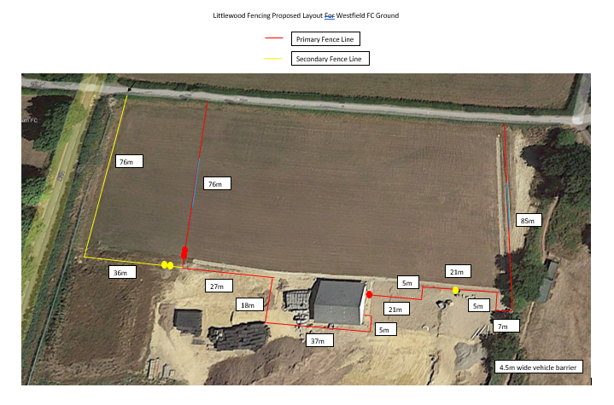
Tractor entrance
New mini woodland section
Football Clubhouse
Football Stand (50)
Dug Outs

- The two sets of football dug outs are clear Perspex with 12 seats in them. The frames are steel and the seats blue similar to the picture below but all the sides are also all clear Perspex. They will be set at the top of the pitch as shown in the map in para 34:

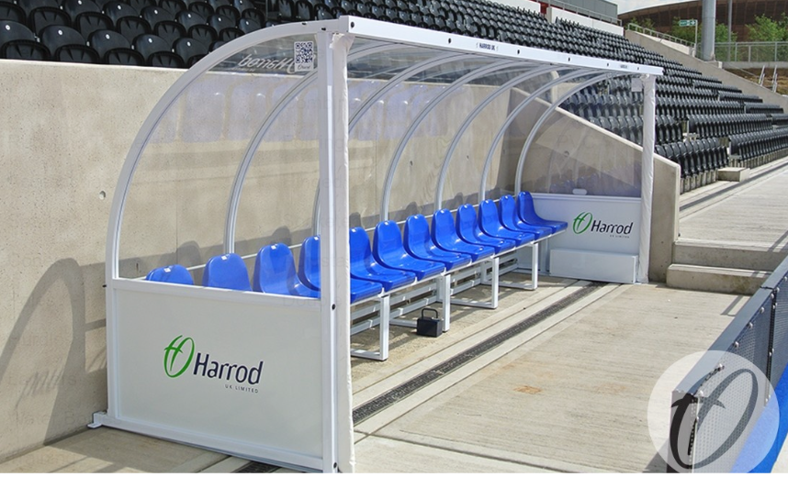

- The temporary clubhouse is a 2.5m x 5m wooden summer house as shown below. Any permanent buildings or additional buildings would always require further permission from WPC and if necessary RDC. The proposal is to place the clubhouse in the top right-hand corner of the pitch rather than next to the changing rooms. This will allow the clubhouse to be next to the stand and have a level of screening from the existing trees here. It would then mean the Parish Council would have an extra 60 x 18 metre plot in front of the pitch itself. This area could be planted up as a ‘mini woodland’ area following the guidance from the FWAG report to help re-establish the wildlife corridors that were lost during the development process. Moving the clubhouse allows for a deeper section of planting in this are which would also support removing any additional surface water in the area.

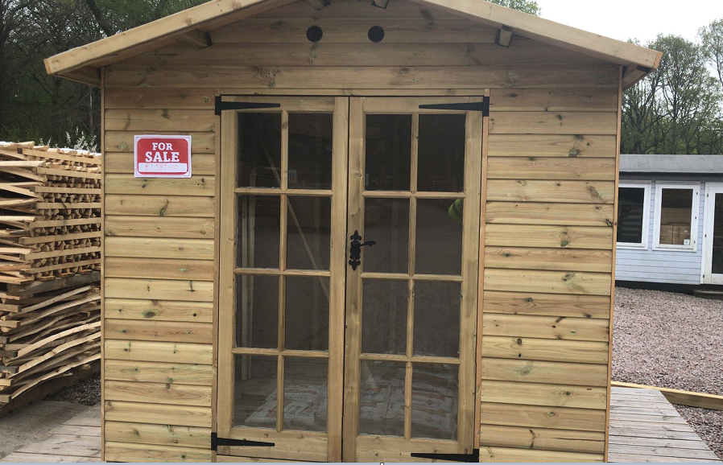

- The final item that WFC are looking to install in line with the FA standards for the pitch of this grade is a 50 person stand. WFC are looking to cite this behind the goal on the right hand side of the football pitch. This could also be screened by some additional planting minimising the visual impact on the space. Whilst this stand has not been purchased the proposed requirements are for a 100 seater stand in green to help it blend in. Dimensions would be 13.5 metres – Length, 2.9 metres – Depth and 3 metres – Height. Below is an image of a 50 seater:

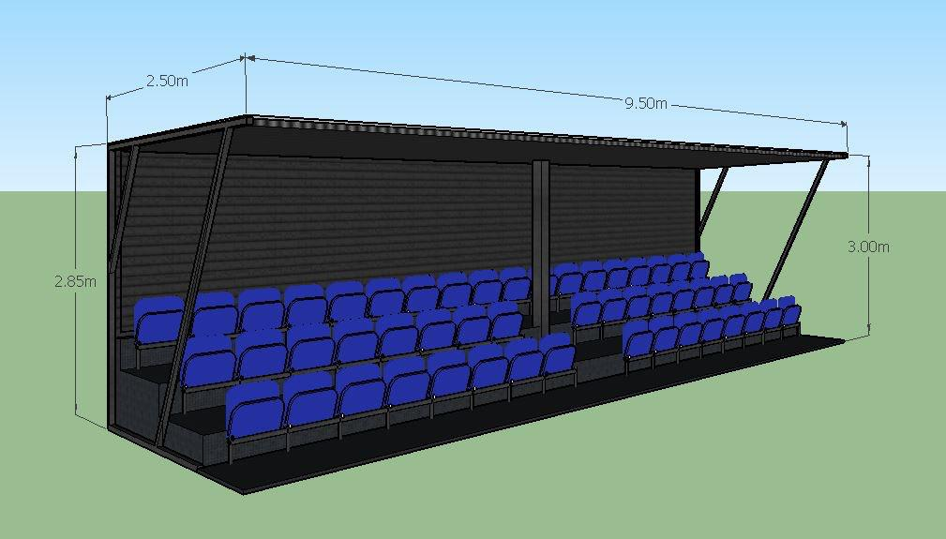

Proposed Floodlighting for the Football Pitch
- To allow the football club to meet the regulations for playing in their league on the pitch quality they have permanent floodlighting will be required. As part of the draft lease the Parish Council have a clause allowing for 10 hours a week for floodlights. WFC still needs to obtain agreement form the landlord on the type and position of any floodlighting and WFC will also need to apply for planning permission to Rother. WFC are proposing four lights one in each corner.
- As the site is within an Area of Outstanding Natural Beauty any proposals will need to have minimum light spill and meet the requirements from the planning department.
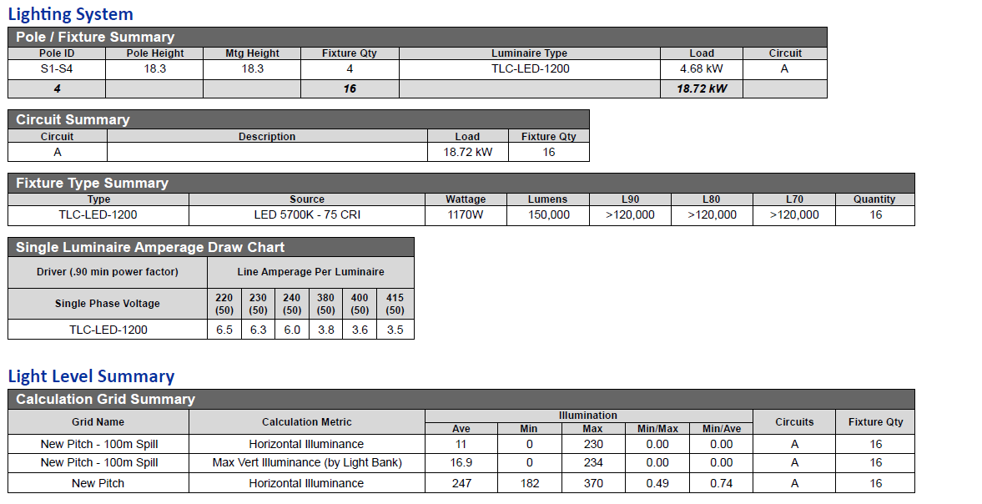
- The proposed lights are from Musco lighting. Below is a table of the spec and light spill. The proposal is for four poles which will be a bit taller. This enables the lights to be angled in a more downward position minimising the light spill.
- WFC have sourced photos of similar lights based at Hastings FC. The photo below shows slightly taller but the bank opposite is less than 10 metres away from the pitch.
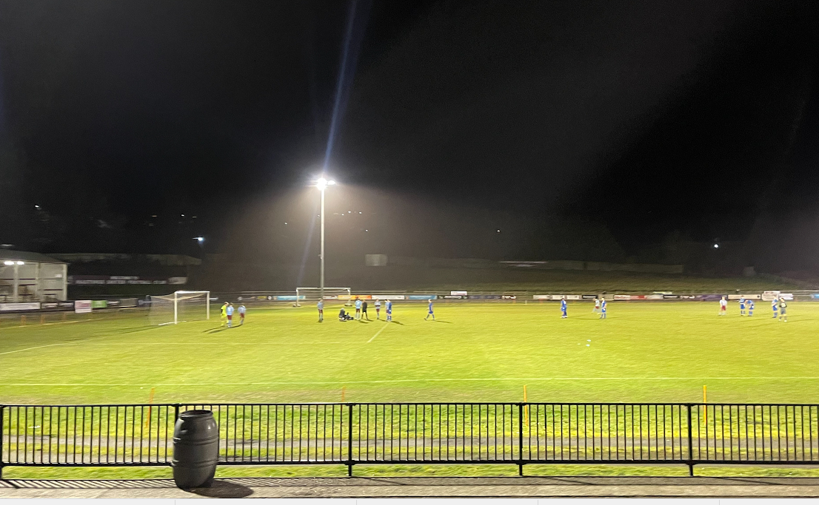

Proposed Land to Transfer to WFC
- The land to be agreed to transferred over to WFC needs to be finalised. The Officer would propose that the site should include the mini pitch, main pitch, changing rooms and the top righthand triangle. Any new drains that are proposed by the developer would also be in the land transfer due to their position and the proposed position of the fencing.
Resolutions for Council
- Councillors are asked to discuss and agree the following within this report:
  - The length of the lease to WFC.
  - The proposed fencing plan.
  - The proposed position of the stand and clubhouse.
  - The proposed floodlights spec, number and position.
  - For the draft consultation on the open spaces to come to council in July.

Please note the football season starts mid-end of August until the following May.

