Agenda Item | 9
Subject | Proposed Brief for Traffic Engineer
Author | Clerk
Date | 08/06/2023

Overview
- This is a brief following the site visit by the traffic engineer to review the previously resolved brief.
- Much of the below information is a recap on the areas being reviewed.

Visibility and Safety at Key Junctions
- Visibility at key crossroads:
  - Crossroads of Wheel Lane/Moor Lane – coming out of Wheel Lane and turning left onto the A28 visibility issues to the left due to not being able to see past parked cars.
  - Crossroads of Wheel Lane/Moor Lane – coming out of Moor Lane onto the A28 or to cross over into Wheel Lane difficulty seeing right.
  - Crossroads of Cottage Lane/Workhouse Lane – coming out of Cottage Lane either to turn right onto the A28 or cross over the A28 into Workhouse Lane poor visibility to the left.
  - Crossroads of Cottage Lane/Workhouse Lane – coming out of Workhouse Lane turning left or right poor visibility to the right.
  - Safety concerns about speeds of traffic on the A28 compounded by the poor visibility and traffic crossing the A28 at these points. Consideration to be given at for options to either improve the junction layout (options such as mini roundabouts etc.) and/or better visibility of the crossroads for those crossing over the A28 and those approaching the junction.
  - Issues about the speed of cars coming off of the A28 and going into Cottage Lane. With no pavement up to junction cars coming up the A28 turning left onto Cottage Lane pose a particular safety issue for any pedestrians walking up the road.
  - Additional concern – Traffic coming into the village from the bottom of Moor Lane
  - To suggest clear options for effective traffic calming on this stretch of road. There is a perceived issue of speeding down the straight lines coming into and going out of the village shown on Figure Three: ‘Straight Runs’ particularly susceptible to speeding.

Safe Crossings
- Options for potential ‘safe crossings’ along the routes. Area where there are not options for formal crossing options to identify ways of slowing traffic down to alert drivers people may be crossing. Also potential options for helping direct pedestrians to cross at safe spots avoiding dangerous areas.
Areas to consider outlined in Figure Four: Potential areas for a ‘Safe Crossing’ to include:
  - Cottage Lane cross the A28 allowing safe passage to the Dr’s and across workhouse lane. It was noted that the 1066 footpath coming from Cottage Lane onto the A28 has no warning you are coming out onto a busy A road.
  - Options for improving safety for residents crossing from the Church to the recreation ground.
  - Suggestions of other sites which could support a ‘safe crossing’ and also act as a form of traffic calming would be welcomed.
  - How to improve visibility of the existing zebra crossing and protect children during school hours in this section of the road. Concern noted on the 40mph coming into the village and the ‘straight run’. It was also clear that viability for the lollypop lady when stepping out is greatly impaired when Chapel Road side of the crossing. Vehicles are able to park right up to the white zigzags making it impossible to see when stepping out onto the zebra crossing.

Recommendation from Engineer for ATC Locations

- Below on the map are the proposed locations of the automatic traffic counters. Each ATC costs £450 to install. These are installed for a week and divide up the vehicles by class and times over each 24 hour period. Therefore, the data is very helpful and would be needed to support any traffic calming, speed limit reductions or crossing proposals.
- The Clerk has already asked ESCC if they have any recent traffic counting data they could share with the Parish Council.

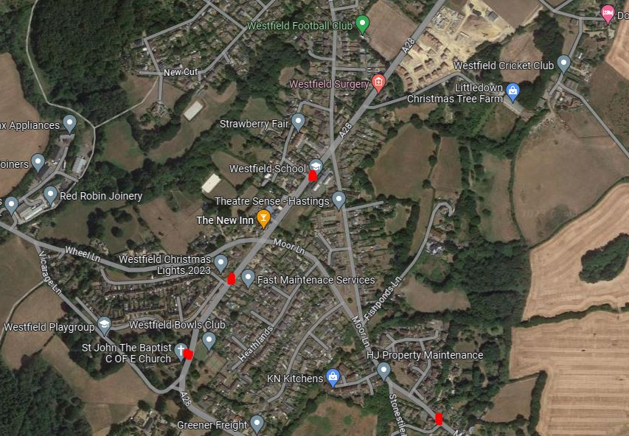

Resolutions for Council
- Council to note the traffic engineer is now working on the agreed brief.
- Councillors to decide a budget for any ATCs. Please note one has been included in the quote. Councillors need to note that any funding will need to come from earmarked reserves.
- Councillors to resolve the position and number of ATCs for this brief.
- Please note that any ATCs, these will need to be installed later in June or early July at the latest. After this, private schools start to finish which affects traffic levels and is considered not to be the right time to undertake a survey. Otherwise you would be looking at September time to get accurate reporting.

Figure One: Section of A28 to review
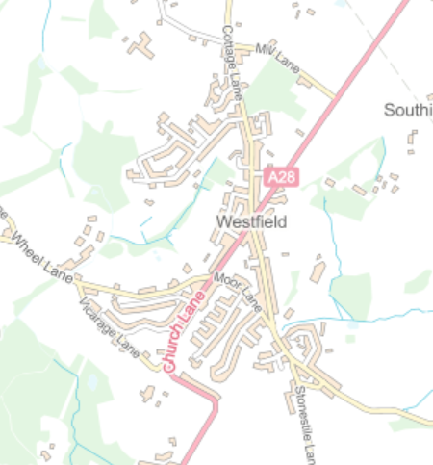

Figure Two: Safety concerns at two key junctions
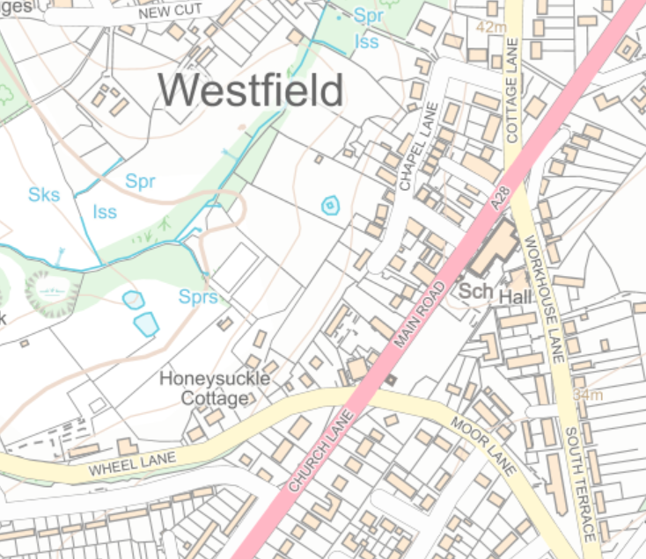

Figure Three: ‘Straight Runs’ particularly susceptible to speeding
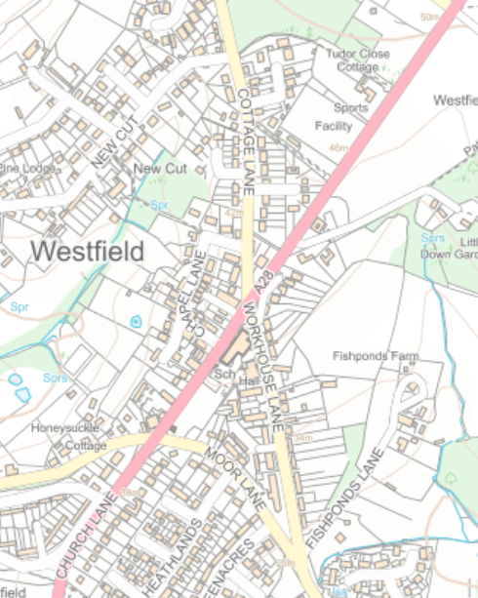

Figure Four: Potential areas for a ‘Safe Crossing’
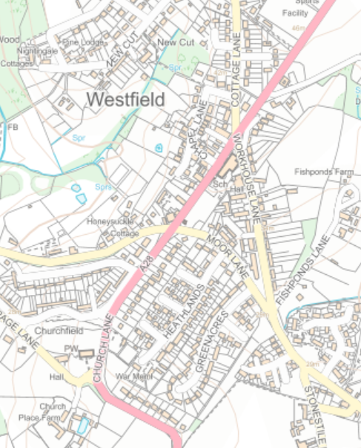
Areas to consider

Existing zebra crossing

