Agenda Item | 10.1
Subject | Car Park Recommendations
Author | Clerk
Date | 07/09/2023

Overview
- This report has been put together to identify the risks, solutions and costs in managing the car park at Westfield Down. The intention is to be clear about these matters and to provide potential cost-effective solutions so they can be installed before the car park becomes open for general public use.
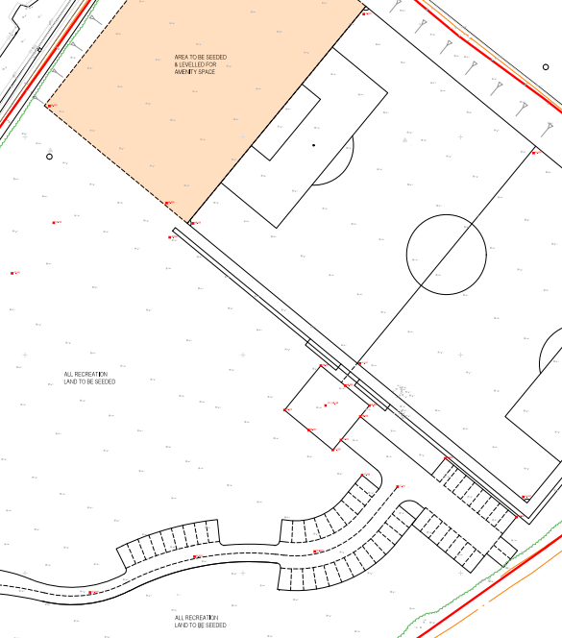
- The car park has 48 spaces in total. Most of these spaces (39) are in the top section of the car park with an additional 9 spaces slightly further down the road.
- Within the current draft lease on match days the Football Club will be able to reserve the top 39 spaces (highlighted in blue) for match days but the lower 9 spaces (highlighted in yellow) will also be open for residents to use for the recreation ground.
- When the site is opened access will be from the A28. The first part of the road up to the turn off into the housing area will be adopted by East Sussex Highways. The remaining ‘access road’ leading up to the car park and the football pitch will be owned and managed by the Parish Council.

Security of the Car park
- The car park site is off the main road and in a secluded area. There are no proposals to light the area throughout the night due to cost but also because the site sites within the AONB and a dark sky site.
- There are several key factors considered when looking at the security of the site based on discussions with the local police and other organisations and parishes who manage similar small, rural car parks. Two key factors came up to consider:
  - Preventing overnight and long-term parking.
  - Stop commercial vans, camper vans etc being parked on site.
  - Reducing the potential for anti-social activities and behaviour.
- After looking at a range of options and taking into account the cost and resources the Parish Council has it seemed the most practical solutions would be to:
  - Install a height barrier with option to open for coaches etc.
  - Install CCTV cameras to cover the car park.

Height Barrier
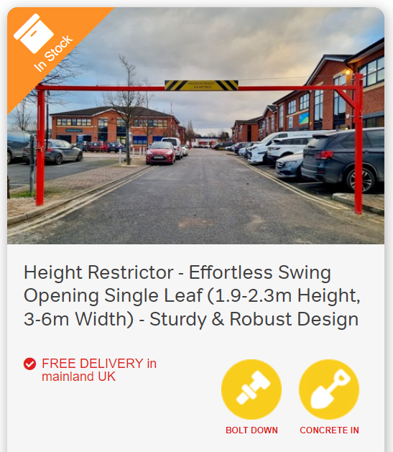
- The proposed height barrier would be set at 1.9 meters high and positioned on the access road. It is suggested that this is at an agreed point that would encompass all of the car parking spaces. The proposed barrier would need to have a single leaf opening system and it has been suggested that an opening system with an accessible latch is the best option as pictured. Please note that the barrier can either be galvanised steel or powered coated yellow, green, black, white or red. And would look similar to the image. It is also recommended to have the maximum height sign included.

CCTV System
- The CCTV system would act as a key deterrent for any potential damage to the changing rooms and management of the car park to monitor antisocial behaviour and car parking enforcement. It would also act as a deterrent for vandalism on the recreation ground and it would be sensible to look if a camera could be installed to look over towards the cricket ground as well and how best to manage this.
- Several local Parish Councils have used CCTV companies which have provided the relevant policy documentation to allow for CCTV on site. The Parish Council already has a CCTV policy in place.

Car Parking Enforcement
- As outlined before there is a concern about overnight parking and the site being used for people leaving cars and commercial vehicles on site. It is vital that the car park is used for users of the recreational ground and the football club so parking can be managed effectively on busy period and spaces available to deter people from parking on the access road or on any of the green areas. The proposal is to have an external body to provide enforcement for the car park and when relevant issue fines for those who breaks the rules. Having the site monitored 24/7 would be a further deterrent to anti-social behaviour.
- Having spoken to several companies one has come forward to carry out the monitoring of the car park at minimal or no cost to the Parish Council. They stated that ANPR will not be necessary. It will just simply be remote monitoring via CCTV with potentially LED sensors near cameras to put the lighting on to take photographs or cameras with sufficient nighttime vision to allow the easy viewing of the car registration. They have also offered to work with the CCTV company to ensure the car park cameras are situated in a way that allows them to capture the car registrations. Whilst there will be an initial lay out for the cost of the cameras there will be no ongoing costs for this service. The company known as ‘ipark’ will also place up any necessary signs and notices showing that they are monitoring the car park. They will manage and administer the fixed penalty notices and any income form this will go directly to the company.
- The Parish Council will need to agree times that would work to ensure people can safely use the car park and this also not infringe on the Football Club use but also keep the car park free of overnight usage. A recommendation would be to essentially close the car park during the hours of 11.30pm and 5.30am. This would allow the Football Club time to leave after any match or training times and use of the clubhouse is only up to 11pm. The extra ½ hour allows any cleaning to take place. Allowing the car park to open from 5.30am allows early dog walkers etc who maybe using the recreational ground before work. Councillors may choose to have slightly different times during the summer and winter.

Resolutions for Councillors to consider
Councillors are asked to resolve on the following items:
- Resolve to install a lockable height barrier of 1.9 metres in a suitable position which would cover all of the car park spaces.
- Resolve for the Clerk to have CCTV installed on site when this becomes possible and obtain three quotes for the works.
- Resolve the hours the car park is open and closed to the public.
- Resolve in principle to work with ipark to cover the car park enforcement matters.

Height barrier which can be opened for larger coaches. | £1,300
Installation of height barrier | TBC
CCTV installed for car park (ipark consult ) | £3-5k
Ipark management of the car park | 0

- Ipark are happy to work with the CCTV company to organise the positioning of the cctv and how it will work. They stated that ANPR will not be necessary. It will just simply be monitoring via CCTV with LED sensors near cameras to put the lighting on to take photographs. Can set the LED sensors to only come on after 11pm. We will need to check the

- light spill/wildlife effect or potential night time
- They will manage any charges.
- Proposal is to have no overnight parking and no vehicles in the car park at all after 11pm at night. Charges will apply.
- On top of the CCTV there will be signage etc. around the
- CCTV £4-5k system 07843598855 need to liaise with Bill Anderson about position etc.
- They need to have the remote access to CCTV imaging to monitor at £0 to Parish Council. More an advertising site for them.
