Agenda Item | 10.2
Subject | Fencing, hedging and footpath recommendations WD
Author | Clerk
Date | 07/09/2023

Overview
- This report has been put together to identify potential options for the fencing, hedging, planting and footpaths at the Westfield Down on areas which will be managed by the Parish Council. The intention is to allow sufficient fencing to protect those using the recreation area and to stop cars and vehicles accessing the site. Much of the advice has been based on the 2021 FWAG report, a visit to Arlington Reservoir, High Weald AONB guidance and advice from hedgelink.org.uk.
- It is envisaged that the proposed planting outlined in this report would be part of a wider environmental programme for the site itself and the surrounding areas. This report is focusing on new planting on the site as phase one. Once this has been achieved phase two would look at improving the existing boundary hedges on the site mainly the hedges on the top road (the access road to the cricket field), the existing boundary hedge along the A28 and hedges along the 1066 footpath. Please note a map on the night will be provided showing the key sections as the diagram at the bottom of this report is not clear but aims to give an outline of the sections discussed.
- Councillors are asked to review the proposal and based on Councillors decisions and feedback will allow the Clerk to get quotes to bring back to Council for the final agreement and start looking at budgets and a management plan for the site over the next 5 years. The Clerk would look to get grants for the hedging and mixes may need to be adapted to be eligible for grants such as MOREhedges and Countryside Stewardship Hedge grants.
- It is important to highlight the main areas being discussed within the Westfield Down site:
  - Areas A, B and C make up the bottom section of the green space.
  - Area D is a proposed build out for a potential woodland area.
  - Area E is the main recreational land earmarked to be managed as parkland.

Planting and hedgerows
- Due to the loss of biodiversity and habitat on the site there is an opportunity for building sustainable wildlife corridors and habitat throughout the site. The following suggestions are after reviewing the FWAG report, visited Arlington Reservoir and reviewed the High Weald guidance.
  - The main site shown as section E has been resolved to be managed as parkland. The site will be largely open space with selected planting of trees on the site.
  - Proposal to install hedges along the bottom fence of the recreation ground up to the changing rooms and long the new green fence of the football club’s new fence and up along the public footpath towards the access road to the cricket club. Suggestion that hedges used are similar to the wildlife friendly mix from English Woodlands selected to offer food, shelter and habitats for wildlife. Their pre-packed mix includes 10 Hawthorn; 3 Field maple; 3 Spindle; 3 Blackthorn; 3 Guelder rose; 3 Dog rose. Planting is suggested with 4-6 plants per metre in staggered rows. It is suggested to develop a cutting scheme to allow for a dense hedge down to ground level at a width of 1.5 meters. The cutting regime should also be devised to ensure a healthy hedge grows to increase the berry crop and shrub health.
  - Options to look at allowing trees to grow up within the hedge itself and regular intervals. Suggested trees would be oaks, beech and crab apples. Thes would be marked out to allow the trees to fully mature.
  - As well as the main hedge at Arlington reservoir they have created a staggered hedge growth of 1 to 2 metres to encourage soft edges to further encourage wildlife. It is also suggested on the hedgelink website “encourage tussocky grass-rich growth to develop at the base of the shrub layer…Dense grassy ground cover is essential for many invertebrates including spiders, beetles, lies and caterpillars, both for overwintering and breeding.” This may not be suitable for all the areas where hedges are planted but as the site is large there could be selected areas where this can be achieved.
  - The area in front of the football pitch could be a suitable build out for a small woodland area to replace some of the lost habitat during the development. This is shown as section D on the map.
  - The green space on the lower section of the access road was originally resolved to be developed into a wildflower meadow. Due to the level of topsoil on the site it has been suggested that this might be difficult to achieve. However, sections A and B shown on the map could be built out as small woodland areas. These could be fenced off to allow these areas to be managed as small woodland and scrub land and would not affect the resident’s enjoyment of the main recreational area as it is in a separate part of the site.
  - Section C of the site could be regularly mown and maintained as this is a potential site for a future community building.

Fencing
- It is important to install fencing whilst the hedgerows develop to protect those using the spaces and mange other areas to be protected to encourage wildlife. All suggested fencing has been marked up with a brown line on the map and the style of fencing suggested is stock fencing at a height to be agreed on the night. It is noted that position for gates/entrances will need to be determined.
- The priority fencing needs to be put in place in the following areas for safety:
  - At the bottom of the recreation ground along the top edge of the access road and along the outer edge of the car park spaces.
  - On the bottom, edge of the access road all the way up and around the car parking spaces up by the football pitch.
- Suggested additional fencing:
  - Either side of the footpath coming off of the 1066 footpath in the bottom right hand corner coming up to the access road.
  - Fencing put in to define two separate areas in the bottom right hand open space area B which is suggested to expand out the small parcel of original woodland space and area C which should be fenced off but should be managed and regularly mowed as this could be a site for a future community building.

Footpaths
- Whilst the main area would be an open space there is an opportunity to place a footpath around the edge of area E the main recreational area. This would be a similar footpath that have been installed at the recreational site in Battle and the playing field in Burwash Common. The proposed surface would be tarmac or a similar hard surface.
- The purpose of installing such a footpath would be for the following reasons:
  - It allows users to use the reactional area in all seasons and most weather conditions.
  - Anyone using a wheelchair or pushchair would have a route that they could use.
  - The footpath would encourage people not to go onto the areas where the staggered hedges and tussocky grass-rich growth is being established and also creates a clear stop line so such growth does not encroach on the main recreation area.
  - This footpath is not intended to stop or divert the existing right of way. This would remain open in the top left hand corner of the field and from the bottom in between sections A and B. Those using the public footpath when entering onto the main Westfield Down recreational area could either follow the original route or use the footpath. Councillors if they support a hard surfaced footpath being laid might want to extend the footpath to include the public footpath up to the entrance near the A28 or use a difference surface to tarmac or not lay a surface at all.

Outline Map
- Below is a map which has had the areas marked out as a visual guide to the above proposal. It is appreciated that this is only a hand drawn guide but hopes to give a visual aid to the sections and potential layout of the site.
- The areas have been colour coded:
  - Dark brown lines = potential fencing
  - Dark green lines = hedgerows
  - Light green areas = areas next to hedgerows are the sections for potential soft edges for the main hedgerows and or areas for tussocky grass-rich growth.
  - Light green areas Sections A and B = potential areas for woodland buildouts or areas for encouraging a variety of planting and density and some scrubland.
  - Light green area Section D = potential small woodland site which would also act as a screen to the football pitch.

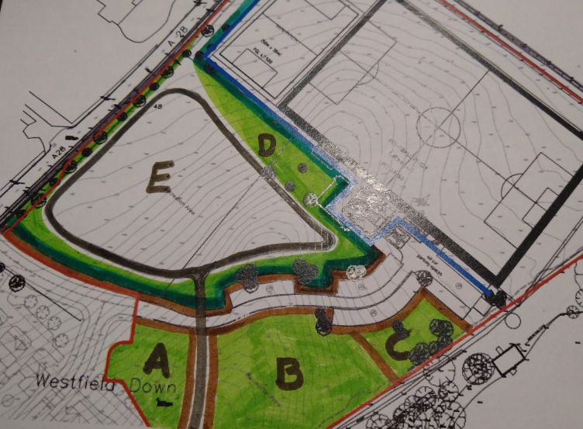
Resolutions for Councillors
- Councillors are asked to review this report and resolve on the following matters. It is noted that all the below components will be reviewed once costings are brought back to Council:
  - The outline proposal for the installation of the hedgerows.
  - The position of the fencing, the proposal to use stock fencing and the height.
  - The managements of sections A, B, C and D.
  - The installation of a footpath and agreement of the surfacing.

