Present: Chair - Cllr Monro, Vice-Chair – Cllr Horley, Cllr Archer, Cllr Baker

Cllr Coupar, Cllr Edwards, Cllr Hills, Cllr Nijhuis, Cllr Skinner and Cllr Stapley

C23 – 06

Apologies for absence

Cllr Hosea. Cllr Hills arrived 15 minutes into the meeting.

- Disclosure of interests under the Council’s Code of Conduct.
Cllr Baker had interests and needs to declared the reasons he left the room left for the following agenda items, it is noted that these reasons were not given on the night but the Clerk has since obtained the reasons to be the following:
  - Agenda Item 7.1 – RR/2022/1118/P – Cottage Lane, Cllr Baker declared a personal interest as his father is the applicant.
  - Agenda Item 7.2 – RR/2023/919/P and RR/2022/2935/P - Westfield Down - Land at, Main Road, Cllr Baker declared a personal interest as his son is a contractor for the site and his father owns the land that Southern are keeping their offices and materials on.
  - Agenda Item 7.3 – RR/2023/1021/P – Tree Tops, Land adj, Cottage Lane, Cllr Baker’s declared a personal interest as his relative is the owner of the site.
  - Closed item 24.1 – Westfield Down variation of s106 and variation of condition one, Cllr Baker declared a personal interest as his son is a contractor for the site and his father owns the land that Southern are keeping their offices and materials on.

Questions from Members of the Public

A resident raised a concern about the issues of the footpath between the school and going up along side the A28 out towards Mill Lane. It was noted that with an extra 39 houses on the Down and the developed at Moorhurst footfall would significantly increase.

Following a discussion the Clerk noted that if any member of the public or Councillor wished to make complaints about a Councillor’s conduct based on the code of conduct the proper way to address this is via the Monitoring Officer at Rother District.

- Minutes of Full Council Meeting held on the 10th May 2023
RESOLVED – The minutes were approved and signed by the Chairman

- Matters arising from the minutes – None

- Correspondence to the Clerk
  - The Clerk had been contacted by the Cricket Club about the vandalism and issues with fires being set on the ground.
RESOLVED – The Cricket Club to put up concerns on Facebook and where appropriate the Parish Clerk will show support for keeping the cricket ground clean and respecting the public space.
  - Proposed meeting with WPC, WCC and WCA to discuss WCC future.
RESOLVED – For a meeting to be set up once the Cricket rep had been chosen.
  - Westfield Parish Council granted Westfield Playgroup a grant for up to £1,900. The Playgroup managed to secure further grants so only needed £1,000 towards the fencing.
RESOLVED – To give the reduced grant at £1,000.
  - The Clerk had been in touch with the Senior Planning Officer re Moorhurst. He confirmed that if Rother were minded to approve the proposed 64 bed care home on Moorhurst

- Planning Applications – Councillors reviewed the applications received since last meeting as found at https://westfieldparishcouncil.com/comments-on-planning-applications/
  - RR/ RR/2022/1118/P - Cottage Lane - Development adjacent to, Westfield TN35 4RD
Outline: Proposed 20 dwellings with new access from Cottage Lane.
Parish Council Comments – OBJECT – The Council discussed the new proposals for 20 houses planning application RR/2022/1118/P. Councillors reviewed the matter last week and feel the comments and objections that they put submitted and were posted on the 29/07/2022 for the 28 houses still stand. Whilst the development has been reduced the size and scale it is still a significantly large development within the AONB. The Clerk resubmitted the document with this email to avoid any doubt. On the evening however several key additional comments were made to object to the current site/proposed development:
      - The proposal of the footpath via the A28 being a suitable route into the village is significantly flawed. This footpath down the A28 is very narrow and would not support wheelchair or
pushchair use safely and so narrow two people cannot safely pass each other. The speed on the road is 40mph and a straight piece of road so cars regularly pick up speed coming out of the village. The Parish Council will be conducting some automatic speed counts via a traffic engineer and will submit these findings once we have the data. I appreciate this will be beyond the deadline for comments but if this goes to the planning committee this is data we can then present the findings. There is no safe crossing from the development side over to the footpath. Any development on this site would need to install a safe crossing such as a pelican or zebra crossing to slow traffic down and keep residents safe when crossing. The developer has provided no details of the proposed crossing nor any speed counts to assess the safety of any proposals. Therefore, the Parish Council cannot see how such a statement can be properly considered until a crossing has been agreed as viable by ESCC road safety team and deemed viable based on costs.
      - Whilst there is a footpath at the south of the development going out onto the A28 this is not suitable for wheelchairs or pushchairs. It is a public footpath and is unpaved, uneven and not suitable access into the village. There is no safe or sustainable access into the village via foot. Whilst the High Weald Design does state that many rural lanes in villages do not have footpaths this does not mean sites in these rural locations should be built on. It further demonstrates that this is a rural setting and unsuitable for such a development of this scale at 20 houses.
      - The site since the application was validated on the 10/06/2022 has been completely cleared. It is noted that the Forestry Commission have made a comment that a breach of the Forestry Act 1967 may have occurred. It also states that if a restocking notice order is applied on the site this stands for ten years. The Parish Council notes that no notice has been served but the emails states the site is being assessed therefore can Rother can even determine this application until the Forestry Commission’s investigated is concluded as a planning permission does not ‘remove the duties contained within that Notice.’
      - Under the Environmental Act 2021 there have been significant changes: “The Environment Act 2021 (EA 21) inserts a new Schedule (Schedule 7A) into the Town and Country Planning Act 1990. Planning permissions will soon need to have a new biodiversity condition included that grants permission subject to the submission and approval of a biodiversity gain plan. A new Schedule 2A is also inserted into the Planning Act 2008 to extend the biodiversity gain obligation to development consents for nationally significant projects, such as future transport and energy projects. These changes will come into effect as soon as secondary legislation is enacted… Concerns had been raised about the possibility of land owners intentionally reducing the pre-development biodiversity value of sites to be developed (e.g. by clearing sites of any habitat before applying for planning permission). In response, the pre-development biodiversity value for the site is measured as at the date of the planning application (or earlier if agreed between the applicant and the local planning authority). However, if activities have been carried out on the land on or after 30 January 2020, without planning permission, which has reduced the biodiversity value of the onsite habitat, the biodiversity value will be taken to be that which was in place immediately before those activities. Further guidance is expected about how this will work in practice and may prove challenging to monitor.” The PEA uploaded on the 09/05/2023 should only be used as a compassion to the level of change on the site since it has been cleared. As the Clerk I cannot find this document on the planning portal. It would have been a disadvantage to any resident commenting as they could not make a comparison. With this in mind the Parish Council asks that the original Preliminary Environmental Assessment is used and if it has been removed from Rother’s planning portal is reposted.
      - The Parish Council would also like to highlight issues about the site being completed stripped BEFORE the planning application was determined. The ESCC County Ecologist recommended refusal due to the lack of information on the impacts on the biodiversity on the site. Due to the lack of this information with the site now having been stripped how will this issue been resolved? The Forestry Commission note that “We would also add that granting planning permission on sites which have been deforested illegally (if this is found to be the case) would set a dangerous planning precedent”. These two issues of not enough evidence to note the environmental impact and the issue of setting a precedent. The National Planning Policy Framework states that (NPPF, 2021 the planning system should contribute to and enhance the natural local environment by…protecting and enhancing…sites of biodiversity or geological value or soils…”, “recognising the wider benefits from natural capitol and ecosystem services…” and “minimising impacts on and providing net gains for biodiversity, including by establishing coherent ecological networks that are more resilient to current and future pressures.” If the County Ecologist felt that there was not enough information originally how is the LPA can only determine the impact on the original PEA which was lacking in information.
      - On these points the application should be refused as a proper assessment on the environmental impact cannot be made and granting permission would set a dangerous precedent.
  - RR/2023/1142/P – Changes to ground levels of recreational lane (retrospective) The Parish Council would like to note the works that have been carried out on the Recreational Area to help alleviate some of the surface waters issues on site. During the last few years there have been serious flooding issues and standing water issues on the site and off of the site onto the nearby 1066 footpath. On the below map we have highlighted the areas of concern and photos showing the levels of flooding we have seen in blue. Please note this is not to scale but purely a visual indication of where the issues have arisen over the last few years.
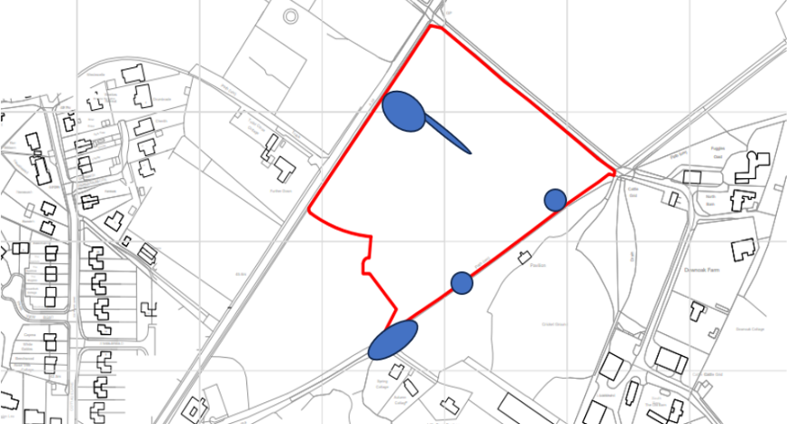

Photos of excess surface water on the public footpath (more were sent with comments)
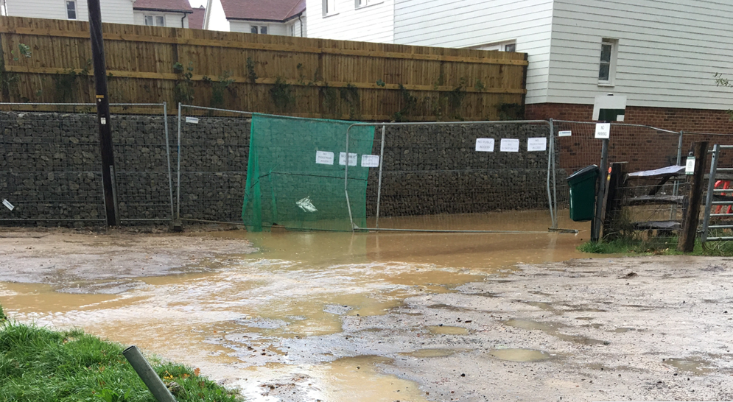
Photos of surface water on the recreation ground 13/03
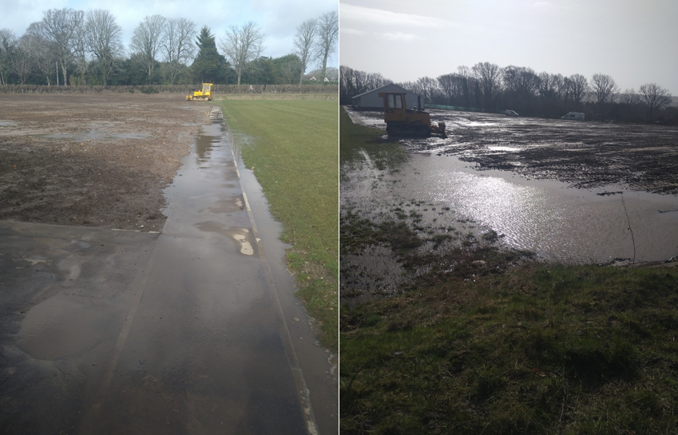

Whilst there are now drains running alongside the mini football pitch and main pitch due to the levels of issues we have seen over the last few years, the Parish Council feels that these should act as backups rather than the main way to remove the surface water as these drains will get silted up. The original levels would have allowed the water to flow off down into the SUDS drains which have now had extra filters installed on them.

Having looked at the plans in detail the levels that have been submitted still do not follow the original levels which Rother Signed off as part of the original conditions: https://planweb01.rother.gov.uk/OcellaWeb/viewDocument?file=dv_pl_files%5CRR_2009_322_P%5CRR_2021_1314_DC-DCD_4.pdf&module=pl . In the top right-hand side of the recreational area in the original plans in the above link shows the levels gradually fall away allowing all of the water to naturally flow off on the recreational ground and not towards the football pitch / mini pitch. The ‘levels compassion sketch – 971’ there is now a ‘bump’ where the levels raise slightly rather than lower resulting in water still rolling down towards the football pitch / mini pitch. The Parish Council notes that this ridge is small but still large enough to stop the water running off the site naturally towards the main SUDS drain system. Therefore, the request is to have this section of the recreational land levelled out to allow the water to naturally fall away from the football pitch and down towards the SUDS drainage as outlined in the original agreed plans.

The Parish Council has also received photos showing the site after a recent down pour on the 18/06/2023. As the photos in figure one show the rain has not moved away off of the site and is causing standing water on the football pitch. We understand that pipes may have been capped off at the top whilst the new drains are being connected. If this is the case it raises concerns as the Parish Council will never have seen the proposed new drains and strategy working. It also raises concerns on the level of water coming off the site seen in figures two and three. Figure two is a photo of a section of the recreational ground is alongside the 1066 footpath but further up the pathway and figure three is the footpath that is regularly flooded.

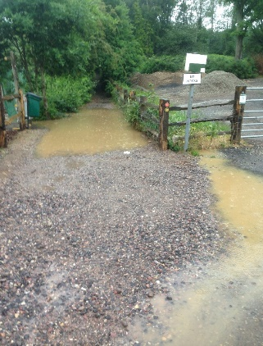
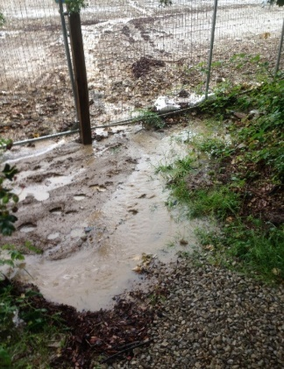
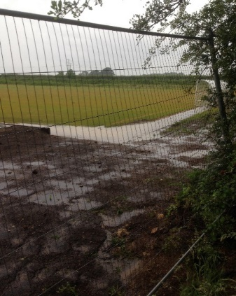

Figure One Figure Two Figure Three

The Parish Council objects to this application on the basis that the new levels in 5971/971REV P2 LEVELS COMPARISON SKETCH do not mirror the originally agreed plans which do not have the ‘ridge’ in them. All the Parish Council asks is that the levels are done in a way to remove this ‘ridge’ and allow the water to flow off the site and the drains are used as a backup for any excess water on site. As the Parish Council understands that this site needs to be futureproofed for the potential increase in rain and feel this is a modest request considering the level of water that has already been seen on the site. The Parish Council raises these issues because the Parish Council needs to be confident that the work has been done well enough to enable them to take on this community asset without the risk of incurring public expense if the surface water issues persist.
  - RR/2023/1021/P - Tree Tops - Land adj, Cottage Lane, Westfield TN35 4QG Approval of reserved matters relating to access, appearance, landscaping, layout and scale pursuant to outline planning permission RR/2021/1625/P for the erection of a single storey dwelling.
Parish Council Comments – OBJECT – The Parish Council are very concerned about the lack of detail of specific areas with this reserved matters planning application.
    - The application is titled as “Approval of reserved matters relating to access, appearance, landscaping, layout and scale pursuant to outline planning permission RR/2021/1625/P for the erection of a single storey dwelling.” However, there are no details given about the access onto the site in particular in relation to condition 5 and 8 of the decision notice for RR/2021/1625/P. Condition 5 states details for the access should be shown “To ensure the safety of persons and vehicles entering and leaving the access and proceeding along the highway” and condition 8 states “No development shall commence until details showing the proposed access and the tie-in to the junction with Chapel Lane/Public Footpath Westfield 30, including details of the profile, levels and proposed construction shall be submitted to and approved in writing by the local planning authority.” It is noted that the Principle Rights of Way Officer has objected to this application based on the lack of details for the protection of the footpath.
    - By not providing any details on these matters despite the reserved matters requiring this and the application stating ‘access’ would be addressed the Parish Council feels this application should be refused until a full application addressing all key matters is submitted. Whilst there is a right of way over the grass the space for vehicles is limited. Smaller vehicles could pass but larger vehicles for construction could not safely pass here. The levels on the grass between the driveway and the public footpath are very unlevel and in the Parish Council’s opinion would not be safe or suitable for larger vehicles to use until the levels are made safe. The close proximity of this access to the well-used and publicised 1066 footpath (Westfield 30) means there is a serious risk to users of this pathway until the issues of access and levels has been agreed. Larger vehicles should not be accessing the site up the bank on the uneven levels as this poses a serious risk to the public. Therefore, the Parish Council questions how this site can be safely constructed with the existing levels and RoW access.
    - The Parish Council would also like to point out that the ‘block plan’ is misleading. The applicant does not own all of the land in red. He only has a right of way over the land known as Tree Tops and the bottom left hand corned of Linden Lea. Also on the proposed site plan the document does not show the services and this needs clarity on where these will be installed as the Parish Council understands the applicant only has access to the services they do not have a right to move these on TreeTops land.
    - If the Officer is minded to approve this application the Parish Council has already requested the matter is taken to the Planning Committee and would ask that a site visit is carried out to see the issues with access and the current levels.
  - RR/2023/1028/P - Hillcrest, Kent Street, TN33 0SF Retention of built decking and ramp works.
Parish Council Comments – GENERAL COMMENT – The Parish Council notes the concern of the neighbour for the proposed ramp and veranda impacting on their privacy. The Parish Council would strongly urge that any agreed development requires conditions to ensure mitigations are found to stop overlooking the neighbours property and into the house.
  - RR/2023/1017/P - Old Inmans, Westbrook Lane, TN35 4PN Erection of a two storey side extension.
Parish Council Comments – SUPPORT – The Parish Council would support this application if the materials are in keeping with the area.
  - RR/2023/1023/L – Claremont School, Ebdens Hill, Westfield TN37 7PW Reinstatement of existing lodge building at Claremont School due to recent fire damage.
Parish Council Comments – SUPPORT – The Parish Council fully supports this application.

- Football Lease and Land Transfer Update
Councillors reviewed the key terms of the revised lease including the car park, CCTV, key responsibilities, drainage, floodlighting and fencing plans. The Clerk provided a written report which was also posted online. The following items were RESOLVED:
  - The length of the lease to WFC to be 50 years.
  - The proposed fencing plan to be accepted with inclusion of the top right-hand tringle for the new location of the temporary clubhouse and the future permanent Clubhouse.
  - The proposed position of the stand and clubhouse as outlined in the report.
  - The proposed floodlights spec, number and position to be 4 floodlights one in each corner, at a height of 18.3metres supplied from Musco as detailed in the Clerk’s report.
  - For the draft outline consultation on the open spaces to come to council in July.

- Traffic Report
Councillors received and noted the written update on the recent site visit based on the agreed brief from Council. Councillors RESOLVED the following:
  - That the traffic engineer is now working on the agreed brief.
  - Councillors agreed to four Automatic Traffic Counters (ATCs) as outlined in the written report from the Clerk. These would cost up to £1,500 for all four and funds would come out of earmarked reserves. The ATCs would be installed later in June or early July at the latest. After this, private schools start to finish which affects traffic levels and is considered not to be the right time to undertake a survey.

- Local Plan Meeting with Rother
Councillors discussed who would be attending the meeting with Rother officer and the Clerk to discuss the Local Plan. It was noted that there would be a full consultation with the Council and community at a later date but details are yet to be confirmed by Rother.
RESOLVED – The Chairman, Vice-Chairman and Clerk would meet with Jeff Pyrah.

- Broadband Update
The Clerk and Chairman would be meeting with Openreach for a full update on the project as key members had been on holiday. The Clerk noted that as far as she was aware the works are still programmed for Autumn time.

- Tennis Club Request
Councillors discussed the proposal from the tennis club to move from having Thursday all day to Thursday PM (noon to 6pm) and Friday AM (8am to noon).
RESOLVED – To accept the proposed changes to the club times. The Clerk would organise for a new metal sign for the tennis courts.

- Defibrillator and First Aid Training
Councillors discussed the option to organise jointing with the WI and other organisations within the Parish some training sessions and follow up on potential new defibrillators.
RESOLVED – The Parish Council would pay for the hire of the hall for the training session. The Clerk would work with the various local groups and sports clubs to look at the best times to deliver some training within the Parish. First Responders have offered to come and help deliver training.

- Appointment of Working Groups and Committees and Parish Council Representatives
Councillors RESOLVED to have the following representatives on the following:
  - Personnel committee – Chairman, Vice-Chairman and Cllr Archer.
  - Finance advisory working group – Chairman, Cllr Nijhuis, Cllr Skinner
  - WCA representative – Cllr Edwards
  - PCSO liaison representative – Cllr Coupar
  - Tennis Club – Cllr Nijhuis
  - Cricket Club – Vice-Chairman Cllr Horley
  - Football Club – Vice-Chairman Cllr Horley

- Policy Review
Councillors review and RESOLVED the below policies and procedures:
  - CCTV Policy – A new proposed policy if the Parish Council needs to install CCTV.
  - Bullying and Harassment Policy
  - Disciplinary Policy
  - Grievance Policy
  - Equal Opportunities Statement
  - Adopt the Society of Local Council Clerk’s Civility and Respect pledge

- District and County Councillor Reports – None received.

- Chairman of the Council and other member’s reports
  - No improvement on the pothole issue outside of Furtherdown.
  - Moor Lane the ‘Welcome to Westfield’

- Reports from local sport teams – No reports received.

- End of Year AGAR and Reports
Councillors re-reviewed and noted the following after the internal audit:
  - RESOLVED – Clerk’s report on any 15% variances between 2021/22 and 2022/23.
  - RESOLVED – The report from the internal auditor and recommendations for the following year.
  - RESOLVED – Councillors reviewed the AGAR Section Two – Accounting Statements and signed these as true and correct.

- Financial payments
RESOLVED – Cllr Nijhuis and Skinner to become signatories on the Unity and Lloyds Bank Accounts. This would be to signatories for cheques and online payments.

- Financial Monthly Reports and Updates
Councillors RESOLVED the:
  - Councillors to review the end of year budget monitoring excel spreadsheet.
  - The Rialtas reports for the monthly finances April and May including:
    - Bank Balances at the end of 30/04/2023 at £86,679.01 for Unity Bank.
    - Bank Balances at the end of 31/05/2023 at £74,894.00 for Unity Bank
    - Bank reconciliations for April and May were both at £0.
    - Detailed and Summary Income and Expenditure Reports. Councillors noted no items of concern. Detailed and Summary Income and Expenditure Reports were sent to all Cllrs.
  - The payment schedule showing June payments were posted online at https://westfieldparishcouncil.com/monthly-financial-reports/ .

Payee | Item | Net Cost | VAT | Total
Jane Clarke | Salary June | -- | -- | --
Jane Clarke | Clerk May Expenses Owed | £383.32 | £6.40 | £389.72
Jane Clarke | Clerk May Expenses Paid | £0.00 | £0.00 | £0.00
Shane Foord | May Hours | £0.00 | £0.00 | £0.00
Unity Card | Monthly Payment – May paid | £35.60 | £0.00 | £35.60
Viking Direct | Folders | £50.44 | £10.09 | £60.53
SLCC | Membership | £337.00 | £0.00 | £337.00
Safeplay | Replacement of swings P/Field | £288.00 | £57.60 | £345.60
Uniserve | Email replacements | £24.00 | £4.80 | £28.80
Hamish Monroe | Parish Assembly costs | £110.00 | £0.00 | £110.00
HMRC | Quarterly payment | £3,074.04 | £0.00 | £3,074.04

- Confirmation of the date of next Full Council Meeting.
12th July 2023 at 7pm.

- Closed Session - Due to the nature of the business being disclosed, Full Council are requested to RESOLVE to exclude members of the public and press for this item under the Public Bodies (Admission to Meetings) Act 1960.
  - Beech Farm – Councillors to discuss the applications and current situation.
  - Westfield Down variation of s106 and variation of condition one from reserved matters planning application RR/2017/1293/P to turn site into 100% affordable housing consisting of 23 social rented and 16 shared ownership properties planning reference RR/2023/919/P.
  - Councillors discussed proposed holiday and work arrangements for the Clerk over July/August.

