Present: Chair – Cllr Monro, Vice-Chair – Cllr Horley, Cllr Baker

Cllr Coupar, Cllr Edwards, Cllr Hills, Cllr Hosea, Cllr Nijhuis and Cllr Stapley

C24 – 03

Apologies for absence

Apologies received from Cllr Archer and Cllr Skinner.

- Disclosure of interests under the Council’s Code of Conduct.
  - Cllr Baker – Planning application re Down Oak Farm disclosable pecuniary interest as the applicant.
  - Cllr Hosea – Planning application re Down Oak Farm personal interest as an affected neighbour.

Questions from Members of the Public – None

- Minutes of Full Council Meeting held on the 21st February 2024
RESOLVED – The minutes were approved and signed by the Vice Chairman

- Matters arising from the minutes
  - Cllrs raised concerns that Cllr Coupar had a conflict of interest in relation to the Beech Farm application. It was noted that a District Cllr didn’t have to represent the opinions of the Parish Council even if they are a member of that Parish Council. It was requested that Cllr Coupar made it very clear that she was not representing the views of the Parish Council.

- Correspondence to the Clerk
  - Rother Clerk Network had a Flexibus meeting with ESCC. Key outcomes showed that the service could be very useful but in many areas it’s very unclear how the service runs. For some residents it has made a huge difference and for others it has been very frustrating.
  - Comments have been made against the Rother Clerk Network – re misinformation and politically motivated by a former Clerk in relation to the Beech Farm application. The Rother Clerk Network will be reaching out to the former Clerk as she never attended any meetings and never raised any concerns. The other Clerks at the meeting strongly contested any political motivation especially as the comments agreed with those from Rother Planning Officers.
  - Further information has been made in relation to the requested toads signs from a local resident. The matter has been passed onto the Traffic Team at ESCC as the Parish Council does not have the power to install signs on the roadside with ESCC’s permission.

- Planning Matters
  - Councillors to review the applications received since last meeting. All applications to be discussed can be found at: https://westfieldparishcouncil.com/planning-items-to-discuss/
  - RR/2024/342/P - Down Oak Farm, Main Road, TN35 4SL - Construction of an agricultural barn
The Parish Council is aware that the proposed barn is on a site that currently has two active enforcement notices on the site. There does seem to be some lack of consistency in the names and titles of different areas. In the planning statement para 2.1 it states that the site is ‘approximately 15.6 acres’ and ‘identifies the land at as Grade 3, which is described as good to moderate quality land, with moderate limitations that affect the choice of crops to be grown, timing and type of cultivation, harvesting or yield. It is mainly suited to grass with occasional arable crops.’ However, it is very unclear what land this is referring to as the whole site is not grassland. Reference is made in the planning statement to a small pole barn on site which currently houses cattle, but this building should not be considered as it has been built without permission (required due to the close proximity of the neighbouring properties).
This development does not meet the criteria of DEN1 nor DEN 2 as the siting, layout and design do not maintain and reinforce the natural landscape. The size of the building will have a significant impact on the High Weald as the barns position and size result in an incongruous man-made feature out of keeping with and harmful to the natural landscape setting of the High Weald AONB in a historically quiet grassland area.

The proposal does not meet the criteria of Policies OSS4 (ii) & (iii). The size of the barn the levels of proposed animals on site would impact significantly on the residents with the noise and smell that would be emitted from this barn within a 400m radius especially the neighbouring properties and the new 39 houses at Westfield Down.

The Parish Council would also ask that the Estate Surveyor to review the proposed levels of ewes, lambs and cattle with calves that are being proposed. The current site has a much smaller number of sheep on there and the proposed numbers seem high for such a small parcel of land.

In conclusion the Parish Council objects to this planning application due to the harm to the protected landscape, having a new incongruous man-made feature on the site which has been historically grassland, the volume of proposed animals on site and the significant impact the size, volume, noise and smell the development would have on the neighbours. The full objection can be found online.
  - Standing items on major developments in the Parish:
    - Moorhurst
    - Cottage Lane
No additional items to note except that the Moorhurst deadline for comments has been extended.
  - Enforcement matters. No additional items to note. However, it was noted that Cllrs are disappointed that Rother seem very reluctant in issuing Stop Notices and concerns about the clarity of the Enforcement Plan. These concerns would be relayed to the Development Manager.

- Appointment of Internal Auditor
RESOLVED – Councillors agreed to have Keith Robertson as the internal auditor for 2023/24 end of year audit. It was notes that this is the final year Keith should do the internal audit and a different person should be put forward in 2024/25.

- Projects Update
  - Westfield Down – Councillors received an update on the handover of the Recreational Land including Rother’s decision to rescind their ‘Certificate of Satisfaction’. Councillors had received the results of the Geo-Mapping survey which have shown that there are high levels of magnetic materials on site. At this stage it is unclear what those materials are made of, manmade or naturally found and how deep the materials are. The image on the next page shows the results from the geo-mapping and labels the following areas:
    - Area A. The five-a-side football pitch, an area measuring approximately 40 x 30m to the south-west and an area adjoining the small wood have been labelled ‘A’. These areas contain minimal magnetic material and would suggest no material has been redeposited in these sections.
    - Area B. This area contains magnetic material probably redeposited within the site.
    - Area C. The areas labelled ‘C’ contain highly magnetic material. Its origin cannot be confirmed by this survey technique.
The Parish Council will inform Southern Housing of the results and ask Rother District Council to withhold the issuing of the Certificate of Satisfaction until it has been confirmed what materials are in the soil and how far down.
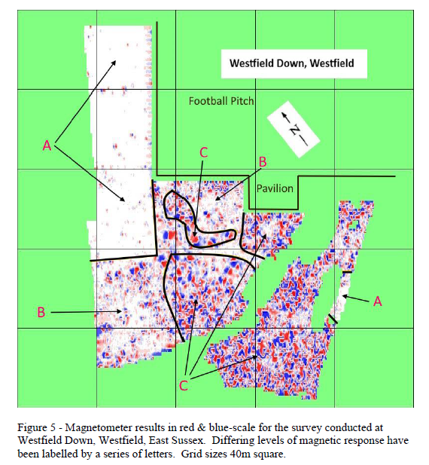

  - Traffic Project Update – Councillors received a report on progress and discussed options to help reduce speeding by making the school more visible to by removing the hedge.
RESOLVED – Councillors asked that the bus shelter is removed first and sooner than later, to see the impact this will have. After this it can be reviewed if there is any benefit from removing the hedge or look at reducing it in height.
  - Open Spaces Project – Councillors had a verbal update on progress.
RESOLVED – The Open Spaces working group (Cllrs Hill, Hosea and Nijhuis) would look to start meeting virtually every month to help manage the many different strands of the project. Cllr Nijhuis will continue to work with the Clerk and Westfield Primary School Council
.
- Condition of roads within the Parish
Councillors considered options to raise concerns on the ongoing issues of the roads. County Cllr Maynard confirmed that there is now a new Highway Steward along with 30 pot hole teams, patching crews and major road repairs. There are potential plans for a surface redressing in 2025/26. Cllrs noted that

- Policy Update
The following policies where reviewed. It was confirmed that they all are the current best practice versions and there are no recommendations for any changes.
RESOLVED – To agree the following policies in their current format:
  - Standing Orders
  - Financial Regulations
  - Code of Conduct for Staff
  - Code of Conduct for Councillors
  - Complaints Policy
  - Members and Officers Relationship Protocol
  - Health and Safety Policy

- Parish Field
An update was received on the progress with the Football Club and removing items from site. Once the ground is drier WFC will look to remove the smaller containers, fencing, barriers with concrete bases summer 2024. By summer 2025 all items would be removed.
RESOLVED – To review options to remove the small brick building and install a suitable container to house the nets used by WFC. This would look to be situated where the existing small brick hut is. The Brick hut is not big enough to store the nets and mower. Any container put in its place would only be as bigger as necessary to house the nets and mower and would be suitably cladded to make it blend into the surroundings.

- District and County Councillors – Reports were submitted to Councillors in writing beforehand.

- Chairman of the Council and other member’s reports – Verbal updates received.

- Reports from local sport teams – All reports will be online.
  - Westfield Football Club have requested permission to place advertising banners on the pitch side only.
RESOLVED – To give permission to place sensibly sized banners on the pitch side only.
  - Update on lease transfer to Westfield Cricket Club CIC.
RESOLVED – To continue working to get the land transferred over to the Cricket Club CIC. The Parish Council will cover all legal fees but further work is need on finishing the lease.

- Financial Monthly Reports and Updates
Councillors are asked to consider and resolve the:

  - The Rialtas reports for the monthly finances including:
    - Bank Balances at 29/02/2024 were at £72,789.57 for Unity Bank.
    - Bank reconciliation for end of February were at £0 for Unity Bank.
  - Earmarked reserves were sent to all Cllrs with no items of concern.
  - Details of RESOLVED payments can be found at https://westfieldparishcouncil.com/monthly-financial-reports/

- Confirmation of the date of next Full Council Meeting
Due to the Alpha Course being held on Wednesdays in the Church Hall the April/May/June meetings will be held in the Westfield Community Hall on the following dates:
- April 17th 2024
- May 15th 2024
- June 19th 2024

- Closed Session - Due to the nature of the business being disclosed, Full Council are requested to RESOLVE to exclude members of the public and press for this item under the Public Bodies (Admission to Meetings) Act 1960.
  - Westfield Down – no items to discuss in closed session.

