Agenda Item
Subject | VE Day Celebrations
Author | Officer
Date | 10/10/2024

Overview
- The following paper is a proposal for the up and coming works and events in the Parish to celebrate VE Day during May 2025.
- The proposal will be discussed and considered in partnership with the WCA and Veteran’s Growth.
- There are a number of activities happening in relation to VE Day. The Parish Council needs to ensure they stay in touch with the various organisations to support and link into these activities.

Proposed Activities
- As highlighted in para 3 there are a range of activities happening in the Parish. However, these activities are suggested for the Parish Council to take forward. Due to time frames this would be carried out in two stages. Items to happen in time for May 2023:
  - Repaint and reglaze the red phone box. The phone box could work as a ‘mini museum’ or information point with an exhibition which changes either every 6 months or annually. For the first exhibition the suggestion is to work with the WCA who are putting together an exhibition in the Westfield Community Hall and look at items that could be displayed in the phone box. Further investigations on the best way to do this either by locked display board or mini cabinets displaying a few items. This needs to all be done in the context of safety and minimising damage to any items displayed.
  - Install a ‘Lest we Forget’ bench next to the phone box. If Council resolve to do this permission will be needed from East Sussex CC to install a new bench.
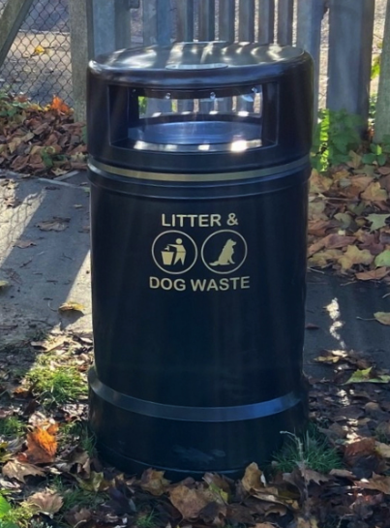
  - As part of the renovations following the removal of the brick bus stop the proposal would be to install a new flower bed in the grass bank opposite Londis Stores. The dog bin and brown bin would be removed and replaced on the right hand side of the bus stop with a single large black duel dog and litter bin similar to the image see here on the right. The proposed flower bed will be funded by the Parish Council whilst working in partnership with Veterans Growth and the WCA to help design a suitable flower display ready for May 2025 to celebrate the 80th VE day. Discussions to take place with Veteran’s Growth if they would also be able to help with the installation of the flower bed and planting in the flowers/blubs.
  - Total cost for the above works is estimated between £2,500-£3,000 to complete.
- Further works would be carried out in the area next to the old brick bus shelter which has now been removed. These are not critical to happen before May 2025 as not focused on VE Day but would finish tidying up that area into a nice new public space for residents. This would include:
  - Building a low wall to retain the soil from the back bank behind the old brick bus shelter to link into the remaining low wall and repaint all of the brickwork. All low bricks creating a trip hazard on the floor will be removed.
  - Install a new bench where the old bus shelter was.
  - Install a new noticeboard near the existing small post box.
  - Explore options to either replace the small letter box with a full size one (subject to Royal Mail agreement and services under the ground) or repositioning the small letter box next to the new noticeboard.
  - Total cost for the above works is estimated Between £5,000-£5,200 to complete.

Resolutions for Council
- Councillors are asked to resolve the proposed works outlined in paragraphs 4 and 5.
- Councillors are asked to review and resolve the expenditure for works outlined in paragraphs 4.1-4.3 estimated between £2,500-£3,000 to complete.
- Councillors are asked to review and resolve the expenditure for works outlined in paragraphs 5.1-5.4 estimated between £5,000-£5,200 to complete.

