Agenda Item | 12.1
Subject | Westfield Down – Fencing
Author | Proper Officer in collaboration with East Sussex Rights of Way Team
Date | 09/01/2025

Overview
- The Westfield Down site is still not in ownership of the Parish Council but works are underway to develop a biodiversity masterplan for the site and to develop a plan for the footpaths and fencing.
- In September 2023 Council agreed to an outline plan which was then consulted on with the community showing the basic plan for fencing and hedging. This report looks to give further detail on where the proposed rights of way/access onto the site should be. This is taking into account fencing, planting and gates on the site. The Officer and Chairman met with the Rights of Way Officer on site to discuss potential options specifically in relation to positions of gates.

Proposal for the Rights of Way on Site
- In 2014 an order was made to make changes to the footpaths 33 and 34. This order still needs to be confirmed by Rother.
- Footpath 34 is a straight line along the A28 on the inside of the hedgerow between points E and F shown on figure one. There does not seem any need to amend this footpath as it makes a logical route for those using the site.
- Footpath 33 currently runs along the edge of the lower part of Westfield Down between points X and G figure one. The levels in the area indicated by the blue triangle on figure one are now extremely steep. This makes it very hard for those accessing the site with any wheeled vehicle, pushchair or those who find steep inclines difficult accessing the site via this route. Plus there are a number of manhole covers in this area. Therefore the proposal would be to apply for a footpath diversion for a flatter and safer access route onto the site between points X and Y and close the current access via point G. The proposal would be to fence and hedge this area off to encourage people to use the main access via Y.
- The access via Y will require the ground be levelled up slightly and some pipes put in to help with any drainage but cost of doing this would be minimal. The benefit of doing this would be:
  - It creates a more accessible access with a much gentler gradient onto the Westfield Down main site.
  - Much less chance of access being flooded or eroded away by surface water coming off the site.
  - It takes the access and footpath away from the edge of residential properties.
  - It allows the area A to be fenced off and planted up creating a natural boundary between users of Westfield Down and residents. This would be done in consultation with the residents most effected by any proposals.
Figure One – Proposed Footpaths
AREA A
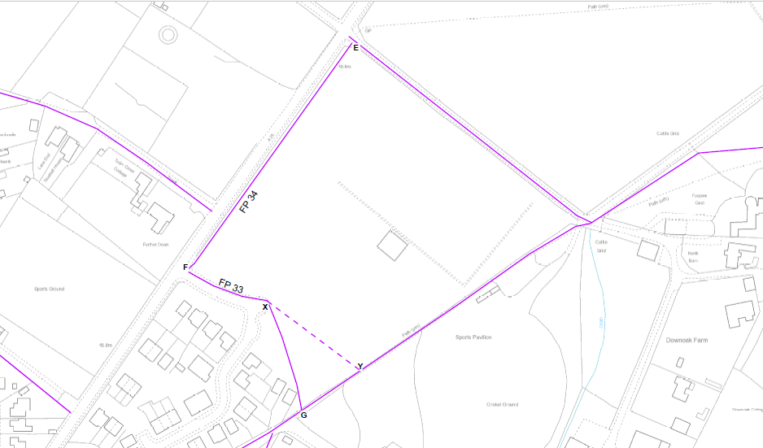

Proposed Position of Gates
- If Councillors agree the proposed position of the footpaths/rights of way across the site this would then influence where the access points onto the Westfield Down would be and any potential gates. Figure Three shows the footpath overlaid with the site plan showing the road and football pitch.
- As outlined in para 6 the proposal is to have one access onto the site via point Y. The proposal would be to have no gate at this point.
- It has been previously resolved that the edges of the green spaces next to the road would be fenced. Therefore, gates will need to be installed to allow access onto the sites. It is important that any gates do not limit people’s access to the site. The ESCC Officer suggested fully accessible gates which act as kissing gates but anyone with a mobility vehicle could also get onto site:
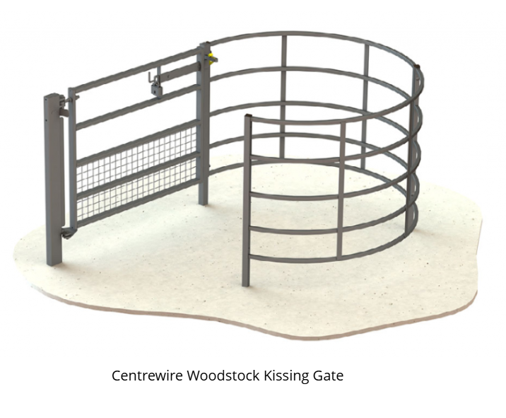
Figure Two – Example of fully accessible kissing gate
- Figure Two shows the potential style of gate recommended by ESCC. Whilst these gates are large they will be sitting within the main fencing and hedge line so will no stick out. It is important to ensure access to the green spaces is balanced with safety and accessibility for the site. The gates are big but sturdy enough to make it difficult for small children to open.
- Such gates are proposed to be installed at points X, F and E with the X point having a gate either side of the road. This would be four gates in total. Figure Three shows the position of the gates in relation to the main section of the site
- At point E space will be needed for a gate to allow a tractor in and the kissing gate. On initial measurements there was space to carry this out.

Figure Three – Footpaths overlaid main site map
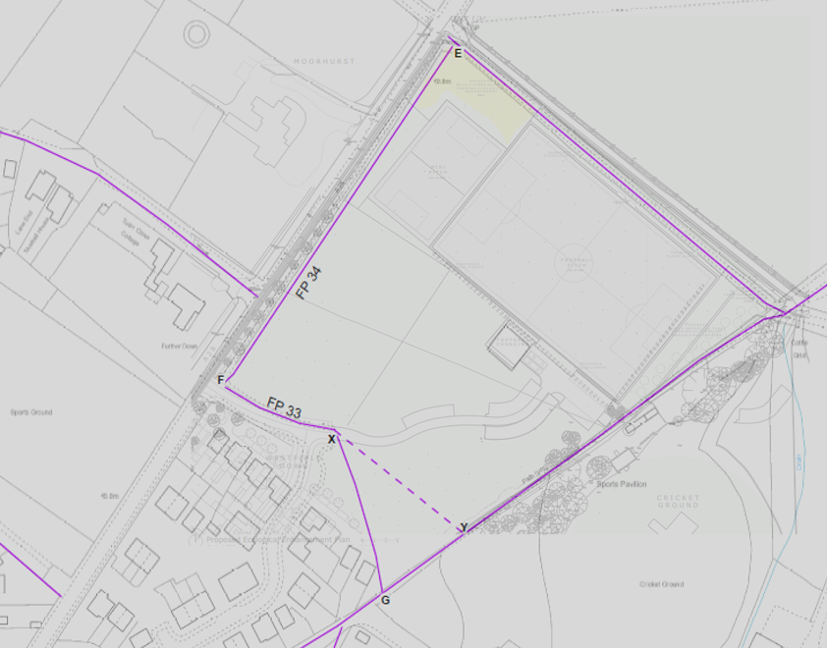

Resolutions for Council
- Councillors are asked to review this paper and discuss if they are happy to resolve:
  - The position of the gates and the style of gate
  - The footpath diversion from points X and G to X and Y.

