Agenda Item | 9.5
Subject | Traffic Project – Feasibility Study Final Draft
Author | Traffic Working Party
Date | 07/03/2025

Introduction
- Following a meeting with the Highways Safety Manger there have been some slight amendments to the proposed traffic project for the first feasibility study which East Sussex Highways need to carry out. Councillors are to review the slight amendments and approve for the next stage of application.

Recommendations
- Recommended items in ‘phase one’. The outline items have been agreed however this is the final proposal for the project based on comments and feedback from Highways:
  - Proposed 30mph speed restrictions to be moved northwards on the A28 when exiting the village to the north to be considered at a later date due to cost implications.
  - Install village gateways, planting and reinstate the red road markings along with relevant speed roundles to compliment the existing speed indicators in the following areas:

Coming into Westfield via Brede:
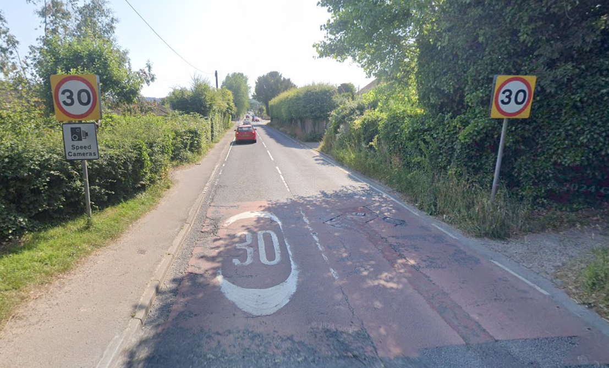

Coming to Westfield via Westfield Lane:
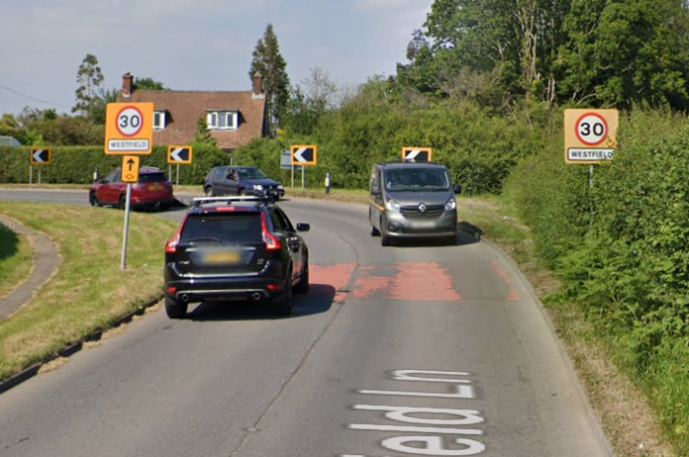

  - Implementation of a ‘School Safety Zone’ outside of the school. This involves the repainting of the zebra crossing, extending zig zag marks on the RHS (Londis shop side) up to one car to improve sight lines and stop the narrowing of the road. A further suggestion is to implement 'maximum wait times' for a few spaces outside the shop to ensure they remain available for customers who are genuinely intending to use the shop.
  - Following representations from several residents the signage coming into the village from Moor Lane has been looked at. Whilst the current sign is a traditional cast iron sign this is not very visible especially at nighttime. The recommendation would be to install a new village sign here as a warning to drivers coming into the village:

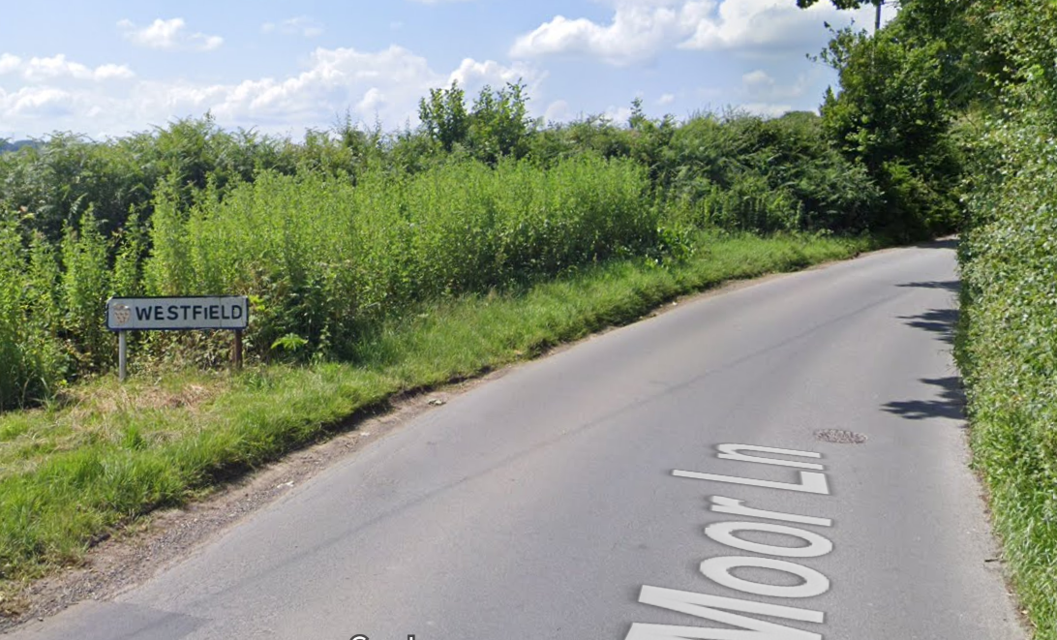

  - Further red road surfacing and roundles to be installed further up the lane to indicate clearly the speed change and entrance:
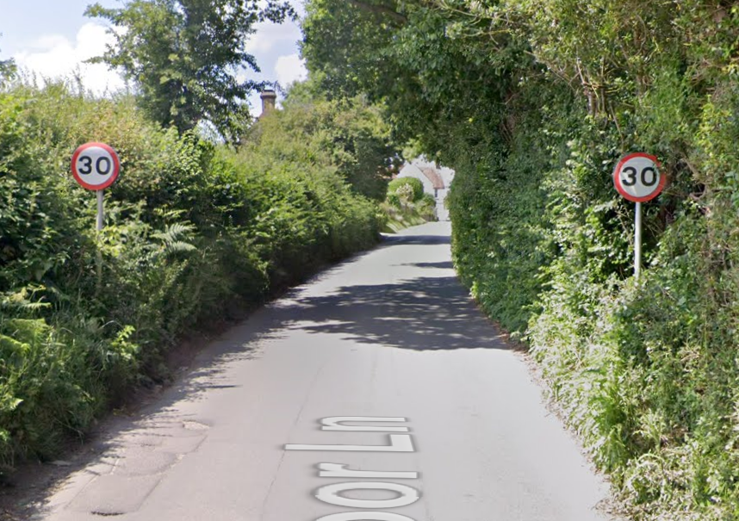

Proposed Gateways
- One of the costs will be the development and construction of the village gateways. Below are some examples of the main styles that could be used.

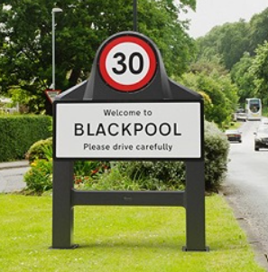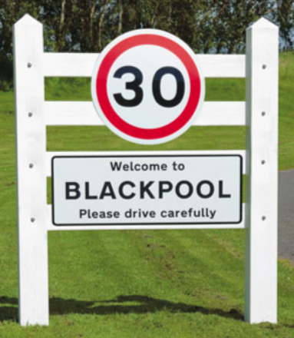
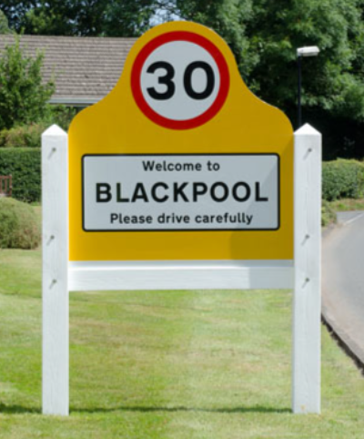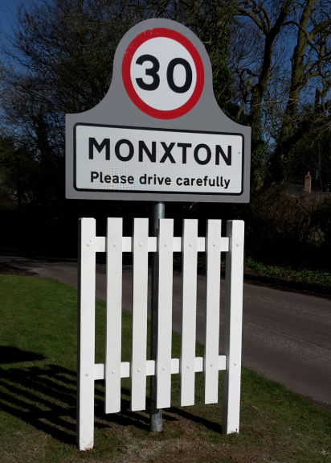

Estimated costs
- As part of the consultation costs will need to be included. East Sussex Highways has an ‘estimated costs’ in part of the application form. Based on these the following costs have been worked out:
  - Installation of gateways and some resurfacing. Example “In 2022 a town installed speed limit gateways, red surfacing and additional road markings at a cost of £12,500.” Three years on expect a 5% increase each year so likely costs closer to £14,470.
  - Improving signage and visibility of the school. Example “- In 2023, an East Sussex Village applied for improvements to signage and road markings along a busy road to highlight the presence of a school and enhance road safety. The expected costs are in the region of £8,500.
  - Replacement road sign at bottom of Moor Lane – No example given but this is just a replacement sign so as estimate would be around £2,500.
  - Total estimated costs for these works (if approved) to be carried out would be £25,470. If match funded the cost to the Parish Council would be £12,735

Other Options
- One of the items discussed was to extend the zigzag markings along the shop side of the school. This could still be a potential option but no examples were available so this will need to go back to the Road Safety team for clarification.
- Changing the speed between the village and the junction with Mill Lane from 40mph to 30mph. This is still an option but the estimated costs given by East Sussex Highways is £60,000 which far exceeds the current budget of £15k (which incudes 50% match funding). However, that was with village gateways installation of repeater signs and roundels on the road, and improved warning signs and slow markings to better highlight junctions. The most expensive part is there will need to be a traffic regulation order (TRO) to see if the proposed change is speed limit is suitable. Recommendation to install gateways at 30mph coming into the village and look at additional costs to have a change in speed on this stretch of road.

Next Stages
- To apply for Community Match Funding from East Sussex County Council there are a set number of steps to go through. Below is an outline of the next steps required:
  - Confirm costs – look at quotes for works including any potential local firms and speak with Highways about realistic estimations for the extension of the zigzags and TRO to reduce speed from 40mph to 30mph. From this the working group to make final recommendations on budget and items for feasibility study.
  - Carry out a public consultation on the proposed works and costs for the speeding options once costs confirmed. Display results at Annual Parish Assembly in June.
  - Apply for the feasibility study based on the outline in paragraph two.
  - Fill out the Community Match Funding forms and apply to have costs match funded up to 50%.

- Resolutions for Full Council
  - Councillors are asked to RESOLVE the paper with the new amendments for the proposed feasibility study as outlined in paragraph two.
  - Councillors to RESOLVE the preferred village gateways.
  - Councillors to RESOLVE a public survey and meeting.

