Agenda Items | 9.1, 9.2, 9.3 and 9.4
Subject | Project Updates
Author | Proper Officer
Date | 06/03/2025

Overview
- A general update on the various projects being currently delivered.

VE Day Project
- Key aspects of the project:
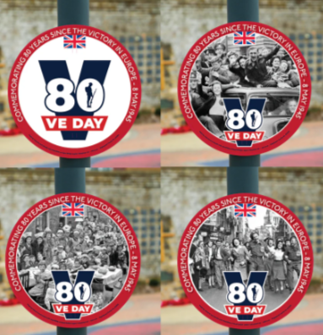
  - Red telephone box to be repainted and reglazed and developed into a ‘mini museum’. Inside to have noticeboards displaying key items from the WCAs main exhibition. The handyman is getting a date to carry out the repainting and reglazing as this kit has already been purchased. Panels for the top need making and text to be agreed.
  - Installation of a new flowerbed opposite Londis. Permissions have been applied for to East Sussex Highways. Once agreed this area will be dug out and planted up with annuals and bulbs. Work also underway to remove the excess soil from the bus shelter allowing the site to be tidied and an new brick wall installed to hold the existing soil back.
  - Install a bench next to the red telephone box. ESH have confirmed that the site is not owned by them so further investigations into ownership of the land continues.
  - Councillors are asked to RESOLVE expenditure for 28 VE Day post circles for the Parish at a cost of £125.99 from the RBLI.

Westfield Down
- At the time of writing this report the Parish Council still have not received the report on the condition of the land and the proposed remedial works.
- The Officer of the Council has been reviewing the proposed title deed when the land at Westfield Down is finally ready for hand over. A plan has been drawn up showing the current housing layout verses the proposed layout as per the S106. Key questions that this raises include:
  - The boundary at the bottom looks like it is going through the wall of one of the properties and could even be on the inside of the wall. Legal advice is being sort about any potential future implications this could have. Southern Housing has also been asked to provide the title deed for the property to ensure they match.
  - The lower corner has all of the manhole cover in it and seem sensible for Southern to retain as they serve the offsite SWALE.
  - In the middle of the plan the line does not follow the kerb of the road. This means that there are odd sections of grass the Parish Council will not be managing. However, if Southern Housing wish to retain the current plan it has been suggested a physical barrier (i.e. fence) be installed to clearly delineate ownership and responsibility, insurance etc.
  - There is section of the footpath not included. It is unclear who owns this so enquiries are being made with East Sussex’s Rights of Way Officer to confirm ownership of this part of the footpath. A future issue if this is not dealt with is who has the authority to install the agreed kissing gate in this bottom corner and then management of this small section especially as it needs managing properly because if allowed to get overgrown will cause visibility issues for those coming out onto the A28.
- Further legal advice is being sort to ensure that any of these issues will not adversely impact the Parish Council in future years. Councillors to delegate authority to the Officer to carry on investigates and bring a final proposal to Council in relation to the legal position of the title deed. Funding to come out of the Legal Fees EMR.

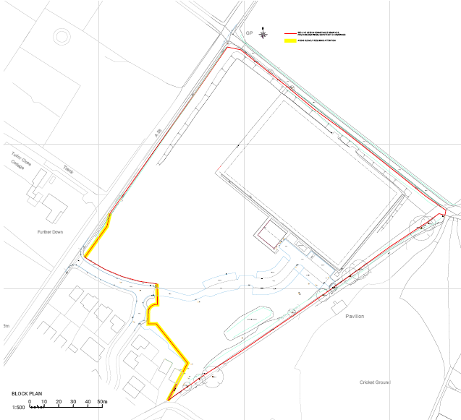

Open Spaces Project
- On the 3rd March it was confirmed that Westfield Parish Council had been awarded the £26,250. The Wicksteed quote £51,976.89 plus equipment removal at £1,200 and installation of a new playground sign £275. Total project cost £53,451 with the Parish Council contributing £26,951.89 and need to install an all weather footpath at an additional cost.
- Councillors are asked to delegate authority to the Officer in consultation with Cllrs Nijhuis and Monro to manage to get the playground delivered as soon as possible. Order of works:
  - Clear old equipment from the site
  - Install new equipment – plan for layout of equipment needs to be agreed first
  - Install new all-weather footpath – quotes needed
- Works on the Westfield Down Biodiversity Masterplan continues.
  - It has been suggested that this be a key feature of the Annual Parish Assembly. The structure would be to have an introductory talk outlining the overall purpose and importance of the Parish wide biodiversity plan and why it is starting at Westfield Down. Following this there is intended to be a series of smaller talks about key features of the planting, wildlife etc on site to be held at Veteran’s Growth and other suitable venues within the Parish (which are currently minimal especially for daytime events).
  - Meetings with the Football and Cricket Club need to take place to review the potential plan and ensure their biodiversity plans form part of the overall plan.
  - Part of the project will be to develop a community engagement plan including the school and look to have community planting days. Part of the plan would also ensure the Football and Cricket Club are engaged and involved.
  - The Officer is intending to speak with The Bright Foundation to see if they would be interested in developing a short film with their young people about the biodiversity project. This would include filming short interviews with key people throughout the project and to come along and film some of the community planting days.

Community Hub
- Meetings have taken place with the Drs Surgery, District Nurses and Rother’s Rural PC Network. All have positively inputted into ideas for the project and welcomed the potential opportunity of having additional clinical space within the Parish. Outline advice on potential equipment, layout and size of rooms was discussed which was very handy as some of the needs to make the space suitable for clinical work would be far more expensive retrofitting rather then.
- Next steps will be to visit Rye Hub on the Hill to learn more about the Northiam Parish’s clubs, which came highly recommended by the District Nurses. Additionally, research will begin for potential modular buildings to assess the costs involved in constructing one to start developing outline budgets for the project. A project plan will also need to be drawn up including outline for community engagement. Aim is to have an outline proposal ready for the Annual Parish Assembly.

Resolutions for Council
- Councillors are asked to RESOLVE the following matters:
  - The £125.99 for the lamppost/railing circles for VE Day celebrations.
  - The Officer to get quotes for the telephone box panels once wording has been agreed at Council.
  - To delegate authority to the Officer to carry on investigates and bring a final proposal to Council in relation to the legal position of the title deed. Funding to come out of the Legal Fees EMR.
  - To delegate authority to the Officer to move forward with the playground redevelopment in consultation with Cllrs Monro and Nijhuis to:
    - Clear old equipment from the site
    - Install new equipment – plan for layout of equipment needs to be agreed first
    - Install new all-weather footpath – quotes needed
  - Agree the format of the Annual Parish Assembly to have a key feature of the biodiversity plan, launch the talks and focus on the outline brief of a community hub.
  - To confirm actions of the biodiversity plan for the community engagement including the football clubs and to approach The Bright Foundation.

