Agenda Item | 13
Subject | Parish Maintenance
Author | Proper Officer
Date | 03/05/2025

Overview
- Items that need attention have been listed below follow on from previous discussions at the March Full Council meeting and the Officer’s asset check.

Baldslow Down Bus Stop Area
- There are still some outstanding items to address to complete the tidying up of the Baldslow Down bus stop area. It is proposed that if Council agree to these works no further works on this area will take place.
- Replace the removed bench with a bench that has a back to it. Potential options include:
  - Wooden bench – Similar to the bench at the A28/Cottage Lane Junction 3 seater in teak £595 plus £10 delivery.
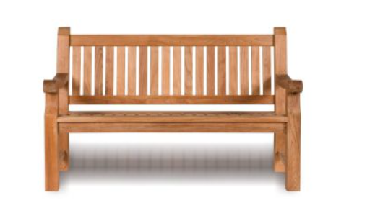
  - A wooden and iron bench – Similar to the bench at the bus stop opposite the church 3 seater with an iron frame please note frame comes in moss green or black and wooden fire resistance slats £813.42 plus free delivery.

- The bus stop has been reviewed several times over the last few years. It has recently been suggested that the current bus stop is properly reglazed to improve the look and visibility for the neighbour instead of a full replacement. Options to fully reglaze all twelve panes of the bus top have been sourced via Croft Glass:
  - Option One: 4mm clear polycarbonate £1,607.45.
  - Option Two: 6mm clear polycarbonate £2,014.25.

Fingerposts in the Parish
- Proposed work on the fingerposts:
  - Replace the fingerpost opposite the New Inn on the A28/Wheel Lane Junction. Base is rotten.
  - Repaint all of the remaining fingerposts.

Resolutions for Council
- Councillors are asked to RESOLVE to replace the removed bench at the Baldslow Down bus stop and confirm the style of bench required. Please note installation will be an additional cost for both benches.
- Councillors are asked to RESOLVE to replace two fingerposts at a cost of up to £900 each. The Officer will apply to East Sussex for 50% match funding. Councillors are also asked to RESOLVE to have the posts repainting and delegate authority to the Officer to get quotes and to use funds from the

