Agenda Item | 9
Subject | Proposal in relation to the Dog Bins in the Parish
Author | Officer
Date | 16/07/2025

Overview
- Report to Council following the June meeting where Councillors aske the Officer to produce a report suggesting the dog bins within the Parish that should remain and those that should be removed.
- Below is the suggestion based on usage and position within the Parish and any other factors that may play into the Councillors reaching a decision.

Current Position
- The Parish Council manages 11 dog bins which they pay to have the waste removed.
- The current cost is £15 per bin and these are collected weekly at a cost of £165 per week.
- The Parish Council moved to managing the dog bins in house based on an unsatisfactory service from Rother District Council and regular complaints from residents.
- Westfield has more dog bins compared to similar sized Parishes such as Burwash (4 bins) and Ticehurst (2). Westfield has currently 11 dog bins plus an additional 6 bins where dog waste can be deposited giving a total of 16 bins available within the Parish where dog waste can be deposited.

Ongoing Matters
- Having moved contractor we are able to have direct links to understanding the core issues facing each of the bins. Reports are given regularly to the Officer about usage and condition of the bins. Regular issues have included:
  - General public using the bins to take carrier bags full of dog waste and depositing it into the local dog bins instead of disposing of it in their own refuse bins.
  - Dog bins being used as general refuse bins. Cans in particular being pushed into the opening stopping people then accessing the bin even if it is not full.
  - Top opening bins have been used which do not have the smaller opening to minimise blockages from item such as cans (which should not be placed in the bins in the first place). However, this then created the issue of bags of dog waste and bags of nappies etc being put into the bin and then it still was overflowing but not with dog bags.
  - General public leaving dog poo bags on top of bins when full instead of taking home or taking to the next bin.
  - Vandalism – we have needed to replace four bins in the last 2 years due to vandalism.

Potential Options Moving Forward
- Remove all dog bins.
- Remove dog bins that regularly have carrier bags full of dog waste or inappropriate waste placed into the bin.
- Remove dog bins that are not on or next to a public footpath route or open space.
- Remove most of the dog bins and replace with refuse bins for ‘litter and dog waste’. Some of these Rother will collect others will be the responsibility of the Parish Council. This may result if overall fewer bins be also fewer individual collections but at a similar cost as they are based on weight.
- Keep all the dog bins and introduce more dog bins at a cost of £200 per bin and an extra £60 per month collection. Councillors may also need to consider a twice weekly collection if bins stay in the same spots.

Proposed Way Forward
- Based on the comments and recommendations from Councillors in the June meeting the Officer has proposed a middle ground proposal in relation to any removal of the dog bins:

 | Reports Of
Dog Bin Position | Overfull | Vandalised | Misused | Notes | Recommendation
Inside twitten at Cottage Lane | No | No | No | No issues | Keep
Near Surgery on 1066 footpath | Yes | Yes | Yes | Bin was regularly overflowing from residents using for home waste. Bin bag was being stolen, and bin was vandalised so removed. | Move to top of 1066 footpath
Parish Field from A28 end | No | No | No | Under used so was moved to the Parish Field and placed inside. | Keep
Parish Field via Cottage Lane | Yes | No | Yes | Regularly has refuse waste place in here. | Keep
Mill Lane | Yes | No | No | Bin occasionally overflowing. Issues with residents using for home waste. | Keep
End of New Cut next to footpath | Yes | No | Yes | Bin occasionally overflowing. Issues with residents using for home waste. | Keep/review
On Main Road opposite Londis | No | No | Yes | There is a nearby refuse bin that can be replace with one stating 'Litter and Dog Waste'. | Remove
Bottom Workhouse Lane | Yes | Yes | Yes | Bin regularly overflowing. Issues with residents using for home waste. Was cut down and needed replacing. | Remove
Entrance to Whitelands Wood | No | No | No | No issues | Keep
Opposite the Church next to bus shelter | No | No | No | There is a nearby refuse bin that can be replace with one stating 'Litter and Dog Waste'. | Remove
End of Westfield Lane service road | No | No | No | No issues | Keep

Proposed Review
- If Councillors wish to proceed with the removal of the above bins The Officer would recommend the following steps:
  - Consult the proposal with the community for a month. Mainly online but options for feedback either via phone or paper would be available and advertised in the WOW magazine for August. Results presented in September full council and acted on.
  - Review need for any future dog bins especially in line with future take over of Westfield Down.

Resolutions for Council
- Councillors to RESOLVE the recommendations from the Officer including the community consultation.

Positions of Current Dog Bins
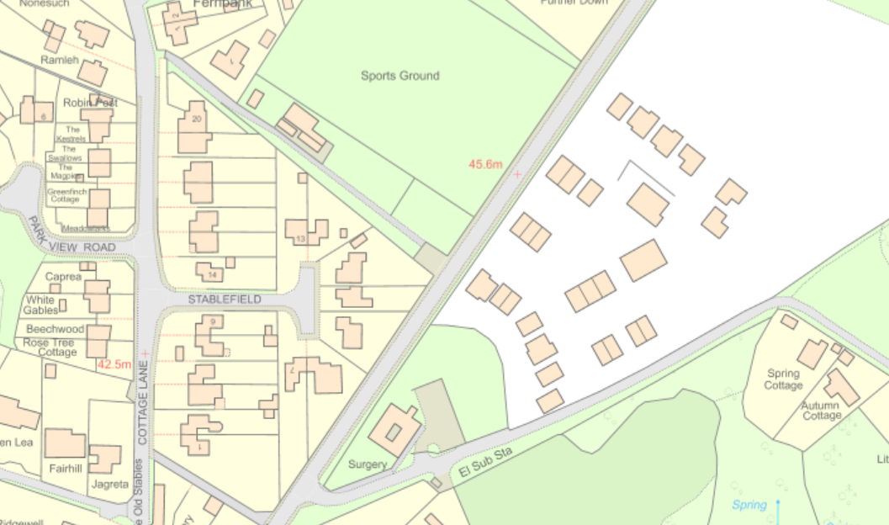
4
3
2
1
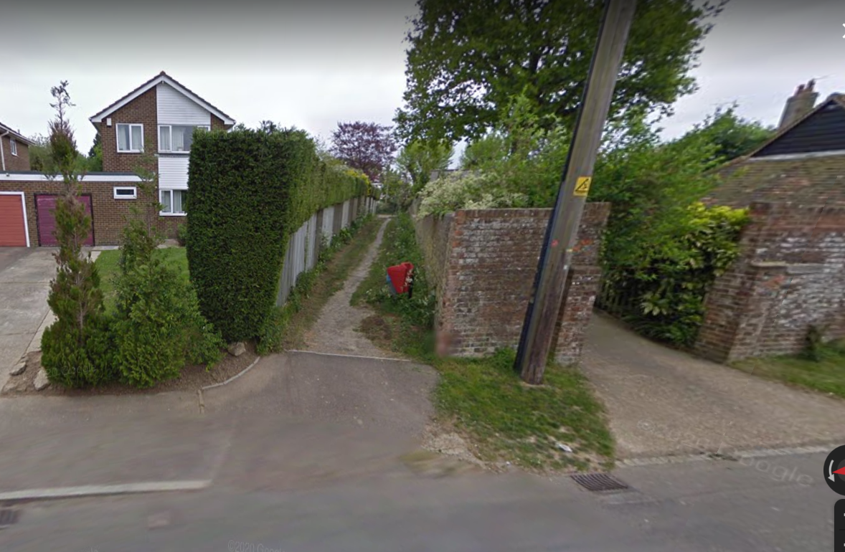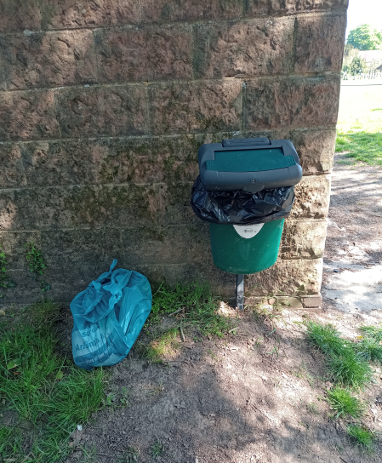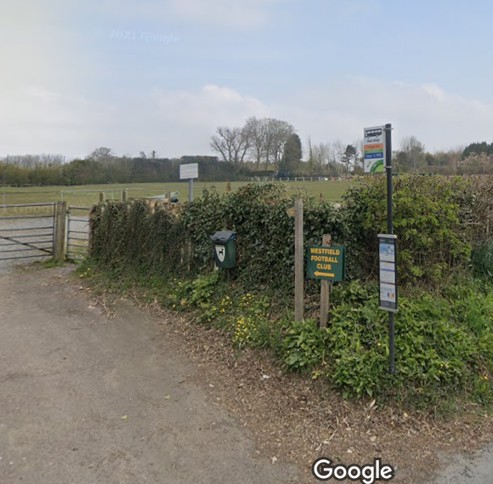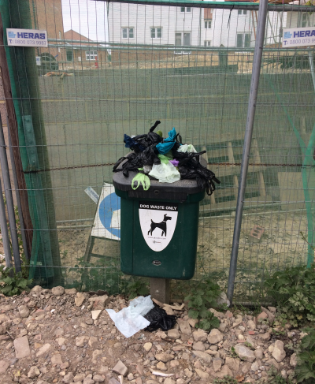

Dog Bin 1 – Inside twitten from Cottage Lane end

Dog Bin 2 – Up from Surgery before entrance into Cricket Ground

Dog Bin 3 – Entrance onto Parish Field from A28 end

Dog Bin 4 – Entrance onto the Parish Field now attached to groundsman hut

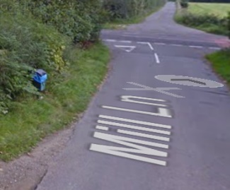
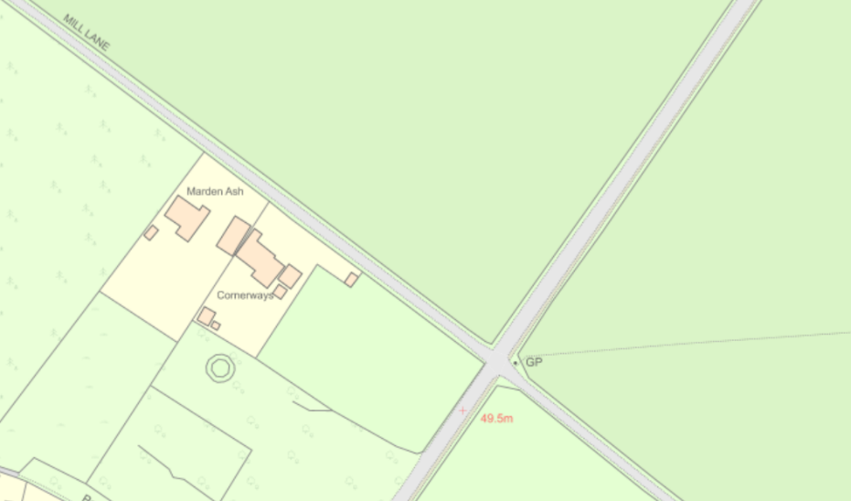

5

Dog Bin 5 – Mill Lane

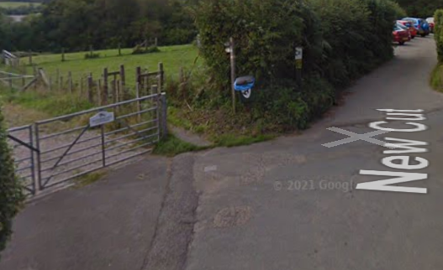
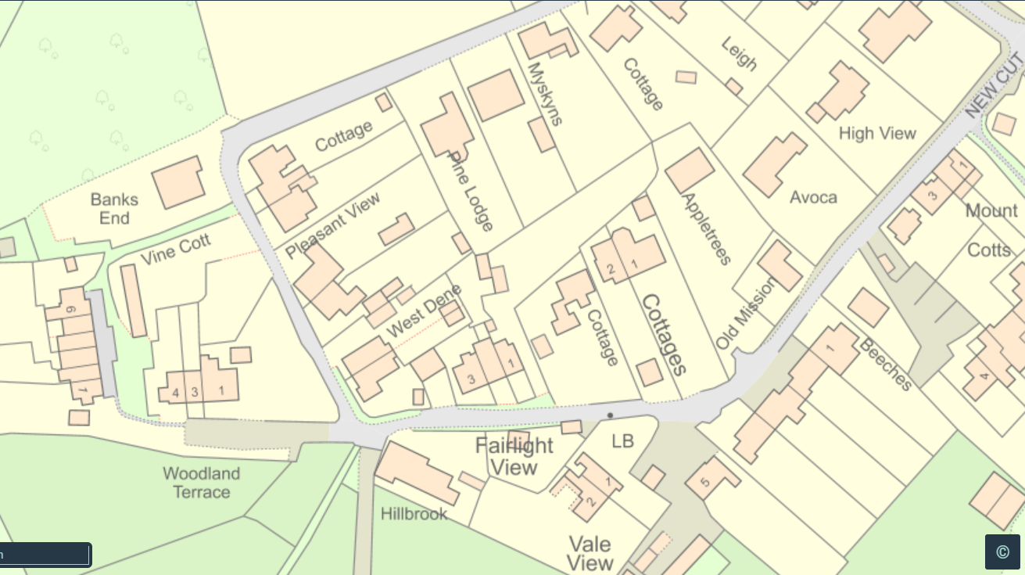
6

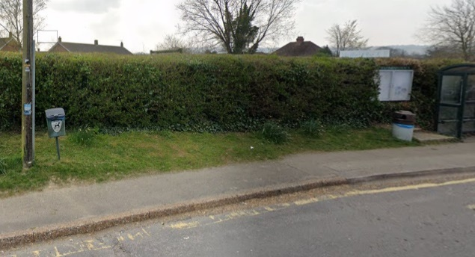
Dog Bin 6 – End of New Cut next to footpath entrance
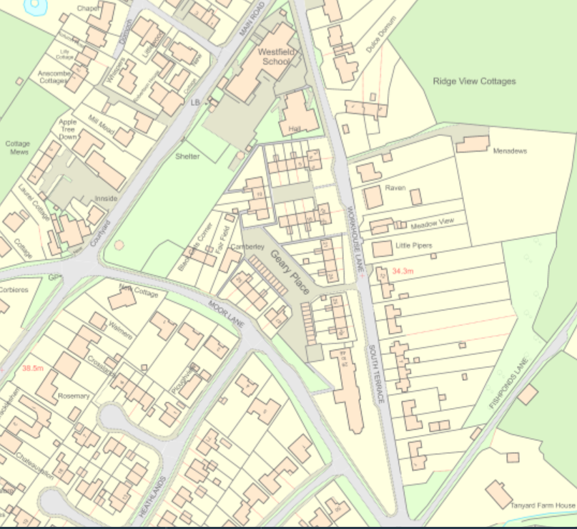
7
8

Dog Bin 7 – On Main Road opposite Londis

Dog Bin 8 – Down Workhouse Lane (no photo)

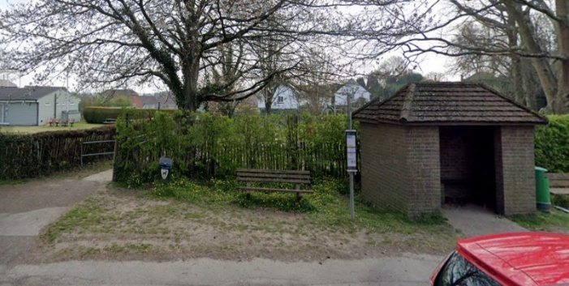
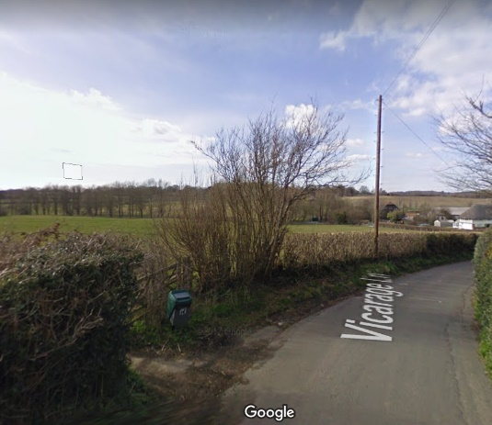
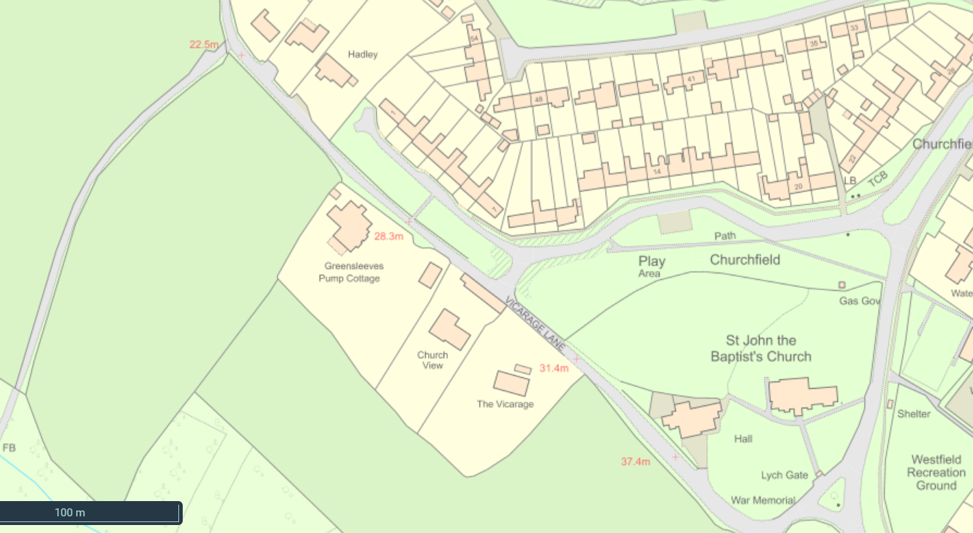
10
9

Dog Bin 9 – Entrance to Whitelands Wood

Dog Bin 10 – Opposite the Church next to bus shelter
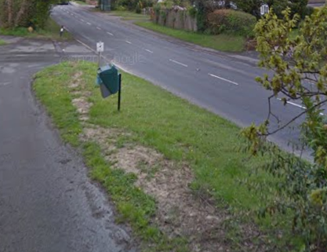
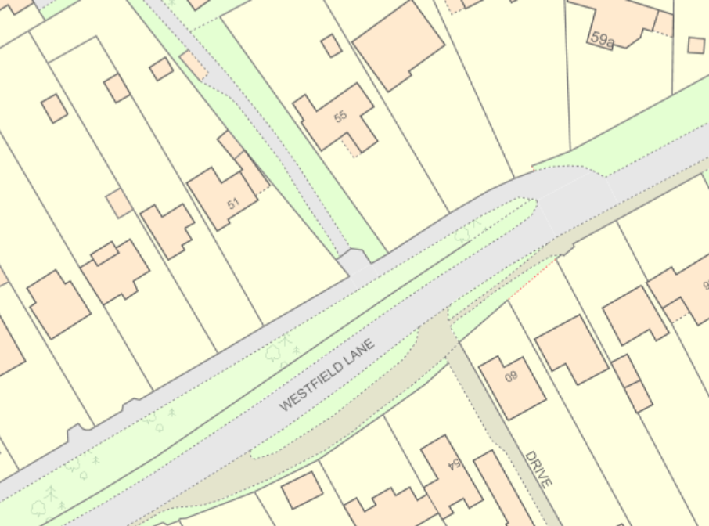
11

Dog Bin 11 – End of Westfield Lane service road

