BIODIVERSITY PROJECT OVERVIEW
The Parish Council continues to work with Councillors and Veteran’s Growth CEO, Horticulturist Sarah Wilson. This is an update report for council about the overall planting proposal for the site. This will then be drawn up as a planting programme and form the basis for the presentation at the Annual Parish Assembly in September 2025.
TOP SECTION
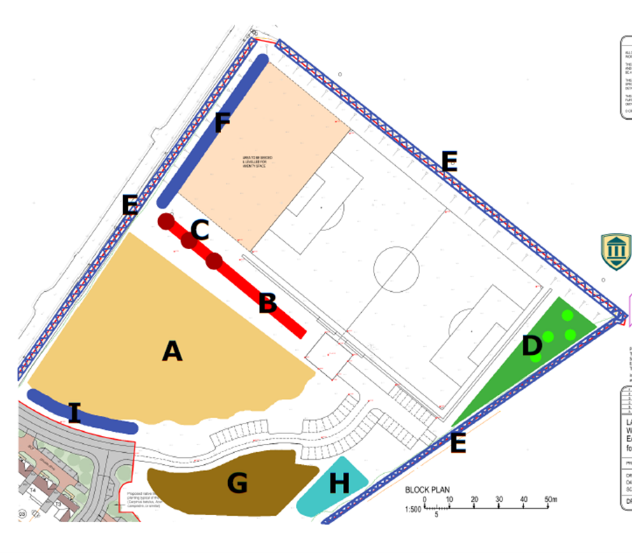
This section has been discussed and agreed at full council. The basis of this was on the Open Spaces Consultation carried out with the community. The purpose was the establish the overall look and feel of the main recreational area on site which is shown as Section A in the FWAG report. Sections G, H and D are discussed later on in this paper.
Figure One – FWAG diagram of Westfield Down Site
- Section A
  - The main central area will mainly be open planned. It will have minimal tree planting maybe of more ornamental trees allowing the space to be enjoyed as open recreational land giving people the opportunity to safely play sports on the site or partake in gentle recreational leisure such as walking and running.
- Sections E, F and I
  - It should be noted that ‘Section I’ has been extended from the original FWAG report. The red hatched area is currently grass but will have the parking extended here.
  - To compensate for habitat loss on site, the plan is to plant wildlife-rich hedgerows along the edges of the recreational land. These will create wildlife corridors and provide food and shelter for local species, with particular consideration given to dormice. Existing hedges will be strengthened and deepened to improve their ecological value.

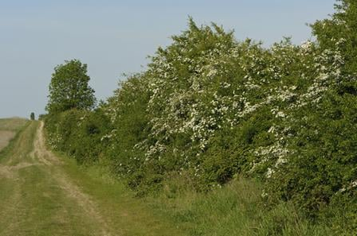
  - Adequate space will be maintained between Hedges E and F to ensure tractors can safely enter and exit the site. In addition, the kissing gate currently located in the middle of the left-hand side of Hedge E will be removed.
  - Stock fencing will be installed all around the edges to keep users of the recreational land safe from the road. The planted hedges are intended to be cut on the roadside to keep them trim and close to the fence line but on the other side the intention is to allow a gradient hedgerow to grow out and encourage a tussocky grass-rich growth to develop at the base of the shrub layer.
  - This is because a dense grassy ground cover is essential for many invertebrates including spiders, beetles, lies and caterpillars, both for overwintering and breeding. The photo on the right gives an idea of the style of hedge however the ones at the recreational land would only grow up to around 2 metres high. The hedge mix is including guelder rose and dog rose to provide a food source for wildlife but is also very beautiful. The other species included in the hedge mix would include hazel, field maple, spindle, hawthorn, dog wood, guelder rose elder and dogrose. Honeysuckle could also be an option as this is a good food source for dormice. It is noted however that if hedges are put inside the fencing or close to the boundary at the football pitch the amount of hawthorn would be minimised in these areas.
  - Oak trees would also be marked out at regular intervals to allow to grow up to full maturity within the hedge itself. This would increase the number of trees on site creating greater biodiversity for wildlife providing shelter, food and nesting for birds and bats, whilst also providing shade for users of the recreational areas.
- SECTIONS B and C
  - These sections were originally proposed for planting with native tree species and a “windbreak hedge,” as recommended in the FWAG report. This planting would both enhance the site’s biodiversity and provide natural screening for the football pitch. However, it is important to retain an access gap wide enough for the tractor to reach the pitch for ongoing maintenance.
  - Another consideration is the potential development of a Community Hub. A suitable location could be Section B, where the former football clubhouse had been proposed. This area is flat, step-free, and accessible via an existing footpath. It is also close to parking facilities, away from major utilities, and could be effectively screened with planting to reduce the visual impact of a new building.
Figure Two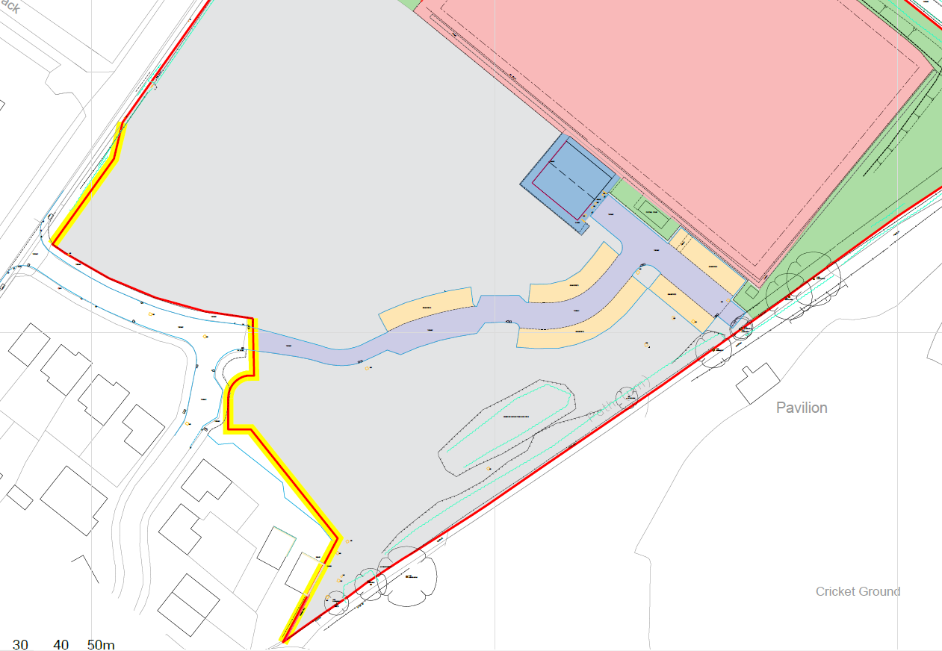
Section A
Section B
Section C

LOWER SECTIONS – Map above
- SECTION A
  - This will remain largely grass to be mown once every one or two months (however the public footpath will be mown every two weeks). It will not be easy to establish a wildflower meadow here due to the level of nutrients in the soil.
  - Suggestion to plant an odd number of ‘tree clumps’ which will have a tree planted in the middle with several shrubs surrounding them. Ideally scattered to look non-uniform.
  - Intention is to put an order in to move the public footpath. The current agreed footpath is outlined by the black dotted line. The proposal which has been agreed in principle with the rights of way ESCC Officer has been outlined by the yellow dotted line. This will make access onto the site easier and flatter rather than trying to navigate the bottom corner highlighted by the orange triangle. This area is particularly uneven with a number of manhole covers which are trip hazards.
- SECTION B
  - The middle section where the last remaining trees are is proposed to be joined up with the back hedge. This will create a ‘belly out’ then in front low level native planting.
  - Look at planting low level shrubs it the top part of this section.
- SECTION C
  - Propose area to be kept grass with the random planting of 5 native trees.

