Agenda Item | 9
Subject | Parish Maintenance
Author | Proper Officer
Date | 10/09/2025

Baldslow Down Bus Stop Area
- There have been some updates to the bus stop this year. To date the noticeboard has been replaced and the glazing in the bus stop has also been replaced. However, there are still some outstanding items to address to complete the tidying up of the Baldslow Down bus stop area.
- Replace the removed bench with a bench that has a back to it. Potential options include:
  - A wooden and iron bench with a frame that comes in moss green or black and wooden fire resistance slats £813.42 plus free delivery.
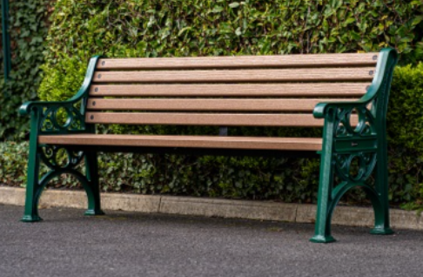

Resolutions for Council
- Councillors are asked to RESOLVE to replace the removed bench at the Baldslow Down. Please note installation will be an additional cost.

