Agenda Item | 8.2
Subject | Proposed Settlement Spatial Plan Consultation Survey
Author | Proper Officer
Date | 14/11/2025

Westfield Parish Council: Settlement Spatial Plan Consultation Survey
Introduction / Background
- Westfield Parish Council is preparing for the Rother Local Plan, which will guide where new housing development takes place over the next 25 years (to around 2050).
- We are currently unsure what housing figures will be allocated to Westfield. Back in the 2019 Rother District Council Development and Site Allocations Local Plan Westfield Parish was allocated to have 89 houses to be built around the village area. These were allocated via the following sites:
  - WES1 Land at Westfield Down, Westfield 39 – Full 39 properties have been built
  - WES2 Land at the former Moorhurst Care Home, Westfield 40 – Planning has now been given for a 64 bed care home which counts in planning as 36 properties
  - WES3 Land south-east of Goulds Drive, Westfield – Undeveloped
- This means of the three sites two have been developed and Westfield Parish has achieved:
- A physical build out of 39 of the 89 housing target.
- Planning permission has been given for the equivalent of 36 properties (Moorhurst 64 bed care home) and another 25 on Cottage Lane which was given on land not allocated in the 2019 DaSA. The position of Cottage Lane remains unclear but that is potentially another 61 houses that have received planning permission.
- Only land se of Goulds Drive remain undeveloped with a potential 10 houses.

New Housing Allocated in the Rother Local Plan
- With the new Local Plan now being developed further housing has been allocated in Rother’s Draft Local Plan. This is within two key areas the fringes of Hastings and within the village area. With this in mind the Parish Council, working with planning consultants O’Neill Homer, has developed a set of growth scenarios to help explore what different patterns of development could look like.
- These are not final proposals — rather, they are options for discussion that will help shape how Westfield grows while protecting its character, environment, and sense of community. It will also help inform whether the sites Rother has proposed fits in with the
- Your views will help the Parish Council:
  - Build an evidence-based response to Rother’s Local Plan
  - Show what kind of growth the community supports
  - Identify key local issues such as infrastructure, school capacity, road safety, health provision, and environmental protection.

Section 1: About You

Section 2: Understanding the Context
- Before this survey, were you aware of the Settlement Spatial Plan or the upcoming Rother Local Plan?
  - Yes
  - No
- How informed do you feel about the issues facing Westfield’s future growth (e.g. housing, traffic, environment, infrastructure)?
  - Very informed
  - Somewhat informed
  - Not very informed
- In your view, which of the following issues should be the highest priorities when planning future development? (Select up to three)
  - Protecting the village’s character and landscape (High Weald AONB)
  - Managing road traffic and parking
  - School and GP capacity
  - Flooding and drainage management
  - Access to green spaces and footpaths
  - Affordable housing for local people
  - Supporting local facilities (shops, pubs, community spaces)

Section 3: The Growth Scenarios
- Each scenario represents a different way Westfield could accommodate around 150 new homes. They differ mainly in location and layout — north, east, south, or dispersed growth.
All assume that infrastructure (school, GP, roads) would need upgrading over time.

- Scenario 1: Northern Growth
The village has grown within the limitations of its current infrastructure away from Hastings. Its roads, community facilities and open spaces are busier, and the school is at capacity. The housing schemes have been focused to the north, necessitating active travel improvements along the A28 into the surgery, school and local facilities and creating a new focal area around the open space and sports facilities nearby.
  - Growth to the north of the village, away from Hastings.
  - Would improve walking and cycling links along the A28 to reach the school and surgery.
  - Could increase through-traffic in the village centre.
  - Constrained by Doleham Lane boundary.
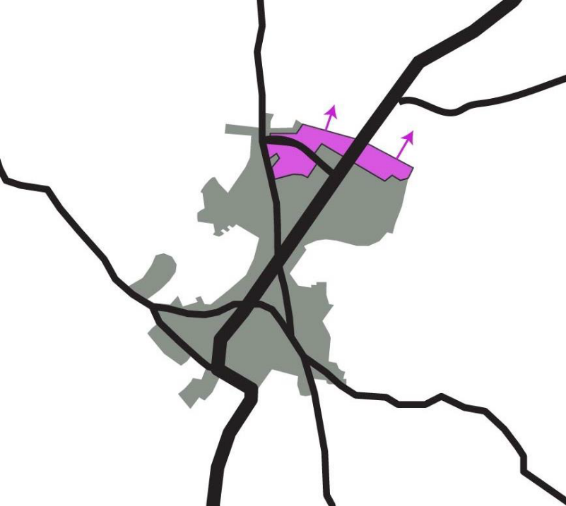
- Q7. How suitable is this scenario for Westfield’s future?
(1 = Not suitable, 5 = Very suitable)
- Q8. What do you think are the main advantages or disadvantages of this approach?
(Open text)

- Scenario 2: Eastern Growth
The village has grown within the limitations of its current infrastructure and improved its resilience to flooding. Its roads, community facilities and open spaces are busier, and the school is at capacity. The housing schemes have been focused to the east of the village within walking distance of the centre, so the essential character of the village has not changed.
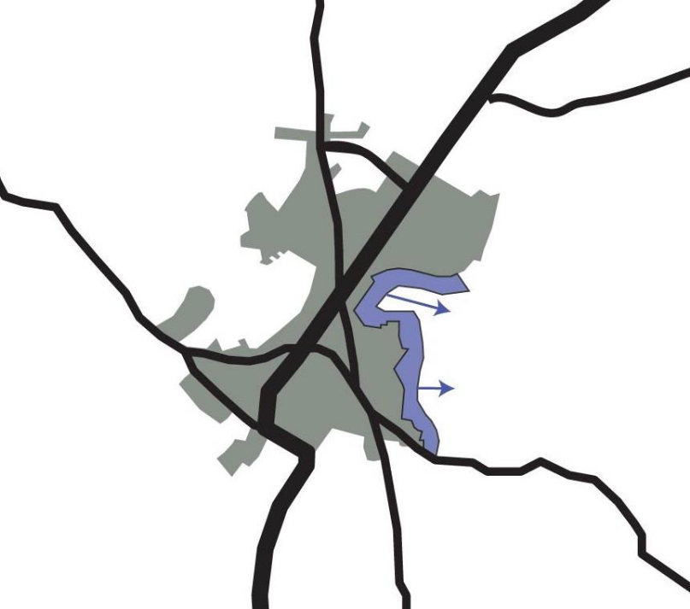
  - Homes to the east, within walking distance of the centre.
  - Limited heritage impact; pedestrian access via Workhouse Lane.
  - Access near the surgery and Fishponds Lane would need upgrades.
  - Area is sensitive due to spring-fed water systems top of Fishponds Lane and near the Westfield Down SWALE and drainage constraints.

- Q9. How suitable is this scenario? (1–5 scale)
- Q10. What are your main thoughts or concerns?
(Open text)

- Scenario 3: Southern Growth
The village has focused growth towards to Hastings, so there is little additional traffic through the village centre. Its roads, community facilities and open spaces are busier, and the school is at capacity. There is potentially additional parking for the church and church hall. The new housing schemes are within walking distance of the centre, and the essential character of the village has not changed.
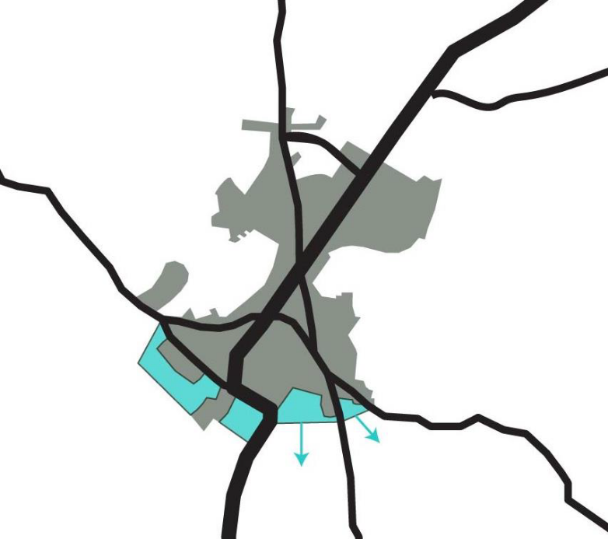
  - Focuses growth toward Hastings, reducing traffic through the village centre.
  - Walkable to local facilities and bus routes.
  - Some landscape and heritage impacts near The Moor.
  - Would require improved access or junctions on the A28.
- Q11. How suitable is this scenario? (1–5 scale)
- Q12. What do you like or dislike about this option?
(Open text)

- Scenario 4: Southern Growth+
The village has grown within the limitations of its current infrastructure , focusing on growth towards to Hastings, so there is little additional traffic through the village centre. Its roads, community facilities and open spaces are busier, and the school is at capacity. Development has provided new open space, and The Plough is re-opened as a pub or community hub. The essential character of the village has not changed.
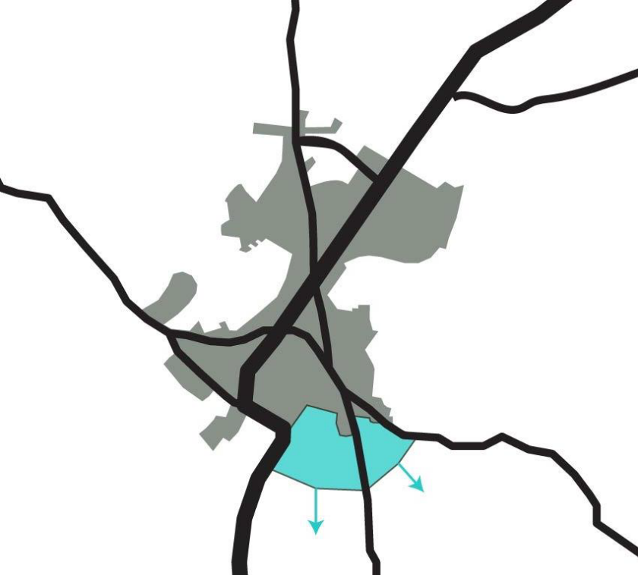
  - Builds on the southern option but includes new open space.
  - Would need a new A28 junction and strong landscape buffers to avoid coalescence with Hastings.
  - Heritage sensitivities near Moor Farmhouse.
- Q13. How suitable is this scenario? (1–5 scale)
- Q14. What are your views on this enhanced southern option?
(Open text)

- Scenario 5: Distributed Pockets
The village has grown within the limitations of its current infrastructure with discrete pockets of development across the village. Its roads, community facilities and open spaces are busier, and the school is at capacity. The essential character of the village centre has not changed, but the piecemeal nature of the new housing has prevented any major road, open space or active travel improvements.
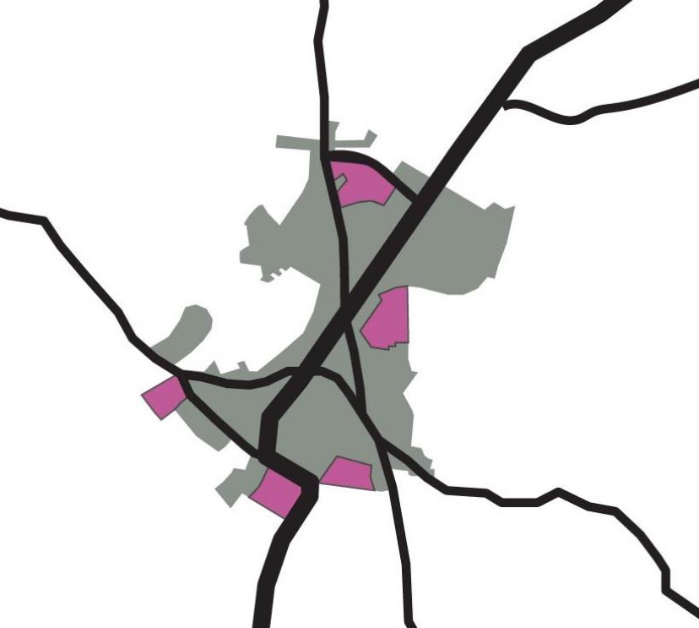
  - Required homes spread across smaller sites of around 10/20 houses around the village.
  - Maintains village character but limits infrastructure contributions.
  - Less scope to deliver new community or transport improvements.
- Q15. How suitable is this scenario? (1–5 scale)
- Q16. What are the strengths and weaknesses of this dispersed approach?
(Open text)

Section 4: Wider Planning Considerations
- Q17. Which of the following local infrastructure issues should be addressed most urgently if new development occurs?
(Select all that apply)
- GP surgery and parking
- School capacity and pick-up/drop-off safety
- Footpath links and active travel routes
- Drainage and surface water management
- Road safety and traffic calming
- Community meeting spaces or recreation facilities
- Q18. How important is it that future development contributes directly to local facilities (e.g., community spaces, green infrastructure, parking improvements)?
- Very important
- Quite important
- Neutral
- Not important
- Q19. How should Westfield’s village identity be protected and strengthened as it grows?
(Open text)

- Section 5: Overall Preferences
- Q20. Which scenario (or combination of scenarios) do you think best reflects the right balance for Westfield?
- Scenario 1: Northern Growth
- Scenario 2: Eastern Growth
- Scenario 3: Southern Growth
- Scenario 4: Southern Growth+
- Scenario 5: Distributed Pockets
- A combination (please specify)
- Q21. Why did you choose this option?
(Open text)
- Q22. What concerns or conditions would you want to see addressed before supporting new development?
(Open text)

- Section 6: Final Thoughts
- Q23. Do you have any other comments about Westfield’s future or the Settlement Spatial Plan?
(Open text)
- Q24. Would you like to be kept informed about the next steps in the Local Plan and community consultation?
- Yes (please provide email address)
- No

